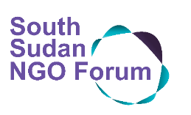

NGO Forum Members Code of Conduct-2022

16 February 2022 | Juba, South Sudan

***The Code of Conduct (CoC)*** is a set of shared norms, principles and values that aim to guide the conduct of NGOs that are members in the South Sudan NGO Forum:

* We are committed to comply strictly with international humanitarian principles, human rights, and humanitarian laws.
* Our work is based on the principle of “DO NO HARM” which focuses on responding to emergencies, chronic needs, reducing the impact of disasters and climate change, dealing with the root causes of poverty, meeting basic needs, and enabling communities to become resilient and self-sufficient.
* We are accountable to those whom we seek to assist, to those providing resources, and to legal authorities.
* We are transparent in our dealings with the government and community partners, the public, donors, and other interested parties.
* We are independent and we strive to maintain our autonomy according to South Sudanese and international law, and to resist the imposition of conditionality or corrupt practices that may compromise our mission and principles.
* We will not discriminate against any individual or group on the grounds of gender, political affiliation, ethnic origin, religious belief, or sexual orientation.

On behalf of my organisation, I agree that we will abide by this Code of Conduct in registering as an NGO Forum member for the year 2022.

Name: Organisation:

Date: