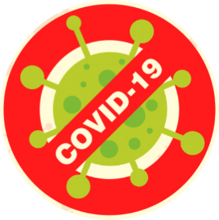

**COVID – 19 & DEALING WITH MISINFORMATION**

**Some Good Online Information Sources**

**www.who.int**

**World Health Organization**

**www.cdc.gov**

**CDC**

**moh.gov.ss/**

**MoH South Sudan**

**Authenticity:** Check for the source authenticity

**Source:** Consider information source - is there an author? Check out their credentials

**Look before you share:** Don’t share with others if you haven’t checked it yourself first

**Read Beyond:** Read the whole story and not just the headlines

**Supporting Sources:** Check if supporting sources confirm the story?









