**MULTISECTORAL ASSESSMENT REPORT- LAINYA COUNTY**

|  |
| --- |
| 1. **General Information:** |

|  |  |
| --- | --- |
| **Assessment Location**  State, County, Payam, Boma, Precise Location | **Lainya County – Yei River State (Former Central Equatoria)**  **Precise location: Lainya center, Lokwili, Loka Round, Lokurubang and Nyaiporu boma.** |
| **GPS Coordinate** | Lainya Centre **N: 040 21’ 2.63’ E: 0310 03.56’.16’**  Lokwili Boma **N04022’8.21’ E: 0310 07’16.39’**  Lokurubang **N 04019,3.39’ E 0310 03 18.09’** |
| **Type of Crises**  (Conflict/Natural Disaster/Other) | Conflict Natural Disaster Other (specify): Protracted, under-served displacement (under- served) |
| **Site Type** | PoC Collective Centres Spontaneous Settlements  Host Communities Other (specify): Returnees |
| **Assessment Team**  (Name of I/NGO in the Assessment Team, Name of Staff, Contract Details of Staff including Sat Phone) | **N*orwe*gian Refugee Council (NRC)/ Partners**   |  |  |  |  | | --- | --- | --- | --- | | **Staff Name** | **Position** | **Contacts** | | | **Phone** | **Email** | | Lodule Peter Laku | Protection Coordinator – Team Leader | 0922475511  0912475511 | [**lodule.laku@nrc.no**](mailto:lodule.laku@nrc.no) | | Abuna Hillary .A. | WASH -PO | 0921712208,  0911712208 | [**abuna.aliardo@nrc.no**](mailto:abuna.aliardo@nrc.no) | | Murye Silas Eluzai | EiE Project Officer |  | [**murye.eluzai@nrc.no**](mailto:murye.eluzai@nrc.no) | | Ladu Charles | S- NFIs P.O | 09282406162 | [**ladu.john@nrc.no**](mailto:ladu.john@nrc.no) | |
| **Date of Alert** | 28th May .2019 ( Follow up meeting with MaCDA 17th June) |
| **Date of Assessment**  (starting date/ending date) | 20th -- 27th June 2019 |
| **Date of Submission** | 01st July 2019 |
| **Population Size (estimated)** | 19,363 (3227 HHs)[1] |

|  |
| --- |
| **2 Introduction:** |

WASH assessment was conducted after getting report from Mother and Child Development Agency (MaCDA) that 6,705 Individuals (15-20) HH returnees IDPs are coming on daily basis to Lainya County. Since MaCDA is implementing FSL, they called WASH partner for a scale up of humanitarian response in Lainya Centre, Logwili, Loka Round, Lokurbang and Nyipara in Lainya County. These areas were reported to be a catchment area for IDPs and returnees and host communities who are also vulnerable too.

According to secondary data sources, there were approximately 19,363 individuals which is 3227 HH influx of returnees who arrived in Lainya County between April and June 2019 due to increasing movement restriction of Refugee to access other services in the camps - Uganda. Also there is no enough class room for children education as such 80-100 pupils are in one classroom, which contributed to poor learner performance in their education. The major reason for coming back to their ancestral place is lack of food as the food ratio which was distributed cannot last for one month before the next distribution take off, with significant improvement on security situation in some parts of Payams in Lainya County made returnees IDPs to come back home

As result NRC conducted WASH assessment in Lainya County mainly Lainya Centre, Logwili, Loka Round, Lokurubang and Nyipara to carry out an in-depth WASH assessment needs of the returnees IDPs as well as Host community. However, there are places were bigger number of IDPs are such as Bereka Payam, Lomikin Payam, Loka west and Mukaya County, but it was not possible for the team to access these areas to find out the need of IDPs/returnees due to security concerns and road accessibility those areas. According to RRC and local authorities, they said it is possible for NRC to reach these communities after proper coordination is carried out by Paramount chief and Religious leaders in Lainya County to talks to authorities of armed groups controlling those areas to allow NGOs to deliver Humanitarians assistance to returnees and IDPs in those areas.**___-**

|  |
| --- |
| **3. Objectives of Multisectoral assessment in Lainya County:** |

The assessment mission majorly aimed at determining if the IDPs and Refugees who were displaced from Lainya are returning to Lainya and to what services are available to them.

**Specific Objectives**

* To verify the shelter NFIs, WASH and education needs of the IDPs and Returnees population in the county.
* To assess the risk and threats faced by the population in the area, what support they have and who are they doing to stay safe.

|  |
| --- |
| 4. **Background:** |

Lainya County is one of the County in Yei River State and it has five Payams (Lainya Centre, Logwili, Kenyi, Limbe and Bereka) Lainya County is one of the newly created county of Yei River State, decreed by the H. E the President of South Sudan in 2015.Lainya County is located along Juba Yei High way about 63 KMs from Juba and 37 KMs from Yei. Lainya County is inhabited by Pojulu tribe of Central Equatoria. Since 2016 conflict broke out in Juba Capital and it escalated to others part of the country, Lainya County was one of the affected Counties in Yei River State, as such all people flee deep to the bush while other went to Yei, Uganda, Congo and Juba.

immediately the same year after the fighting stop and calm return in the area, people displaced nearby started returning to Lainya Centre, Logwili, Loka Round, Lokurubang and Nyipora, however highest number of IDPs are in Bereka Payam, Loka west in Lainya Payam, Lomilikin in Kenyi Payam located 5-10 KMs away from Lainya Centre. These areas are in accessible due to security concern since it is they are under controlled of armed groups in Lainya County Yei River State.

According to the authorities and the Relief and Rehabilitation Commission (RRC) there are currently 19,362 individuals 3,227 HHs Returnees / IDPs who came to Lainya County and surrounding Payams or villages such as Lainya Centre, Logwili, Kenyi Bereka and Limbe. However, 26,700 Individuals, 4,660 HH are host community in the five Payams of Lainya county.

The areas accessed by NRC assessment team where returnees IDPs and host Communities are including Lainya Centre and Lokwili is 13,410 individuals, 2235 HH, while host community in these two community are 24,738 Individuals, 4,123 HHs however the figures given were not verified.

The IDPs/ Refugee returnees started coming back to Lainya County in Feb 2019, however, RRC reported that from April- June 2019, approximately 15-20 HHs are coming on daily on voluntary basis.

The assessment was prompted by the information shared by ES-NFIs cluster dated 28th May, 2019 which stated that the case load of 6,700 individual’s returnees need assistance. Hence NRC made a follow up meeting with MaCDA dated 17th June 2019.MaCDA updated NRC team on the gaps in Education S-NFIs, WASH and Protection, on 20th June 2019, NRC decided to conduct Multi- Sectoral Assessment in Lainya County.

***Map of Lainya County***

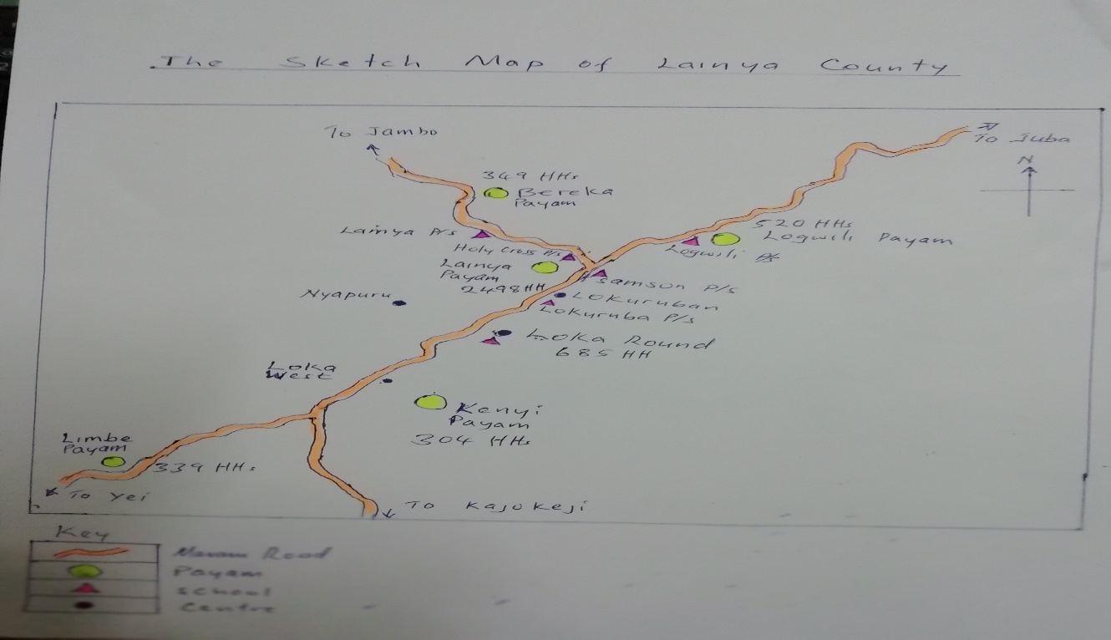

|  |
| --- |
| **5. Assessment Methodology:** |

The methodologies used to achieve these objectives included interviews with key informants, Observations, focus group discussion, and meetings with the government authorities, community leaders and humanitarian partners.

|  |
| --- |
| **6. Key Findings** |

The following are the major findings by sectors:-

|  |
| --- |
| **WASH** |

WASH:- services in the Lainya County currently are been managed by ACROSS and Islamic Relief International. In regard to water supply, ACROSS drilled 4, planned to repair 10 boreholes, however, there are still many boreholes in some Payams of Lainya county deep in bush drink direct from un safe water source such as river/stream water even some hand pumps need major or minor repair, the households deep in the villages reportedly collected untreated water directly from the river and streams for their domestic needs. From the FGD only few households treat their water using filtering or boiling. Community reported that even water from repaired boreholes in 2017-2018 by other WASH Organisation were yellowish in color while other boreholes breakdown already thus makes them to walk long distance in search for water.

On sanitation, no any other WASH partners in baked on construction of latrine. Returnees reported that they are sharing latrine that exist where they are putting, thus because many latrines collapsed, burnt down or not there but the latrines were not enough to meet the sanitation needs of the affected population. From the 3 FGD and the KII most returnees IDPs and host Communities expressed their willingness to use the latrines but need more support in tern of sanitation tools and plastic slab or some emergency latrines be constructed through the involvement of the community.

On hygiene promotion, RRC said that there are 15 trained Hygiene Promoters at the county level comprised of both returnees IDPs and host community, however, knowledge of the of the affected population to the basic hygiene practices such as hand washing is really low among the women and children in the HHs visited by the enumerators.

On WASH NFIs, most of the interviewed households to have received some water containers and soap in 2017-2018, but the distribution was only targeted the most vulnerable people. Recently, returnees IDPs from Uganda, Juba and deep in the bush did not receive any WASH NFIs more specially women and girls at child bearing age in the communities and 6 schools operational schools lack sanitary pad for their famine’s hygiene as the teachers explained that upper classes girls missed classes when they experienced their monthly period. In the schools visited by NRC assessment team, children said that, they fear to used latrine since some of the doors were broken and lack of soap and handwashing facilities.

**Water point- Lainya County:**

|  |  |  |  |
| --- | --- | --- | --- |
| **Location** | **Total #of boreholes** | **# functional boreholes** | **# Nonfunctional boreholes.** |
| Logwili | 20 | 10 | 10 |
| Kenyi | 37 | 08 | 29 |
| Limbe | 48 | 09 | 39 |
| Bereka | 19 | 13 | 06 |
| Lainya Centre | 89 | 37 | 52 |

|  |
| --- |
| **EDUCATION** |

Key Education Finding During Multi Sectoral Needs Assessment in Lainya County

* Lainya County which comprised of five (05) Payams (Logwili, Bereka, Lainya, Kenyi and Limbe) has twelve (12) functioning and sixteen (16) nonfunctioning primary schools.
* Out of the twelve (12) functioning primary schools, seven (07) are under government control areas and the team only assessed six (06); Lainya P/S, Logwili P/S, Loka Round P/S, Lokurbang P/S, Holly Cross P/S and Samson P/S. Kenyi Primary school which is newly opened don’t have enrollment data from the County Education Office and is not assessed.
* The other five (05) functioning primary schools are under rebels (National Salvation Front) and are not accessible by the team. Out of the five schools, two are IDPs primary schools i.e. Lomilikin primary school in Kenyi Payam and Monokindyita primary school in Bereka Payam with a bigger enrollment as compared to schools under government control Areas according to the county commissioner, Lainya County.

**Generally, the functioning primary schools lack the following**;

* Scholastic materials for pupils and teacher preparation books
* School fees payment. Most of the children of the returnee parents and some host community parents are at home due to lack of money to pay their fees. For example, in Lokwili primary school, learners pay 1,200 SSP. The PTAs contribution through school fees payment is for buying teaching and learning materials and motivation of volunteer teachers.
* Lack of chalks in the schools. The few available were bought from Yei Town expensively
* Lack of textbooks. Almost all the schools lack textbooks for lesson preparation as they were destroyed during the crises.
* Lack of sanitary kits. Girls of 14 years and above are out of school due to lack of sanitary pads for regular lesson attendance during their ministration cycle.
* Recreational materials. Most of the schools lack sport materials such the football, valley ball, skipping rope and others
* Latrines. Holly Cross primary school don’t have even single latrine. Teachers and learners shared from the church and in Samson primary school, the one that exist is full and in bad conditions. Schools with latrines like Lainya, Logwili, Loka Round and Lokurbang P/S don’t have cleaning brushes
* Hand washing facilities. All the schools lack hand washing materials to promote health and sanitation of the learners.
* The roof of primary three in Lainya primary school and Nursery is blown down by wind
* The absence of school feeding program in schools made many children to be at home
* Most of the teachers in the six (06) primary schools are volunteers. The few government have stayed now for 6 months without getting salaries.
* Most of the volunteer teachers don’t receive any training either on psychosocial support or participatory teaching approaches.

**IDPs/Refugee Returnees and Host Community Populations as per the data provided by RRC Agt. Coordinator for Lainya and Logwili Payams Assessed by NRC team**

|  |  |  |  |  |  |  |  |
| --- | --- | --- | --- | --- | --- | --- | --- |
| **Population Category** | **Total Population** | | | | **Age bracket 5-18 years** | | |
| HHs | Individuals | M | F | M | F | Total |
| IDPs/Refugee Returnees | 2235 | **13,410** | 5365 | 8045 | 3110 | 4666 | **7,776** |
| Host Community | 4123 | **24,738** | 10,652 | 14,086 | 5739 | 8609 | **14,348** |

***Table 1: The general population of host community, IDPs, IDPs/Refugee Returnees.***

According to the RRC Agt. Coordinator for the greater Lainya county, the two payams has a total population of 24738 (910652 males, 14086 females) host community and 13,410 (5365 males, 8045 females) IDPs and IDPs/Refugee Returnees. Out of the general total population of host community and IDPs/Refugee Returnee, 22,124 (8,849 boys and 13275 girls) are primary school-age going children within the age limit of 5-18 years.

**Number of school-age children currently attending schools in Lainya County as per the data provided by County Education Director and School Head teachers as on 24th June 2019**

|  |  |  |  |  |  |  |  |  |  |
| --- | --- | --- | --- | --- | --- | --- | --- | --- | --- |
| **S/N** | **School Name** | **Location** | **Enrolment of children** | | | | | | |
| **IDPs** | | **Returnees** | | **Host Community** | | **Total** |
| Boys | Girls | Boys | Girls | Boys | Girls |
|  | **Pre-schools** |  |  |  |  |  |  |  |  |
| 1 | Lainya |  | 10 | 10 | 27 | 11 | 22 | 16 | 96 |
| 2 | Logwili |  | 7 | 5 | 12 | 7 | 34 | 37 | 102 |
| 3 | Holly Cross |  |  |  | 11 | 8 | 20 | 22 | 61 |
| 4 | Samson |  | 30 | 24 | 10 | 10 | 6 | 9 | 89 |
| 5 | Lokurbang |  |  |  | 39 | 31 | 35 | 25 | 130 |
| 6 | Loka Round |  |  |  | 6 | 12 | 14 | 13 | 45 |
|  | **Sub-total** |  | **47** | **39** | **105** | **79** | **131** | **122** | **523** |
|  | **Primary Schools** |  |  |  |  |  |  |  | **523** |
| 1 | Lainya |  | 22 | 28 | 72 | 65 | 73 | 42 | 302 |
| 2 | Logwili |  | 18 | 12 | 12 | 14 | 91 | 108 | 255 |
| 3 | Holly Cross |  |  |  | 28 | 29 | 65 | 68 | 190 |
| 4 | Samson |  | 23 | 18 | 21 | 25 | 21 | 17 | 125 |
| 5 | Lokurbang |  |  |  | 46 | 58 | 52 | 67 | 223 |
| 6 | Loka Round |  |  |  | 63 | 45 | 29 | 37 | 174 |
|  | **Sub-total** |  | **63** | **58** | **242** | **236** | **331** | **339** | **1269** |
|  | **Total** |  | **110** | **97** | **347** | **315** | **462** | **461** | **1792** |

***Table 2: pupils’ enrolment data 2019***

There are 1792 IDPs/refugee and host community school-age going children (873 girls (48.71%) and 919 boys (51.28%) are currently attending classes in six primary schools. Consideration the number of IDPs/Refugee returnees and host community, a bigger population of school age-going children have not enrolled in schools because of security reasons and lack of support

**Teachers enrolment data**

**Number of teachers currently teaching in the functional host primary schools in Lainya County as per the data provided by the County Education Director and Head teachers on 24th June 2019**

|  |  |  |  |  |  |  |  |  |  |  |  |
| --- | --- | --- | --- | --- | --- | --- | --- | --- | --- | --- | --- |
| **S/N** | **School Name** | **Location** | **Enrolment of teachers** | | | **Teachers on MoGEI payroll** | | | **Teachers not on MoGEI payroll** | | |
| Men | Women | Total | Men | Women | Total | Men | Women | Total |
| 1 | Lainya |  | 7 | 2 | 9 | 1 | 0 | 1 | 6 | 2 | 8 |
| 2 | Logwili |  | 9 | 0 | 9 | 0 | 0 | 0 | 9 | 0 | 9 |
| 3 | Holy Cross |  | 10 | 0 | 10 | 0 | 0 | 0 | 10 | 0 | 10 |
| 4 | Samson |  | 6 | 2 | 8 | 0 | 0 | 0 | 6 | 2 | 8 |
| 5 | Lokurbang |  | 8 | 5 | 13 | 4 | 1 | 5 | 4 | 4 | 8 |
| 6 | Loka Round |  | 11 | 2 | 13 | 5 | 0 | 5 | 7 | 1 | 8 |
|  | **Total** |  | **51** | **11** | **62** | **10** | **01** | **11** | **42** | **09** | **51** |

***Table 3: Teachers enrolment data 2019***

There are 62 teachers (51 males and 11 females) currently teaching in six host primary schools in Lainya County. Out of the 62 teachers, majority (51) are volunteers (42 males and 9 females) who are actively teaching in the six primary schools according to the County Education Director and head teachers. Most of the government teachers flew to Uganda during the crisis and others left teaching profession in search for other opportunities. The few teachers on Ministry of General Education and Instruction Payroll have now stayed for six months without receiving salary.

**Number of teachers that have received training on life skills and psychosocial support in the schools**

|  |  |  |  |  |  |  |  |  |  |  |  |
| --- | --- | --- | --- | --- | --- | --- | --- | --- | --- | --- | --- |
| **S/N** | **School Name** | **Total Teachers** | **Trained (Professional)** | | | **Untrained teachers** | | | **Trained on Life Skills & Psychosocial support** | | |
| Men | Women | **Total** | Men | Women | Total | Men | Women | Total |
| 1 | Lainya | **9** | 1 | 0 | **1** | 6 | 2 | **9** | 1 | 0 | **1** |
| 2 | Logwili | **9** | 2 | 0 | **2** | 7 | 0 | **7** | 0 | 0 | **0** |
| 3 | Holy Cross | **10** | 0 | 0 | **0** | 10 | 0 | **10** | 2 | 0 | **2** |
| 4 | Samson | **8** | 1 | 0 | **1** | 5 | 2 | **7** | 0 | 0 | **0** |
| 5 | Lokurubang | **13** | 1 | 0 | **1** | 7 | 5 | **12** | 1 | 0 | **1** |
| 6 | Loka Round | **13** | 0 | 0 | **0** | 11 | 2 | **13** | 2 | 0 | **2** |
|  | **Total** | **62** | **5** | **0** | **5** | **46** | **11** | **57** | **6** | **0** | **6** |

***Table 4: Number of teachers who received training on life skills and psychosocial support***

Out of the 62 teachers, only 5 (8.0%) were professionally trained while 57 (91.9%) were not professionally trained teachers and 6 ((9.6%) teachers attended training on Life skills and Psychosocial support conducted by Plan International while ,56 (90.3%) did not attend any training on Life skills and Psychosocial support.

**Availability of learning materials for teachers and children in the schools in the crisis affected area**

|  |  |  |  |  |  |
| --- | --- | --- | --- | --- | --- |
| **S/N** | **School Name** | **Location** | **WASH Facilities** | | **Remarks** |
| Latrine blocks | Water source |
| 1 | Lainya | Lainya | 2 | 1 |  |
| 2 | Logwili | Logwili | 1 | 0 | Have water tanks but need rehabilitation |
| 3 | Holy Cross | Lainya | 0 | 0 | Use community bore hole |
| 4 | Samson | Lainya | 2 | 0 | The two latrines are in bad conditions |
| 5 | Lokurubang | Lainya | 3 | 1 |  |
| 6 | Loka Round | Lainya | 3 | 0 |  |
|  | **Total** |  | **9** | **2** |  |

***Table 5: Availability of learning materials***

Most of the respondents 42 (64.61%) said most of the primary schools don’t have teaching and learning materials for teachers and children because they were looted or destroyed during the crises. Only 8 (12.30%) said they have learning materials. This is because Plan International provided teaching and learning materials to their supported primary schools last year. Most of the schools lack basic writing materials for teaching and learning. According to County Education Directors and head teachers of the primary schools visited, Plan International with support from UNICEF provided teaching learning materials to their four supported primary schools last year. However, schools have run out of the writing materials including recreational materials because the supplies given were limited. According to the head teachers of the respective schools visited, lack of scholastic materials are contributing to pupils’ absenteeism and drop out in schools

**WASH Facilities in Schools:**

**The number of WASH facilities (latrines and safe water source) in the host primary schools**

|  |  |  |  |  |  |
| --- | --- | --- | --- | --- | --- |
| **S/N** | **School Name** | **Location** | **WASH Facilities** | | **Remarks** |
| Latrine blocks | Water source |
| 1 | Lainya | Lainya | 2 | 1 |  |
| 2 | Logwili | Logwili | 1 | 0 | Have water tanks but need rehabilitation |
| 3 | Holy Cross | Lainya | 0 | 0 | Use community bore hole |
| 4 | Samson | Lainya | 2 | 0 | The two latrines are in bad conditions |
| 5 | Lokurbang | Lainya | 3 | 1 |  |
| 6 | Loka Round | Lainya | 3 | 0 |  |
|  | **Total** |  | **9** | **2** |  |

***Table 6: WASH facilities in schools***

Most of the primary schools have latrine blocks. Only Holy Cross which is not operating in its premises don’t have single latrine block for both teachers and pupils. The school population share from the church. In Samson primary school, the existing latrine blocks are full and in bad conditions. Almost All the schools don’t have privacy and WASH facilities for girls to manage menstruation.

**Children Protection concerns:**

**Protection concerns for children to access or attend school**

|  |  |  |  |  |  |
| --- | --- | --- | --- | --- | --- |
| **Boys** | **Respondents** | **%age** | **Girls** | **Respondents** | **%age** |
| Financial barriers, no cash to buy writing materials, school uniform and other school requirements | 34 | 52.30% | Financial barriers, no cash to buy writing materials, school uniform and other school requirements | 26 | 40% |
| Long distance; some children walk more than a kilometer to schools. | 17 | 26.15% | Lack of privacy WASH facilities & sanitary kits to manage menstruation | 14 | 21.53% |
| Child Labour or exploitation | 9 | 13.84% | Child Labour or exploitation | 7 | 10.76% |
| Lack of WASH facilities | 5 | 7.69% | Long distance; some children walk more than a kilometer to schools. | 15 | 23.07% |
| Sexual harassment or Abuse |  |  | Sexual harassment | 3 | 4.61% |

***Table 7: Child’s protection concerns***

The major protection concerns limiting children to access or attend schools included financial barriers for both boys and girls, long distance, lack of WASH facilities and sanitary kits for girls and child labour or exploitation. Girls are more affected than boys because girls are more vulnerable compared to boys in the communities **Teachers’**

**(P Parents, Teachers’ Association (PTA) data TA) data**

**Number of PTA members in the two schools hosting IDPs learners:**

|  |  |  |  |  |  |
| --- | --- | --- | --- | --- | --- |
| Number of | IDPs | | Host Community | | Total |
| Men | Women | Men | Women |
| Current PTA members | 13 | 10 | 34 | 17 | **74** |

***Table 8: PTA number by gender and displacement status***

According to the data provided by the head teachers, all the schools have PTA Executive committees comprising 13 members. However, most of the PTA committees were not trained by any humanitarian agency on the roles and responsibilities of PTA.

**Community Contributions**

**What community can do to support/ contribute to smooth running of education services**

|  |  |  |
| --- | --- | --- |
| **Community contribution/ support to restart education services** | **Respondents** | **Percentage** |
| Cash contribution for paying volunteer teachers | 30 | 31.4% |
| Mobilize school fees for their children | 13 | 28.5% |
| Community mobilization & awareness for parents to send children to school | 18 | 17.1% |
| Local materials for construction of temporary learning space | 4 | 11.4% |

The community can do cash contribution for the paying volunteer teachers, mobilize school fees for their children, mobilization and awareness for parents to send their children to school. However, due to the economic hardships, most parents could not afford financial contribution for the payment of the volunteer teachers and termly school fess.

**Other education partners and the services they provide in the school/ community:**

|  |  |  |
| --- | --- | --- |
| **Partner** | **Services provided** | **Period/ duration of services** |
| Plan International | School feeding and teaching and learning materials | Last year 2018 |

***Table 10: Education partners in Lainya County***

Plan International supported Lainya, Lokwili, Lokurbang and Loka Round primary schools with school feeding and teaching and learning materials last year. Early march this year, Plan International did education needs assessment and never came back for any respond. So currently there is no education partners supporting education activities in greater Lainya County.

**The top priorities (main needs) for the affected population (both displaced and host community)**

|  |  |  |
| --- | --- | --- |
| **Top priorities (main needs) for affected population** | **Total # of respondents** | **Percentage** |
| Food | 18 | 27.69% |
| Education | 32 | 49.23% |
| Water and Sanitation | 3 | 4.61% |
| Protection and Safety | 12 | 18.46% |

***Table 11: the top three priorities of the community in Lainya County***

The top priority needs of the affected population (IDPs/refugee returnees and host community) include food, education, water and sanitation, protection and safety. Provision of education was rank top 49.23%) because there is no partner on the ground supporting education activities. Food is the second priority of the affected population (34.2%) because all the school do not have school feeding program. Protection and safety ranked 3rd because the learners move/ travel longer distance to reach school.

**The top education activities most important to support children to attend schools in the crisis affected area:**

|  |  |  |
| --- | --- | --- |
| **Top education activities to support children to attend schools** | **Total # of respondents** | **Percentage** |
| Payment of teachers’ salaries | 65 | 100.00% |
|  |  |  |
| Provision of teaching and learning materials including recreational materials | 65 | 100.00% |
| Training of teachers and PTA | 28 | 43.07% |
| Construction/ rehabilitation of school infrastructures | 15 | 23.07% |
| Provision of WASH facilities including sanitary kits for girls | 22 | 33.84% |

***Table 12: the top education activities to support children attend school***

The top most education activities is to support children to attend schools in the crisis affected areas or communities (both IDP and host community) include payment of teachers’ salary, provision of teaching learning materials including recreational materials, training of teachers and PTA, construction/ rehabilitation of school infrastructure and provision of additional WASH facilities including soap, hand washing facilities and sanitary kits for girls.

|  |
| --- |
| **FOOD SECURITY & LIVELIHOOD** |

**Access to the market:**

There are three market, one is located in Lainya Centre, Logwili and Loka Round, Lainya Centre having one wholesale there are food commodities, clothing as well as vegetables. During time of the assessment, there were food items presence, such as dry fish, okra, maize flour, rice bean, salt coffee and Sugar in both market. but there are few shelter NFIs materials in Lainya Centre and Loka Round like plastic sheeting, few mosquito nets, cooking utensils including reusable sanitary pad and soap for famine hygiene seen in the market.

Road linking Lainya from Juba and Yei to Lainya is accessible big trucks transporting good and taking back Logs, bamboo and charcoal, the traders have to travel for about 1-2 hours by road from Lainya to Yei town and 2-3 from Lainya to Juba to get commodities, however population like Yei town. The returnees and host community cannot afford to buy good and food commodities due to a lack of capital and inability of returnees, Host communities to purchase food items and valuable items.

**Market Chain:**

Due to shock of 2016-2017, the major disruptions are at the local farmer’s level because of the limited access to farming land due to the insecurity, this has direct effect on the whole sellers and retailers because of the low commodity influx to the main market. Again because of scarcity and over inflation, consumers are directly affected.

These disruptions mainly affect manufactured goods and staples food. Vegetables are affordable because many families have tried to grow in small scale; a few vendors are selling their own products (mainly vegetables). The rest of them buying items that are brought from Juba and Yei, and Indeed, the two commercial roads (Lainya Juba, Lainya Yei) are open though most traders are still reserved about the security on the roads.

**Price fluctuation:**

In general, prices are relatively higher than usual, because of the unstable exchange rate, which mainly affects staple food, animal products, and manufactured goods. The vegetables prices are following the normal fluctuation, currently during this rainy season the prices are low because of the high availability of vegetables in the markets (locally produced) and at least very person struggled to put down green vegetables; while manufactured goods increases during rainy season as result trader faces challenges in transportation.

All small traders replenish their commodities on a monthly basis, while those medium and wholesales said it will take them about 1-2 months to stock since the commodities that they are bringing are in balky and cant be completed within one month. Out of the ten (10), when asked on how many bags do they use to sell before and after the the crisis, those with medium/wholesale shops said they use to sell 100-200 bags within a month, and now selling 10-15 bags within one month. While those with small has an decrease in number of bags, before they use to sell 6-10 bags in a month but now sells 2-3 bags per a month.

When asked on which month that they have difficulties, all mentioned that April –October and reason been due to heavy rains that make roads not passable, again from October to December most of the local produce would be out to the markets hence reduce their business.

When asked where their Customers are coming from, all of the traders responded that their customers come in all the villages within Lainya center and some outside Lainya (such as Moje, Bereka, Kenyi, Limbe, Loka, and Logwili.

When asked if demand of commodities is to increase what will they do to make sure that communities get the commodities; all traders said if they are supported financially, they will bring supplies to the community within 3 days, as well as if the community were supported financially, they will be able to buy food commodities in the market hence boosting the business.

Out of ten (10) traders that were assessed, 3 mentioned that they were 1500 traders before the crisis and now remain 50 traders in the market that means 1450 shut down their business, other 4 said about 1200 before, and remaining 40 traders that means 1,160 shut down business, other 3 said 900 traders but now remaining 40 traders that means 860 traders shut down their business, while in the general findings, from the key traders group, about 40 remaining in Lainya market.

All of them stated that the reason of shutting down business was due to armed conflict, most shops looted, insecurity, theft/robbery. While the reasons for their remaining in doing business is because this their only way to get money as well as feeling of serving the community though they are getting small profits a times with many loses.

However, the impacts of those who shut down their business will result to reduced number of competition, some essential items will not be found by the community, reduce market development. There has been an increase in demand for cereals and People used cash to buy commodities, they pay in South Sudanese pounds.

Food commodities are most available during the month of August –December because of people will be preparing for the new year; again the local produce will be available in the markets within the month of August and September, and also December to January.

**Challenges traders faced:**

The traders generally mentioned that their major challenge is the price fluctuation, high transportation cost, insecurity, low purchasing power due to no cash in circulation. People relies for few functional money transfers companies/agencies in Yei town.

***Price of Food Items given in Kilogram by the Traders in Lainya Market:***

***Price Analysis:***

From the above graph, shows slight difference in buying prices per items ranging from 50- 300 SSP for local foods, such as meat, potatoes, tomatoes, charcoals, groundnuts as well as manufactured goods ranging from 20SSP to 250 SSP (sugar, rice, cooking oil, wheat, pasta). And other items remained the same.

The above graph, shows May –June 2019 selling prices of the commodities. However, the difference in selling price for local goods increased ranging (50-300SSP) and 20-250 SSP for manufactured goods. This implies that prices for both local and manufactured goods are not stable;

**Response Recommendations:**

|  |  |  |  |  |  |  |
| --- | --- | --- | --- | --- | --- | --- |
| Market | Price instability | Market access | Current market food availability | Local food production | Capacity of traders | Overall conditions |
| Lainya Main market | Medium | Average | Medium | Low | Large/medium | Number of both small, medium, wholesale traders has reduced by about 60%  due to insecurity and low business operations.  traders require financial support to boost their business operation;  if demand increases from the customers.  Favorable to do the cash intervention because commodities are available in the market and  beneficiaries can access the market at all times. There were no money transfers in the area and  agent has to take sole responsibility. |

|  |
| --- |
| **SHELTER** |

According to FGDs, most returnees’ have found the houses destroyed or burnt. Most of who are either hosted by those who remained behind or occupy the houses which are left by those who fled and have not yet return. This arrangement of occupying empty houses was organised by the local authorities and the community leaders until the owners return.

Few of the returnee population occupy semi-permanent houses in Lainya center while majority live in grass thatched which are in bad condition (the roofs are licking and have no doors or lockers). This houses are either belonging to those who have not yet return or host families and few have occupied their own houses which were not burnt but damaged.

Few shelter can be seen being used in the community such as plastic sheet. This could be the remaining of what IOM distributed in 2017. Local materials for building shelter can been found in area such wooden poles(tick), grass and bamboo. Bamboo are available Lankoda and Nyaporu areas 3 miles away from Lainya center. Due to movement restrictions it is difficult for the population to access these materials.

The returnees and IDPs households share kitchen sets with the host families and the IDPs who receive the items in 2017 IOM distribution. Some of the cooking materials seen are worn off and leaking and cannot be used for their purpose anymore. The alternatively the people use locally made pots and calabashes for preparing meals.

Most of the households interviewed stated that they lack mosquito nets, bedsheets and blankets. They are using toned clothes to cover themselves and given the houses they are sleeping in and the cold weather in the area in this rainy season.

***Graphic Analysis***

The ages of the people who were interview and key informants is between 19-59 and 60+

The population high number of returnees in the areas covered in the assessment

The high percentage of temporary shelter could be a result of the new IDPs and the returning population who could not afford to build semi-permanent.

|  |
| --- |
| **PROTECTION** |

**Security and Safety**: - According to focus group discussion chiefs and women, there are no security threats to people in the area. Lainya has been so calm that is why many people who were displaced started returning to their homes since February 2019. During the conflict in July 2016, Looting of civilian property, robberies and burning of houses and shops took placed then. The perpetrators according to the several respondents were the army. These acts made many people to leave the area for safer locations. Others were displaced internally while many move across border to Uganda. There were people who were also displaced from other location s such as Bereka who settled in Lainya center and Lokwili. Beginning February 2019 to date, many people have returned from Uganda and other location within South Sudan (Juba, Yei, and deeper villages which were not affected by the conflict). Also movement is restricted on certain roads for example Lainya –Yei Roads has four road blocks where checking is done on the civilian property in each of them. During the checking if money is found exceeding 10000 SSP, it is confiscated for unknown reasons but seemingly that the person carrying the money may be taking it to the opposition forces in the area. Lainya -Jambo road (passing through Bereka payam is located) is under heavy military patrol and any civilian seen branching to any village along the road is suspected to be member of the opposition.

**Intention**: - The returnees have expressed their intention of staying in their previous homes and have no intention of leaving the area. In a focus group discussion with women in Logwili Payam, they expressed that the only things that may make people leave the location is lack of services and if another conflict erupts.

**Relationship in the Community**: -The IDPs and Returnees are integrated within the host community and are living together without any major problem. The only reported issue is the issues of secondary occupation of houses. Some returnees are in dispute with the IDPs who occupied their houses and are not willing to moved out. However, the paramount chief has been solving the disputes. However, they have not explained how the chiefs are solving it.

**Protection of Children**: - Being a conflict affected area, Lainya County has several protection concerns facing children. The children in the area are made up of Host community, IDPs and Returnees. All are faced with similar problems which include lack of school materials and parent’s inability to pay the school fees as well as schools located far from their homes. These problems lead to protection risk such as early pregnancy and marriage for adolescent girls because they have no other activity which could occupy most of their time. There are cases of UASC and children with disabilities who could not access education because of lack of support. In an FGDs conducted with teachers, there are 8 UASC and 4 PWDs children who are currently enrolled in Lokurbang primary school.

**Women and SGBV Concerns**: - Women in the area are accorded due respect and involved in decision making both at the family and community level. Women decision regarding the future of the children is taken into consideration. Therefore, they can influence decision in the community. During the assessment women who got involve in FGD could freely contribute to the discussion and their contribution. During the conflict in 2016, there were incidents of physical and sexual violence on women and girls.

**Mine Risks**: - There are no Mines and UXOs cases in the area. The last time a Mine Risk Education was conducted before the conflict in the area.

**Community Structure**: - The community is organized under the general administration of the County authorities. The traditional chiefs however head each village and are highly respected. The chiefs act as link between the community and the local government in the area. There is no functional formal court in the whole county. However, there are customary courts which handle cases of adultery, pregnancy, domestic violence and disputes over land and property as well as theft. But its powers are limited on issues involving serious crimes. The Police and army tasks over criminal cases and refer to Yei Courts. There are no female chiefs in the area. However, in these communities women are given equal right to take part in decision making in community matters. Women are accorded due respects.

**ACCESS TO SERVICES: -**

**Health Service**: - There are three health facilities in the area. Lainya Hospital and Logwili PHCC and St. Luke PHCC. The first two are public health facilities being supported by South Sudan Health Association (SSUHA) in Lainya payam and Logwili payam while St. Luke PHCC is a private health facility in Lainya center supported by the ECS church. The population access the services free of charge. The civilians from the other payams (Bereka, Kenyi and Limbe) also access but there are likely protection risks in doing so given the distances and the bushy path to the facilities. In accessing the services, people move on foot through bush path and the main roads to read the facilities. Women are girls are exposed to SGBV on the way. While men and boys may be suspected as rebels and subject to arrest, abduction and torture or even kill. So far no such cases have reported. However, it is a common fear expressed by two key informants during the assessment interview.

**Education: -** There are 6 functional schools in the whole of Lainya county. The number of children enrolled is less that the number of children who are out of school. The reasons include among the lack of support in the schools, high school fee which the returnees and IDPs cannot afford, lack of teachers and schools located far away from the populated areas; the practice of child labour discouraging children from school. There is no functional secondary school in the county. Learners who complete primary eight (8) could not proceed to secondary school. The few who are able moved either to Juba or Yei town. Primary schools located deep in the villages operate from Primary one to four. All children who have completed primary four in those schools move to Lainya for primary 5-8. The distance and overgrown vegetation in the area exposed learners to several protection risks such as sexual assaults and abduction.

**WASH**: The community of Lainya was organize in terms of latrine construction before the conflict. The conflict has reduced the community’s capacity to maintain their latrines. There is evidence of latrines which can be seen in few households. The community of returnees and IDPs are willing to construct and use latrines but lack materials. The few latrines observed are not divided by gender and has no lightings given the situation in the area. Some latrines even have no doors and lockers. This can lead to exposure of women and girls to sexual violence. In school, there are also need for latrine and hygiene promotion to the learners and the teachers alike especially Holy Cross primary school and other outreach schools, also menstrual kit for adolescent girls because FGD with teachers in the schools visited pointed out that many girls leave school when they experience menstruation. This need to be addressed in order to keep girls in school.

**Food Security & Livelihood: -** Food was distributed in Lainya center by Mother and Child Development Agency (MaCDA) in May 2019, and ACROSS in June 2019 targeting 400 HHs returnees. The distribution has not reached people who are far from Lainya center especially persons with disabilities and the unaccompanied elderly. Also, the new returnees were not included in the distribution because registration was conducted before they arrived. ACROSS also distributes seeds and hoes to bust agricultural activities in the community. There are three functional market in the area located Lainya center, Logwili and Loka round. The markets have most of the basic commodities which are taken from Yei or Juba since it is located along the Juba –Yei road. The returnees, IDPs and host community have no sustainable livelihood activities which could generate income for them. Even if there are basic commodities in the market, majority of the population cannot afford to buy the basic commodities.

**Shelter/NFs: -** The destruction caused by the armed conflict in greater Lainya from 2016 has equally destroyed property. Houses were burned and household’s items looted. The displaced people left without taking their belongings and they return to find nothing left of their properties. IOM distributed NFIs to IDPs returnees and host community affected by the conflict. in 2017. Several people are observed staying in old and damaged houses. This exposed them to further risks.

**Legal Service: -** There is no functional county court since 2016. The only operational legal system in customary courts presided over by the chiefs are running all cases including criminal cases which it is not competent enough to handle due to the technicalities involved. This means that the due process of law does not work properly in this context leading to many miscarriage of justice. However, the traditional courts have also been instrumental in handling disputes on Housing, Land and property as well as family disputes especially domestic violence cases. With the returns, disputes over land and housing may increase due to secondary occupation of houses in the area. These court include the A, B and C Courts which are spread all across the different payams of the county each under the area chief. There is no Protection or GBV actor in the area. There has never been any protection awareness programme on topics related to human rights, child protection and gender equality since the outbreak of the conflict in 2016.

|  |
| --- |
| **RECOMMENDATIONS** |

**EDUCATION**

Education in Emergency intervention should be prioritized for the IDPs/refugee returnees and host community in Lainya County focusing on the following activities:

* Payment of monthly incentives for all the volunteer teachers in the six host primary schools in Lainya and Logwili payams
* Provision of teaching and learning materials for the teachers and children in primary schools. The materials should include exercise books, pens, mathematical sets, pencils, rulers and bags for children and chalk, black boards, counter books, pens, back-park bags, manila cards, glue, scissor flip charts and papers among others for teachers and text books
* Provision of recreational materials for children in the primary schools to promote recreational activities in schools for physical and social development
* Training of teachers on Teaching methodologies, Life Skills, child protection and psychosocial support to enrich their knowledge and skills in teaching
* Training PTA executive committees on their roles and responsibilities of PTA committees
* Formation and training of school hygiene and sanitation clubs in all the primary schools
* Construction of school latrine blocks for teachers in Holy Cross and Samson primary schools.
* Rehabilitation of Lainya Nursery and primary three classrooms which is blown off by strong wind.
* Provision of sanitary kits to primary school girls who are from the age of 14 years and above in order to promote regular attendances.

**WASH**

* Conduct AAP in WASH training to Local authorities and returnees/IDPs and host Communities to know their roles and participate accordingly for the sustainability of the humanitarian’s assistance/response.
* Refresher training to already trained Community hygiene promoters and conducting hygiene promotion activities
* Provision of Information, Education and Communication (IEC) materials to enhance hygiene promotion activities.
* Distribution of WASH NFIs materials and water treatments materials and to be backup with hygiene promotion activities in the Community.
* Distribution of hygiene and dignity kits for feminine Menstrual Management hygiene to returnees and host community and Schools children to be accompany by Menstrual hygiene awareness among feminine of reproductive ages on the usage of reusable sanitary pads.
* Distribution of hygiene kit to young girls and boys in 6 schools.
* Construction of communal latrines and family shared latrines through community participation.
* To conduct minor and major repair of 25 broken boreholes in Lainya County. To address the borehole issues in the villages which highly populated but lack clean source of water such as Nyaporu, Bereka, Loka Round.

**Shelter/NFI**

* To verify, register and distribute shelter materials and other households NFIs to returnees and IDPs and vulnerable host community.
* Provision of plastic sheets to the returnees in order to temporarily repair their leaking roofs until grass are matured enough to be used to repair the roofs of their houses.
* Provision of kitchen sets to the returnees and IDPs to lessen the pressure of sharing with and dependence on host families for cooking utensils.
* Provision of blankets and mosquito nets is highly recommended to prevent malaria and effect of exposure to coldness.

**FSL**

* Cash transfer is feasible in Lainya, however there is need to support traders to increase stock to meet demand and that is by Providing cash to community to boost their purchasing power and will enable traders to stock more.
* Money transfer companies are not available in the area unless assigned right from Juba or Yei to do the cash transaction in Lainya.
* Food provision for the returnees, and Vulnerable host community and IDPs

**Protection**

* Conduct awareness/information sessions focusing on Protection and GBV in order to prevent protection risks (Sexual and Gender based violence, forced or early marriages, child labour, discriminations) for women, girls, men and boys while accessing services.
* Carry out training of teachers and PTAs on PSS to enhance Child Protection in schools and community.
* Trained community protection volunteers to enhance identification of protection cases in the community.
* Conduct comprehensive service mapping and referral pathway.

**ANNEXES**

|  |  |  |  |  |  |  |  |  |  |  |
| --- | --- | --- | --- | --- | --- | --- | --- | --- | --- | --- |
| **RRC - Estimated Population of IDPs and Returnees** | | | | | | | | | | |
| Payams | Total | # of HHs | 0 - 4 | | 5 - 17 | | 18-59 | | 60+ | |
| M | F | M | F | M | F | M | F |
| Lainya | 10290 | 1715 | 658 | 988 | 1729 | 2593 | 1235 | 1852 | 494 | 749 |
| Lokwili | 3120 | 520 | 199 | 299 | 524 | 786 | 374 | 562 | 150 | 224 |
| Bereka | 2094 | 349 | 100 | 151 | 352 | 528 | 251 | 377 | 100 | 151 |
| Limbe | 2034 | 339 | 98 | 146 | 342 | 512 | 244 | 366 | 98 | 146 |
| Kenyi | 1824 | 304 | 117 | 175 | 306 | 460 | 218 | 328 | 88 | 131 |
| **TOTAL** | **19363** | **3227** | **1172** | **1460** | **3253** | **4879** | **2322** | **3480** | **930** | **1393** |

**Assessment Photos**

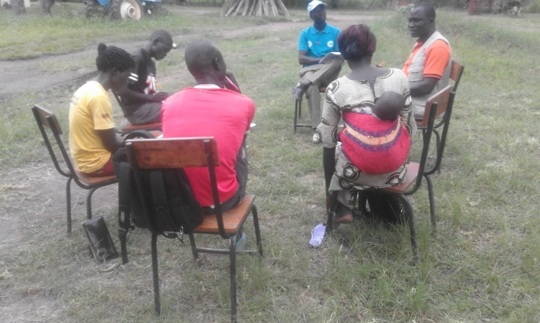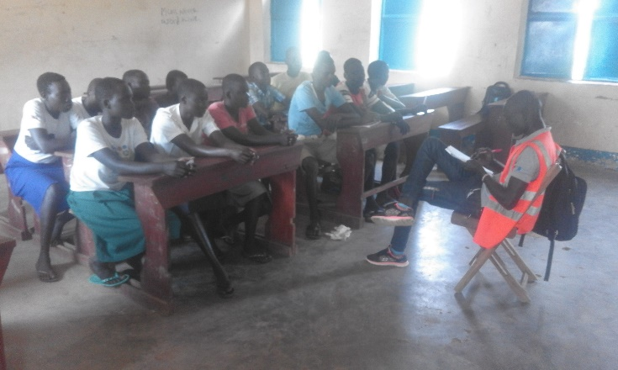**FGD with Teahers** FGD with Learners

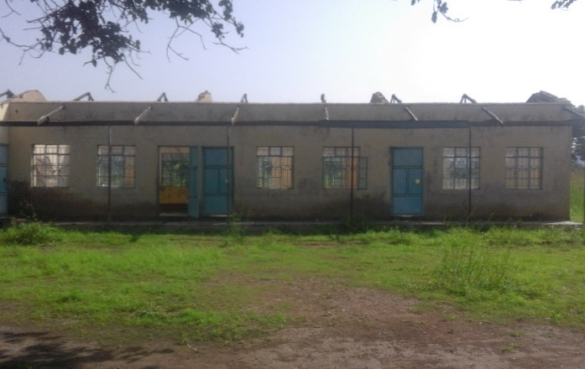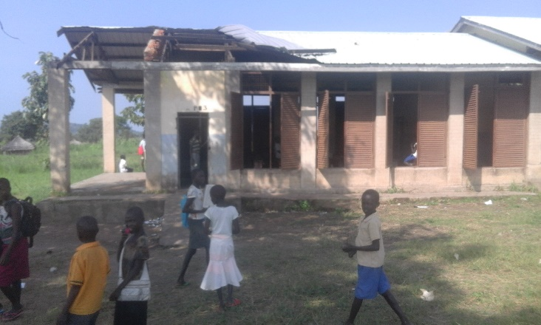

Lainya Nursery school roof blow offLainya Primary 3 classroom roof blown off

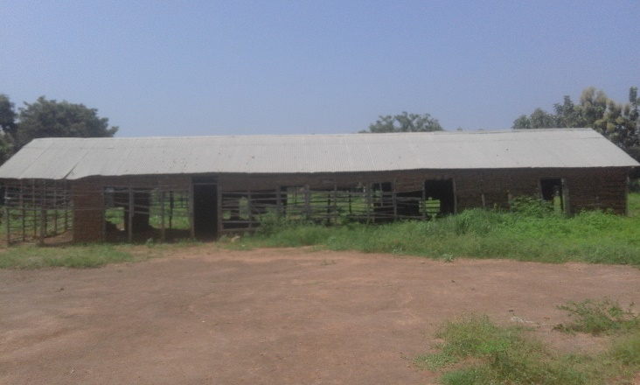 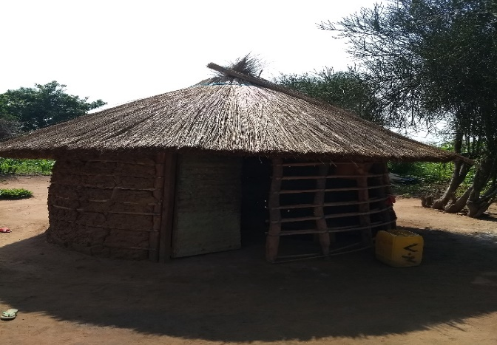

Logwili Nursery classroom block in bad conditions Unfinished hut used by Returnees

1. See the table in the annexes below for details.