MARKET ASSESSMENT REPORT FOR LAINYA 20th -27th JUNE 2019

|  |
| --- |
| 1. **General Information** |

|  |  |
| --- | --- |
| **Assessment Location**  State, County, Payam, Boma, Precise Location | **LAINYA COUNTY (CENTRAL EQUATORIA STATE)** |
| **GPS Coordinates** | Lainya Centre **N: 040 21’ 2.63’ E: 0310 03.56’.16’**  Logwili Boma **N04022’8.21’ E: 0310 07’16.39’**  Lokurbang **N 04019,3.39’ E 0310 03 18.09’** |
| **Type of Crises**  (Conflict/Natural Disaster/Other) | Conflict Natural Disaster Other (specify):protracted under-served displacement |
| **Site Type** | PoC Collective Centre Spontaneous Settlements  Host Communities Other (specify) and Returnees |
| **Distribution Team**  (Name of I/NGO in the Assessment Team, Name of Staff, Contract Details of Staff including Sat Phone) | |  |  |  |  | | --- | --- | --- | --- | | Lodule Peter Laku | Protection Coordinator – Team Leader | 0922475511  0912475511 | [**lodule.laku@nrc.no**](mailto:lodule.laku@nrc.no) | | Abuna Hillary .A. | WASH -PO | 0921712208,  0911712208 | [**abuna.aliardo@nrc.no**](mailto:abuna.aliardo@nrc.no) | | Murye Silas Eluzai | EiE Project Officer |  | [**murye.eluzai@nrc.no**](mailto:murye.eluzai@nrc.no) | | Ladu Charles | S- NFIs P.O | 09282406162 | [**ladu.john@nrc.no**](mailto:ladu.john@nrc.no) | |
| **Date of Notification** | 28th May 2019 |
| **Date of Assessment** | 20-27 June 2019 |
| **Date of Report Submission** | 1st July 2019 |

|  |
| --- |
| **Overview/Introduction:** |

Lainya is one of the counties of former central equatorial state that borders Juba, Kajo-Keji, Yei, and Morobo. Food security situation of Lainya continues to deteriorated due to armed conflict, economic crisis, and below-average harvests, though there was a significant scale up in the humanitarian responses; However, the situation remains dire in the county as more people are returning and access to humanitarian assistance remains limited as the County authorities had nothing to support the population with. (See Map below)

**Map of Lainya County showing Neighboring Counties and Villages within Lainya**:

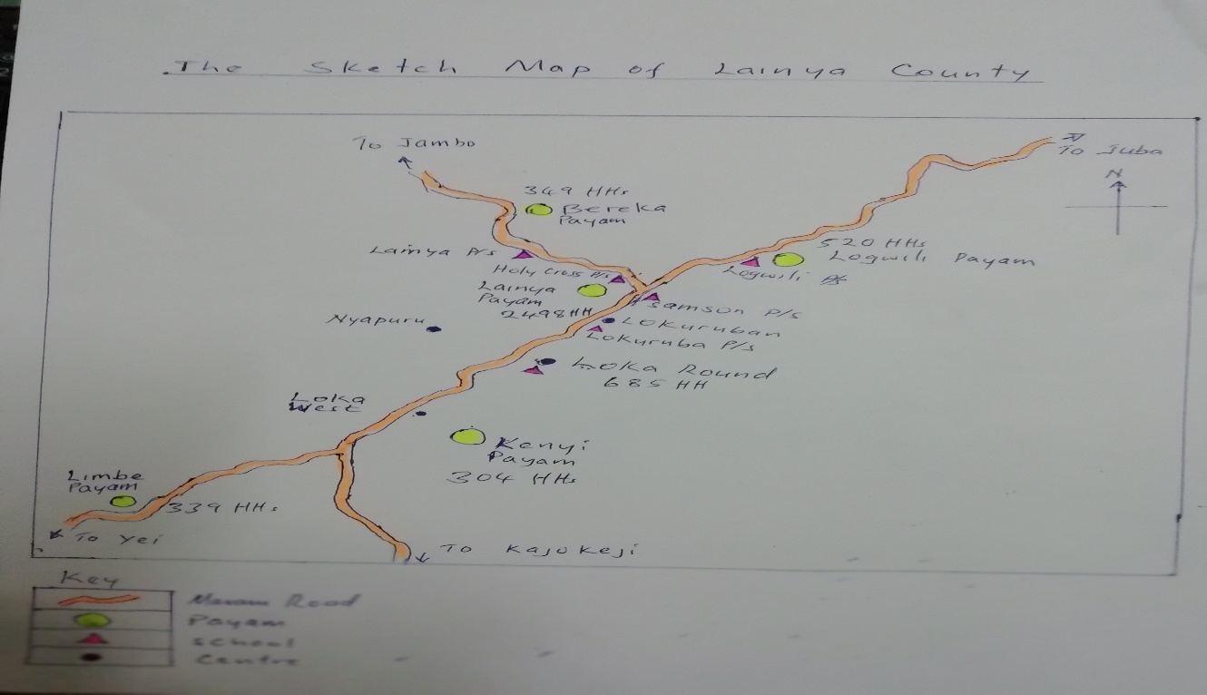

Of greatest concern Lainya County was one that harvest of food crops are poor in the last two years after the crisis, and access to humanitarian assistant were limited for a section of the population. With the possible return of IDPs(returnees) within and outside of the County/state, this has caused further pressure on already scarce available resources; though there is improvement of security within Lainya, still the communities can not move deep in to their far farm lands these may result to depletion of livelihood.

NRC has been responding to the humanitarian crisis through multi sector mobile teams that are deployed for assessments to areas of high priority as prioritized by EP&R partners and sector clusters. Under ECHO NRC has an obligation to support households to meet immediate food needs through cash transfers. This activity is complementary to WFP funded general food distribution (GFD) activity implemented by NRC. On cash based intervention, the functionality of markets is a prerequisite and NRC Rapid Response Teams conducted a fact finding assessment in Lainya county/on 20th -25th June 2019 as part of NRC committed to monitor the functionality of the markets through collection of primary data in the MSAs, but also through analysis of secondary data to inform on the appropriateness of cash transfers.

***Objectives of the fact finding assessment was to assess pre-conditions of a cash intervention as follows: -***

* Ability of market to respond to increase demand, market integration, functionality and trader capacity,
* Market accessibility by traders and beneficiaries
* Availability and affordability of essential food commodities

|  |
| --- |
| 1. **Methodology** |

The FSL team assessed ten (10) traders in Lainya market, 5 trader’s businesses are in small scale while 4 traders operate in medium scale, and 1 operates in wholesale/large. Out of the 10 traders assessed, 3 were female trader and 7 were male. The assessment was only done in Lainya market, and within the markets all commercial roads are open (**Lainya Juba and Lainya Yei**) though there is still suspicion of insecurity along the trade routes but still traders are managing to bring in food commodities to the community.

Major disruption was on the market (both whole sellers, retailers, customers) infrastructures such as banks, money transfers, were directly affected coupled with the exchange rate inflation has a negative impact on the prices, affecting the customers demand, access to food, and consequently the traders offer.

**Secondary** data review of food security, livelihoods and markets in targeted area was conducted. Qualitative data collection comprised primarily of key informant interviews with traders in Lainya market. ***A food gap analysis was not conducted as it requires in full depth.*** The main questions sort to gather the following information on market in Lainya are: -

* What are the key food commodities that targeted populations purchase in the market and are they available?
* How capable are the local traders to adequately respond to an increase in effective demand (based on their storage capacities, lead times of stock replenishment, required quality and quantity, customer preferences)?
* How have the prices for the selected key commodities changed since the shock, and how has this impacted on the affected population?

The market was purposefully selected as main market within Lainya town as it is the busiest market that the population relies on, and Lainya was selected as one of the priority area for RRT multi-sector interventions because the returns, IDPs, and host populations continue to face challenges in relation to humanitarian assistance; data collection was carried out NRC rapid response team making a total population of 19,363 in five locations Lainya County. (**See table below)**

|  |  |  |  |  |  |  |  |  |  |  |
| --- | --- | --- | --- | --- | --- | --- | --- | --- | --- | --- |
| **RRC – Registered Population of IDPs and Returnees in Lainya County** | | | | | | | | | | |
| Payams | Total | # of HHs | 0 - 4 | | 5 - 17 | | 18-59 | | 60+ | |
| M | F | M | F | M | F | M | F |
| Lainya | 10290 | 1715 | 658 | 988 | 1729 | 2593 | 1235 | 1852 | 494 | 749 |
| Lokwili | 3120 | 520 | 199 | 299 | 524 | 786 | 374 | 562 | 150 | 224 |
| Bereka | 2094 | 349 | 100 | 151 | 352 | 528 | 251 | 377 | 100 | 151 |
| Limbe | 2034 | 339 | 98 | 146 | 342 | 512 | 244 | 366 | 98 | 146 |
| Kenyi | 1824 | 304 | 117 | 175 | 306 | 460 | 218 | 328 | 88 | 131 |
| TOTAL | 19363 | 3227 | 1172 | 1460 | 3253 | 4879 | 2322 | 3480 | 930 | 1393 |

**Table 1. Locations Covered:**

|  |  |  |  |
| --- | --- | --- | --- |
| Location/ County | Market Name | Number of traders | Traders Description[1] |
| Lainya County | Lainya market | 10 | Small size shop 5traders, 4 medium traders, 1 wholesaler. 3 female traders, and 7 male traders |

|  |
| --- |
| 1. **Summary of Situation** |

According to the survey conducted by NRC Multisectorial team this year 20-27th June 2019, it was found that the typical livelihood for Lainya people in the side of food security is farming (both subsistence and for sale) and little of livestock; nevertheless because of insecurity as a result of crisis, many people lost their livestocks and currently though the security have improved still people fear accessing far farm lands for cultivation. Those displaced and those who returned are cultivating within the nearest farm lands, Lainya generally depends on food commodities supplies from Yei and Juba currently, but by then they to bring in the neighboring country like Uganda in south; though Lainya was by then known to be good in food production, due to the crisis of 2016-2017 the County has no longer been good in food production as many populations flew and many agricultural activities get stopped.

Currently with the coming of the returnees to their places, agricultural activities are expected to increase as well as the disrupted Market functionalities’ that operates by then in small scale is now booming up as medium and wholesale shops are now available in Lainya market.

While issues to do with food assistance is a major problem/concern for the returning population in Lainya as partners that are suppose supporting on food such as MaCDA, and ACROSS are targeting only most vulnerable people hence the returning population currently relies from community support, assistance from relatives, and again engaged in casual labor work for their survival/purchase of food. A few have put down some crops but not yet to be harvest and estimated to take 2-3 months to harvest.

**Access to the market**:

There are three market, one is located in Lainya Centre which is the main market, Logwili and Loka Round, Lainya Centre having wholesale, medium, traders with food commodities available, clothing as well as vegetables. During time of the assessment, food items such as dry fish, okra, maize flour, maize grain, cassava flour, rice, bean, salt, coffee, Sugar, meat, groundnuts, sorghum flour/grains, tomatoes, including nonfood items like charcoals are in both market. But there are few shelter NFIs materials in Lainya Centre and Loka Round like plastic sheeting, few mosquito nets, cooking utensils including reusable sanitary pad and soap for famine hygiene seen in the market.

Road linking Lainya from Juba and Yei to Lainya is accessible big trucks transporting good and taking back Logs, bamboo and charcoal, the traders have to travel for about 1-2 hours by road from Lainya to Yei town and 2-3 from Lainya to Juba to get commodities, however though of the available food items in the markets, the returnees and host community cannot afford to buy food commodities due to a lack of capital to purchase food items.

**Market Chain:**

Due to shock of 2016-2017, the major disruptions are at the local farmer’s level because of the poor access to farming land and it was caused by the insecurity, this has direct effect on the whole sellers and retailers because of the low commodity influx to the main market. Again because of scarcity and over inflation, consumers are directly affected.

These disruptions mainly affect manufactured goods and staples food. Vegetables are affordable because many families have tried to grow; a few vendors are selling their own products (mainly vegetables). The rest of them buying items that are brought from Juba and Yei, and Indeed, the two commercial roads (Lainya Juba, Lainya Yei) are open though there is still fear by traders.

**Price fluctuation:**

In general, prices are relatively higher than usual, because of the exchange rate fluctuation, which mainly affects staple food, animal products, and manufactured goods. The vegetables prices are following the normal fluctuation, currently during this rainy season the prices are low because of the high availability of vegetables in the markets (locally produced) and at least very person struggled to put down green vegetables; while manufactured goods increases during rainy season as result trader faces challenges in transportation. All small traders replenish their commodities on a monthly basis, while those medium and wholesales said it will take them about 1-2 months to stock since the commodities that they are bringing are in balky and cant be completed within one month. Out of the ten (10), when asked on how many bags do they use to sell before and after the the crisis, those with medium/wholesale shops said they use to sell 100-200 bags within a month, and now selling 10-15 bags within one month. While those with small has an decrease in number of bags, before they use to sell 6-10 bags in a month but now sells 2-3 bags per a month.

When asked on which month that they have difficulties, all mentioned that April –October and reason been due to heavy rains that make roads not passable, again from October to December most of the local produce would be out to the markets hence reduce their business.

When asked where their Customers are coming from, all of the traders responded that their customers come in all the villages within Lainya town and some outside Lainya (such as ***Moje, Bereka, Kenyi, Lembe, Loka, Lokurbang, Unduruba, Nyaporu, and Logwili.***

When asked if demand of commodities is to increase what will they do to make sure that communities get the commodities; all traders said if they are supported financially, they will bring supplies to the community within 3 days, as well as if the community were supported financially, they will be able to buy food commodities in the market hence boosting the business.

Out of ten (10) traders that were assessed, 3 mentioned that they were **1500** traders before the crisis and now remain 50 traders in the market that means **1450** shut down their business, other 4 said about **1200** before, and remaining 40 traders that means **1,160** shut down business, other 3 said **900** traders but now remaining **40** traders that means 860 traders shut down their business, while in the general findings, from the key traders group, about **40** remaining in Lainya market.

All of them stated that the reason of shutting down business was due to armed conflict, most shops looted, insecurity, theft/robbery. While the reasons for their remaining in doing business is because this their only way to get money as well as feeling of serving the community though they are getting small profits a times with many loses.

However, the impacts of those who shut down their business will result to reduced number of competition, some essential items will not be found by the community, reduce market development. There has been an increase in demand for cereals and People used cash to buy commodities, they pay in South Sudanese **pounds.**

Food commodities are most available during the month of August –December because of people will be preparing for the new year; again the local produce will be available in the markets within the month of August and September, and also December to January.

**Challenges traders faced:**

The traders generally mentioned that their major challenge is the price fluctuation, high transportation cost, insecurity, low purchasing power due to no cash in circulation. People relies for few functional money transfers companies/agencies in Yei town.

**Price of Food Items given in Kilogram by the Traders in Lainya Market (Price Analysis)**

From the above graph, shows slight difference in buying prices per items ranging from 50- 300 SSP for local foods, such as meat, potatoes, tomatoes, charcoals, groundnuts as well as manufactured goods ranging from 20SSP to 250 SSP (sugar, rice, cooking oil, wheat, pasta). And other items remained the same.

The above graph, shows May –June 2019 selling prices of the commodities. However, the difference in selling price for local goods increased ranging (50-300SSP) and 20-250 SSP for manufactured goods. This implies that prices for both local and manufactured goods are not stable;

**Response Recommendations:**

|  |  |  |  |  |  |  |
| --- | --- | --- | --- | --- | --- | --- |
| Market | Price instability | Market access | Current market food availability | Local food production | Capacity of traders | Overall conditions |
| Lainya Main market | Medium | Average | Medium | Low | Large/medium | Number of both small, medium, wholesale traders has reduced by about 60%  due to insecurity and low business operations.  traders require financial support to boost their business operation;  if demand increases from the customers.  Favorable to do the cash intervention because commodities are available in the market and  beneficiaries can access the market at all times. There were no money transfers in the area and  agent has to take sole responsibility. |

|  |
| --- |
| 1. **Recommendations** |

* Cash transfer is feasible in Lainya, however there is need to support traders to increase stock to meet demand and that is by Providing cash to community to boost their purchasing power and will enable traders to stock more.
* Money transfer companies are not available in the area unless assigned right from Juba or Yei to do the cash transaction in Lainya.
* Food provision for the returnees, and Vulnerable host+IDPs

March –May 2019, returnee’s households requires more support to access the markets as they have nothing to depend on (with little assistance from partners) and community support.

Report written by: **Kennedy Ayuku Stephen**

Report reviewed and approved: **Ahmed/Mary/Sultan**.

1.