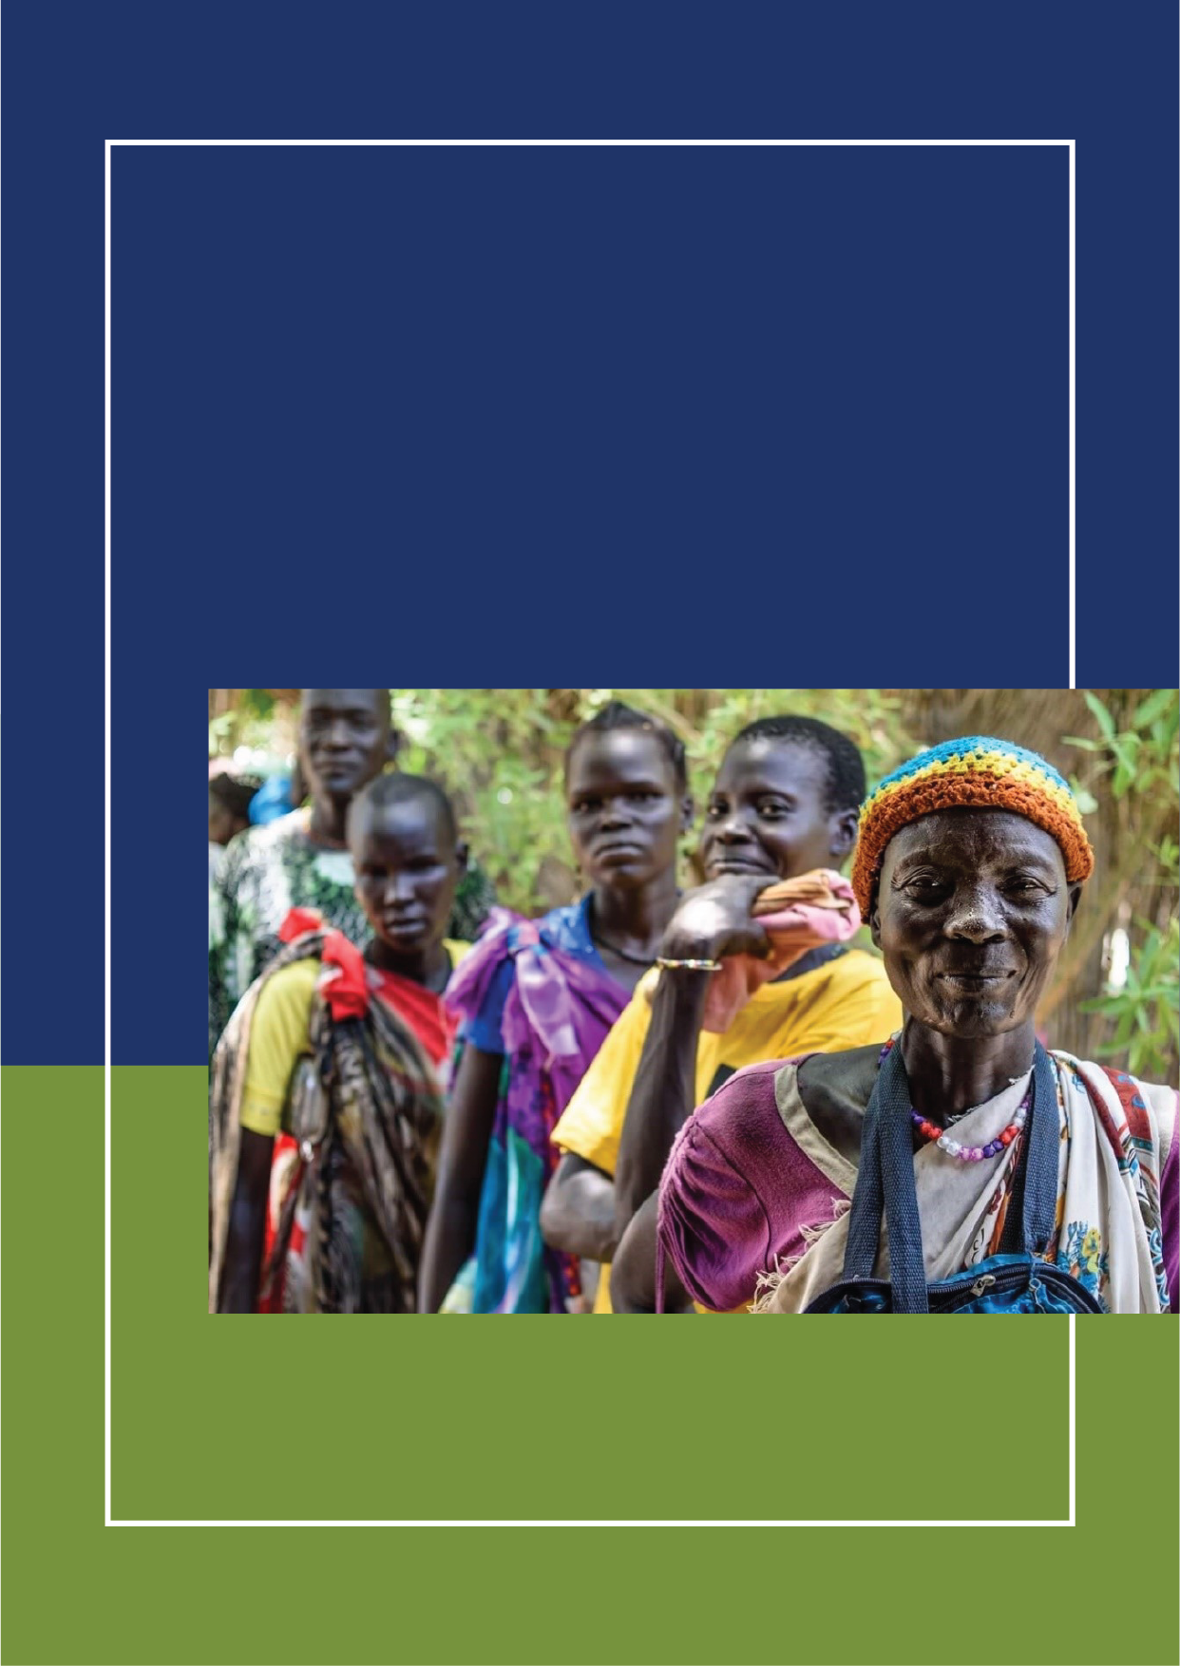1

Partnership for Recovery and Resilience

**YAMBIO JOINT WORK PLAN (2019 - 2020)**

# 

# CONTENTS

Annexes 5

Acronyms 6

Executive Summary 7

Overview of the Joint Work Plan 7

Participation 7

Work Plan Structure 8

Work Plan Process 9

Work Plan Content 10

The Pillar Plans 13

Pillar One: Trust in Institutions and People 13

Pillar Two: Re-Establishing Access to Basic Services 19

Pillar Three: Restoring Productive Capacities 27

Pillar Four: Nurturing Partnership 32

Operationalizing the Work Plan 36

Community-based Service Delivery Operational Model 36

Activating the Convergence Points 38

The Monitoring & Evaluation Framework 39

Conclusion 40

Lessons Learned 40

Next Steps 42

Summative Recommendation 42

Annex 1: Background to the PfRR 43

Annex 2: Existing Interventions, Proposed Activities and Gaps 47

Pillar 1: Trust in People and Institutions 47

Pillar 2 Re-establish access to basic services 48

Pillar 3: Productive Capacities 53

Annex 3: Glossary of Partnership Terms (as defined by the Yambio JWP) 56

Annex 4: Proposed Agenda for Future Work Planning 59

Annex 5 Institutional Capacity for Resilience Assessment Framework (IA4R) Tool 71

Annex 6: List of Participants 77

# List of Figures

Figure 1: Participation in the JWP 8

Figure 2: Participation by Gender 8

Figure 3: Facilitation Model 9

Figure 4: From Ideas to Activities 9

Figure 5: Results Framework 11

Figure 6: Institutional Architecture, Households and Communal Assets 12

Figure 7: Major Institutions Affecting People 13

Figure 8: Examples of Social Risks by Community Groups 14

Figure 9: Top 3 Causes of Conflict 14

Figure 10: Effects of Conflict on Households & Communities 15

Figure 11: Effects of Conflict on Households by Gender 15

Figure 12 Most Effective Conflict Resolution Mechanisms 16

Figure 13: Cooperation around Community Assets 16

Figure 14: Education 19

Figure 15: Distance to School 19

Figure 16: Ownership of the Schools 20

Figure 17: Education Excerpts 21

Figure 18: Water Sources 21

Figure 19: Perception about Public Services 22

Figure 20: Food Security 27

Figure 21: Status of Social Capital and Assets / Environmental Problems 28

Figure 22: Main Livelihood Challenges / Markets: Access & Coverage 28

Figure 23: Top 4 Livelihood Trends by Community Groups 29

Figure 24: Institutions and Household and Communal Assets 36

Figure 25: Community-based Service Delivery Indicators 38

Figure 26: Convergence Tool 39

Figure 27: The Four Pillars 44

Figure 28: Theory of Change 45

Figure 30: The Six Commitments 46

# List of Tables

Table 1: Functions of Traditional Leaders 16

Table 2: Logical Framework for Pillar One 17

Table 3: Pillar One Institutions 18

Table 4: Institutional Perspectives for Pillar One 18

Table 5: Logical Framework for Pillar Two 23

Table 6: Pillar Two Institutions 26

Table 7: Institutional Perspectives for Pillar Two 26

Table 8: Logical Framework for Pillar 3 31

Table 9: Pillar Three Institutions 31

Table 10: Institutional Perspectives for Pillar Three 32

Table 11: Activity Calendar for Cooperation 34

Table 12: Institutional Perspectives for Pillar Four 35

# Annexes

ANNEX 1: Background to the PfRR

ANNEX 2: Activities and Intervention Areas per Pillar

ANNEX 3: Glossary of Partnership Terms (Towards a Shared Understanding)

ANNEX 4: Proposed Agenda for Future Joint Work Planning

ANNEX 5: Institutional Architecture for Resilience (IA4R) Tool

ANNEX 6: See JWP Participants List

# Acronyms

CPA Candidate Partnership Areas

CDC Community Development Committee

C4C Champions for Change

CSO Civil Society Organization

FAO Food and Agriculture Organization

FBO Faith-based Organization

DAI Development Alternatives Inc.

FG Focus Group

IA4R Institutional Architecture for Resilience

IFPRI International Food Policy Research Agency

INGOs International NGOs

JWP Joint Work Plan/Planning

KI Key Informant

MSI Management Systems International

NGO Non-Governmental Organization

NNGO National NGO

RIMA Resilience Index Measurement and Analysis

RP Resilience Profiles

USAID United States Agency for International Development

UN United Nations

PfRR Partnership for Recovery and Resistance

UNDP United Nations Development Programme

WFP World Food Program

WV World Vision

PA Partnership Area

# Executive Summary

The Partnership for Recovery and Resilience (PFRR) Joint Work Plan (JWP) enables the local and international entities in Yambio to cooperate and enhance their resilience programming. It details the evidence, outcomes, monitoring tools and management mechanisms determined through an ongoing participatory process with UN agencies, International Non-Governmental Organizations (INGOs), National NGOs (NNGOs), and the Yambio community leadership.

Yambio had been one of South Sudan’s most peaceful and productive areas up until 2015, when it became embroiled in the civil war. According to key informants (KIs) and focus groups (FGs), families were broken up by the war, as young men took to the forest to join the militias that had mobilized against the government. Subsequently, parents and siblings were scared and clustered within Yambio town. They were unable to cultivate their fields, as their sons who had joined the militias became a threat to their families’ security.[1]

In response to the shock of conflict, the Yambio community, faith-based organizations (FBOs), and members of traditional and political leadership came together to mobilize. Delegations of elders embarked on several missions to engage the militias, and encourage them to exchange dialogue with the government. This eventually led to an agreement that significantly reduced conflict and insecurity in the area, including the demobilization of armed youth and reintegration of child combatants.

The level of vulnerability in Yambio increased due to conflict and the inability to sustain agriculture. The humanitarian community remained engaged, however, access to services remained a challenge. Due to peace-building efforts led by the local peace initiative in the region, Yambio emerged as one of the seven Candidate Partnership Areas (CPAs) to launch the Partnership. In addition, local leaders continued their commitment to create an enabling environment for greater investments in recovery.

The United Nations (UN) developed a Joint Resilience Program, while the Yambio community began to organize community development committees (CDCs), a technical working group and a steering committee. From March 18-22 2019, after two weeks of preparatory work, more than 90 individuals representing 53 partner organizations developed a JWP to enhance the Partnership in Yambio. This was achieved by co-locating operations in targeted bomas; coordinating planning, information sharing and activities in those areas; and collaborating on the ground. This document seeks to be an operational tool to reflect the people, ideas, resources and efforts around the community-identified priorities.

# Overview of the Joint Work Plan

## Participation

As depicted in the graphs below, participation in the JWP exceeded the expected number by a factor of 3. The total participants registered included 95 individuals, representing 53 different agencies. The high turn out by local government officials reflects the seriousness with which the local community is engaged in this process. Moreover, the Governor reinforced that they were not participating in their official government capacities, but as fellow community members.

In the future, it is important to improve gender balances and ensure equal representation of both genders in the process. In addition, more proactive measures should be taken to ensure the participation of women at the technical levels in Government, UN and NGOs. One positive observation is that throughout the workshop, participants maintained a keen awareness of gender dynamics, indicating that it had been well incorporated in the training material.

|  |  |
| --- | --- |
| Figure 1: Participation in the JWP | Figure 2: Participation by Gender |
|  |  |

## Work Plan Structure

The JWP follows a logical framework, and includes the following relevant columns: result (goal, pillar, outcome, outputs); indicators; benchmarks; responsibility; relevant institutions; assumptions; risks; mitigation measures; gaps; and convergence points. In this document, the results, indicators, and benchmarks columns are included. However, more detailed log frames are available. Convergence points are also discussed in the chapter titled – Operationalizing Convergence.

The JWP was framed around the following themes and questions:

1. **Shared understanding:** Do partners have a shared understanding of the basic concepts framing the Partnership?
2. **Greater impact:** What are the results that would produce the greatest impact in reducing vulnerability and building resilience in Yambio?
3. **Inventory of partners’ activities:** Do we understand what partners are currently doing in Yambio, where their activities are located, how long they will be active, and what assets they have available?
4. **Convergence in practice –** Can we layer, sequence and cluster our activities in Yambio for greater impact through strategic integration?
5. **Co-location –** Can we identify sub-county level geographic targets to converge our efforts for greater impact?
6. **Coordination –** Can we prioritize the most critical activities needed to strengthen the Partnership in Yambio, commit to firm dates, and allocate core responsibilities and resources?
7. **Collaboration and adaptation –** Can we propose any financing and/or compliance adjustments to our donors to make strategic integration and high impact programming more viable in Yambio?
8. **Building consensus** – What should the Partnership do in order to ensure consensus among partners on the consolidated work plan and the Partnership layering strategy for Yambio?
9. **Socialization of tools –** Are we familiar with the key documents and tools that relate to the Partnership?

## Work Plan Process

Based on these themes and questions, the agenda of the workshop was divided, and a mix of working groups and plenary discussions were utilized to ensure optimal participation. Each discussion group contained approximately 5-7 individuals. Within each group, participants identified a moderator, note taker and presenter. Following this activity, the small groups would later merge into larger groups, where they would consolidate their analysis and conclusions, and present to the plenary. Each session was followed by instructional material that allowed for subsequent sessions to incorporate new learning, and apply it to the refinement of the logical framework.

Figure 3: Facilitation Model

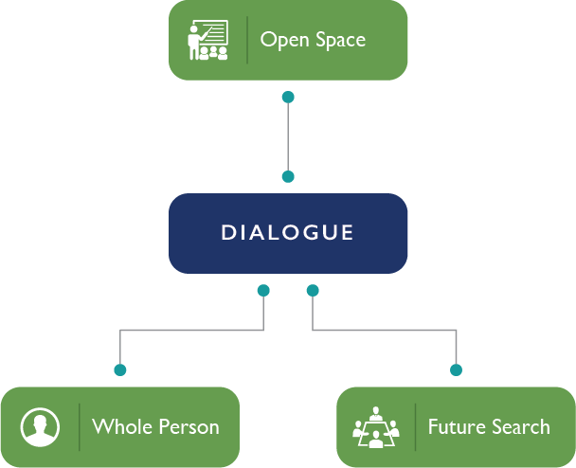**3 facilitators** from DAI Africa Lead directed the process under the guidance of the co-leads and pillar leads (UNDP, FAO and World Vision). Pillar leads organized the community on the ground and sensitized the partners.

As depicted in Figure 3**, open space** was used to maximize participation and enable participants to think outside of the box by framing a question, and allowing small discussion groups to brainstorm and organize their presentations.

**The Whole Person** strategy was used to sustain engagements, and unlock creativity using a mix of physical movement, creative exercises, and active listening techniques. In addition, the **Future Search** strategy was used to arrive at agreements using a logical process and group work.

Figure 4: From Ideas to Activities

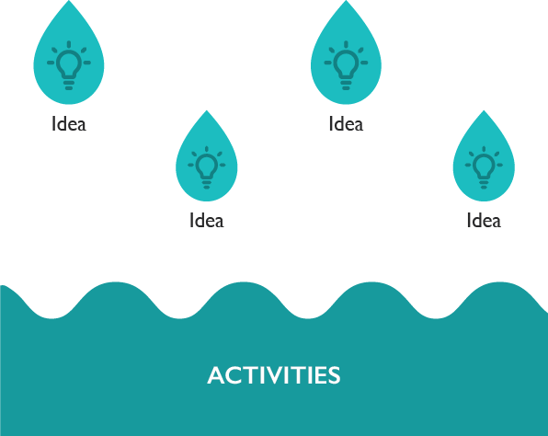The methodology is designed to help participants nurture ideas through dialogue and execute desired results. This process should continue beyond formulation of this JWP to form a basic organizational process at the heart of the Partnership. By putting ideas of community members at the heart of the enterprise, the new business model puts the community’s concerns first.

## Work Plan Content

### Resilience Profiles

Resilience Profiles (RPs) consist of assembled and visualized data. These profiles served as a basis for grounding results in evidence. The significance of the RPs is that they provide a common evidence base for establishing standards across the CPAs. The information contained in them derive from household surveys, Focus Group Discussions (FGDs) and Key Informant Interviews (KII). The categories of information were based on 13 chapters, and covered themes submitted by the partners at the Juba level. While these 13 chapters informed the design of the data collection tools, the findings are presented based on the four pillars. In the work plan, a relevant analysis of findings per pillar helps to establish the context for the Results Framework and its indicators.

### Program Results Framework

The JWP must be expressed through strategic phases, and reflected in the Four Pillars and 11-Point Agenda. In addition, the JWP translates its activities into the IR level based on highest priorities for the next year. It also provides the tool and proposes a mechanism for the next phase of work planning, which must take place at the boma level. The Results Framework presents the 16 results that were determined by the participants in response to the questions presented at the beginning of the workshop.

Figure 5: Results Framework

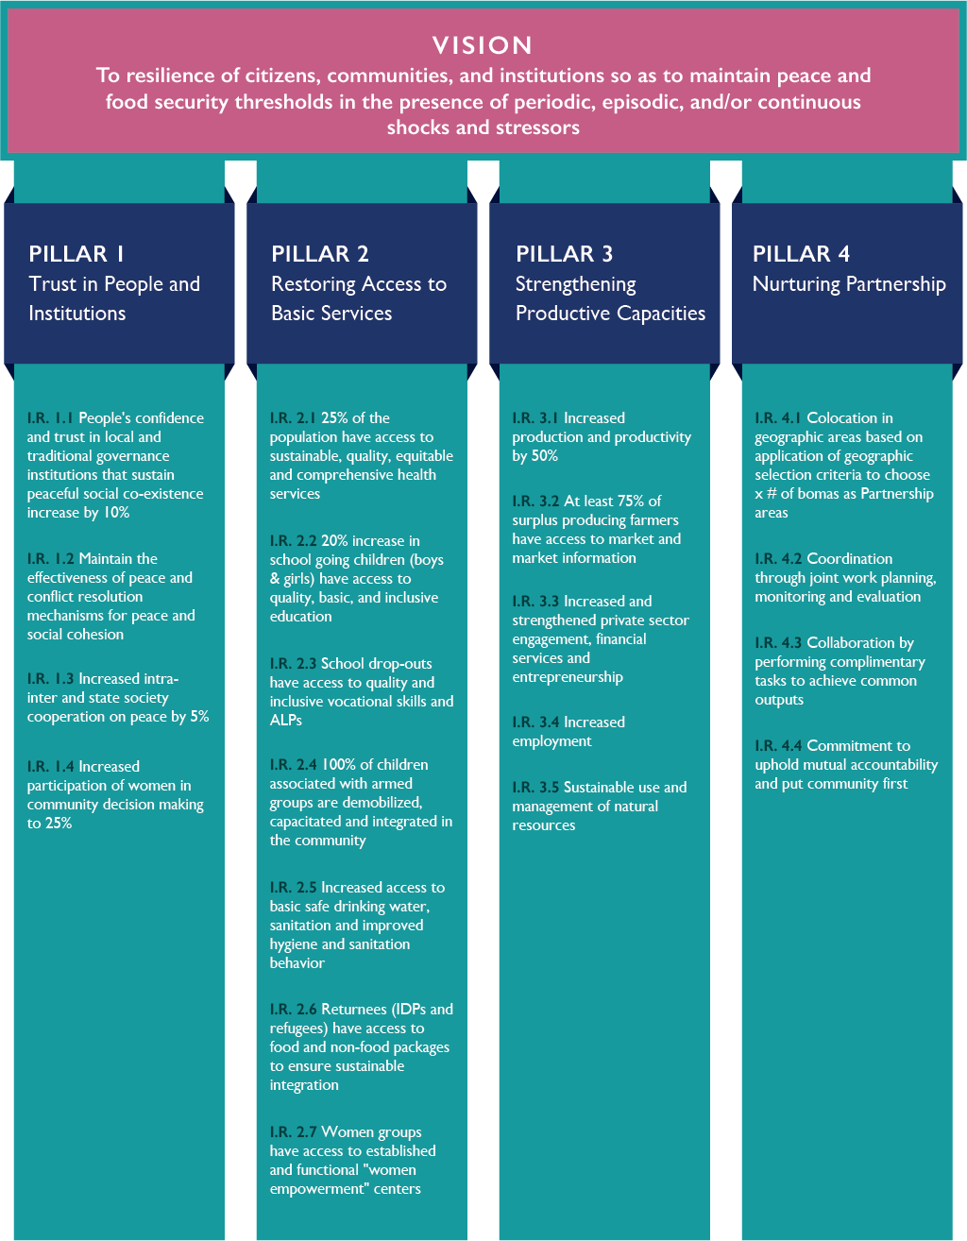

### Institutional Architecture for Resilience (IA4R)

In the absence of an effective institutional and policy framework at a national level for agriculture, the community-level partners aimed to adapt the Institutional Architecture Assessment (IAA)[2] approach to the sub-national level (County, Payam and Boma) to focus on community institutions, and to establish a resilience framework that also accounts for household and community resilience.

Renamed the Institutional Assessment for Resilience (IA4R), the exercise demonstrates that in addition to the institutions that support social cohesion (Pillar One), institutions also relate to service delivery (Pillar Two), productive capacities (Pillar Three) and nurturing partnerships (Pillar Four).

Community institutions include the players, rules and practices that are the mechanisms to co-create these results and ultimately sustain them. For these community institutions to be relied upon for service delivery implies a transitional approach that includes capacity building. The community first approach links household and communal assets to the Institutional Architecture for Resilience (IA4R) tool through the three core coping capacities as shown in the figure below.

Figure 6: Institutional Architecture, Households and Communal Assets

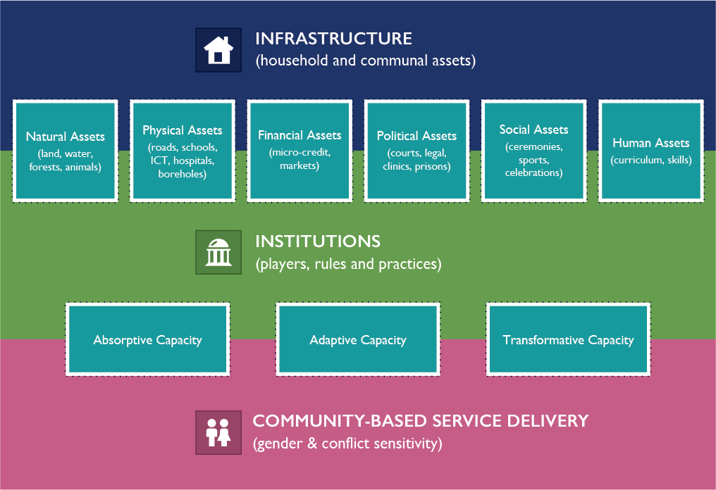

The IA4R tool casts the four pillars of the PfRR against the three coping capacities to frame a self-assessment of institutions relevant to the resilience agenda. This tool was embedded in the JWP exercise to enable partners to plan a phased transition from direct service provision by technical agencies to greater reliance on community-based delivery mechanisms. Important capacities identified during the exercise must be built over time, including early warning systems, and the capacity to foresee and avert crises before they strike. Each institutional element was scored on the basis of the attention required to achieve the specific pillar objective, and expressed in percentage terms. The attention required was categorized as red, yellow or green, with the corresponding definitions shown below (the IA4R Tool is in Annex I).

(Red) - Institutions require significant attention to ensure the pillar objective is achieved.

(Yellow) - The conditions required to achieve the pillar objective are partially achieved, but additional attention is required.

(Green) - The pillar objective, from an institutional perspective, is realized to a sufficient degree, and additional attention to this area is not required at this time.

Each participant scored only the specific pillar objective to which they belonged, except for pillar four (4) that was scored by all of the participants given its crosscutting nature.

# The Pillar Plans

For each of the first three pillars, the resilience profile evidence is presented, followed by the results framework and the institutional architecture. For Pillar Four, more information is included with respect to the strategic cooperation framework by which the Partnership in Yambio will operationalize coordination.

## Pillar One: Trust in Institutions and People

### Resilience Profiles

In Yambio, community members identify themselves in ethnic and religious terms. This means that traditional institutions emerge as central to community-level processes, and understanding cultural dynamics is important in approaching the community’s institutional architecture.

The family represents the primary institution that administers household assets. The Partnership is working to help these households to increase their access to and influence over these assets. Institutions that cut across traditional administration, local government, civil society and private sectors have emerged to also assist this process. However, parental absenteeism remains a significant challenge, with 1/3 of father and 1/4 of mothers not present in many households.

Figure 7: Major Institutions Affecting People

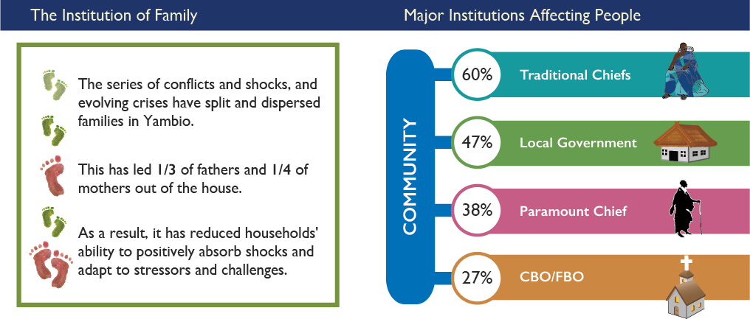

The findings indicate significant community trust in traditional institutions, with the chiefs playing core governance functions across the CPAs. This indicates that traditional institutions are well-established, and reflect the community’s organizational logic. Understanding these institutions and how they adapt to the shock of independence, civil war and the impacts of modernity is a key challenge for the Partnership and its capacity building agenda.

Across households in Yambio, youth comprise of more than 70% of the population. Traditional institutions organize youth as a pool of labor and a fighting force in times of war. The chiefs are still responsible for guiding these youth, however, relations between age-sets must be strengthened through the institutions that govern them.

As indicated below in Figure 8, social issues such as gender-based violence are a serious concern for families and households.

Figure 8: Examples of Social Risks by Community Groups

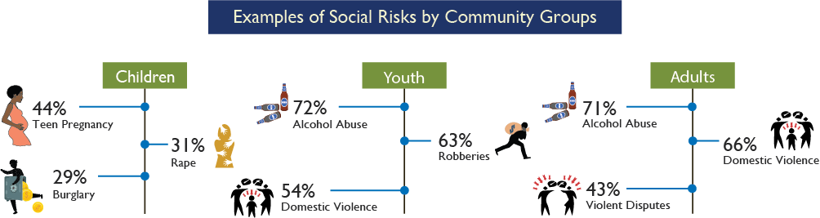

According to community members in Yambio, the top three causes of conflict include tribalism, unemployment, and lack of rule of law. These issues will have to be addressed in order to achieve and maintain community-level resilience.

Figure 9: Top 3 Causes of Conflict

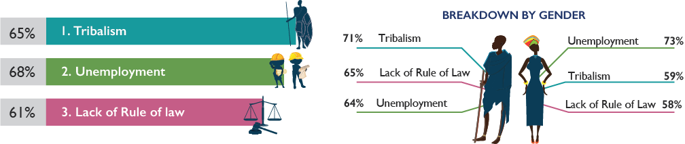

Environmental degradation is undermining livelihoods and fueling conflict. This is because unemployed youth remain unable to secure income from agriculture, and are vulnerable to recruitment into violence against each other and the state. The graphic below illustrates the impacts of conflict at the household level, with displacement, death and loss of household assets as the most prevalent shocks. At a community level, the impacts of conflict include civil war, death and loss of social status.

Figure 10: Effects of Conflict on Households & Communities

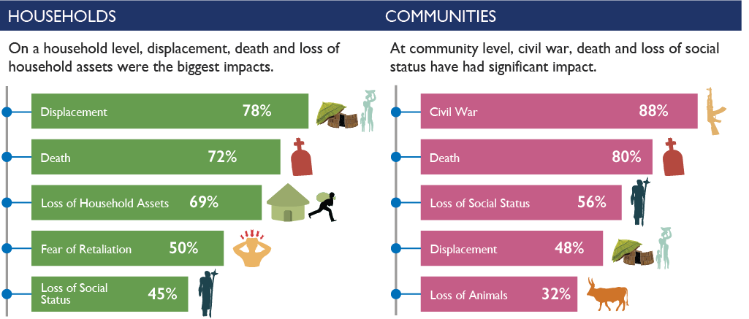

As depicted in Figure 11, women cite land and forests as sources of resource-based conflicts, whereas men perceive oil and water as sources of resource-based conflicts. In Yambio, women and men tend to view important issues of resilience differently, and these differences may have policy and program implications. In this case, women associate conflict more closely with the productive assets locally, whereas men lean towards national-level issues.

Figure 11: Effects of Conflict on Households by Gender

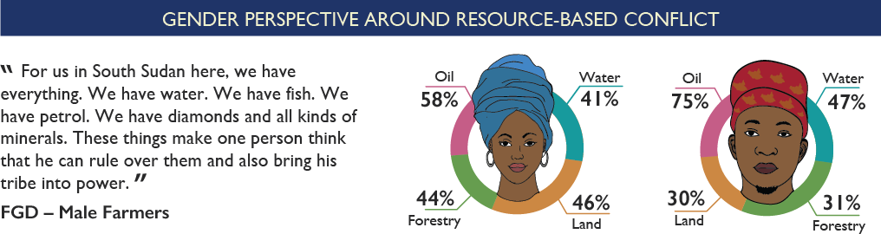

The response depicted in Figure 12 indicates that traditional leaders have significant influence over community members, and this ultimately underpins the success of PFRR. These results may determine how future PFRR development interventions are decided. A case in point is the question on the most effective conflict resolution mechanism, which elicited the following responses:

Figure 12 Most Effective Conflict Resolution Mechanisms

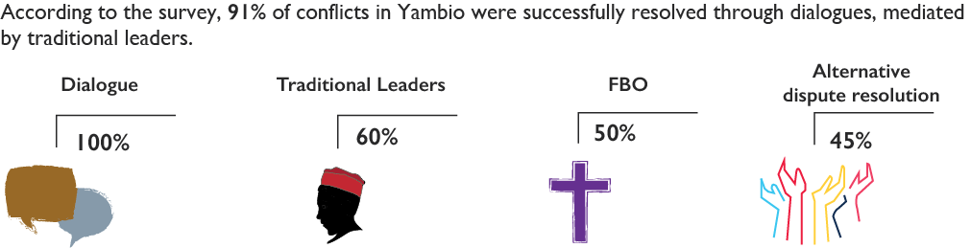

According to the responses obtained from the Yambio Resilience Profiles, the most effective conflict resolution mechanism (Figure 12) is dialogue mediated by traditional leaders (60%). A more detailed analysis on the role of traditional leaders is outlined in the table below.

Table : Functions of Traditional Leaders

|  |  |
| --- | --- |
| Functions | Percentage (%) |
| Settling disputes | 95 |
| Settling land disputes | 85 |
| Keeping law and order | 55 |
| Protecting subjects | 28 |
| Humanitarian coordination | 28 |
| Public relations | 25 |

Traditional Leaders in the Yambio Community play a large role in settling disputes, particularly land disputes and, to a lesser extent, maintaining law and order. In all cases, dialogue is perceived as the key modality of conflict resolution and a core resilience capacity by men and women. It supports the bonds, bridges and links of the social contract, including with the development cooperation.

When asked where social capital tends to be strongest, land scored last, followed by forests and water, fishing and agriculture, and finally markets, where both men and women see a high degree of cooperation among communities and the government.

Figure 13: Cooperation around Community Assets

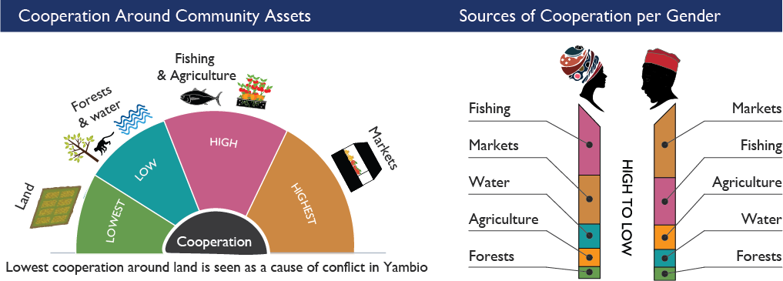

The results on the institution of traditional leaders have a bearing on the performance of the PFRR, and therefore must be accounted for during the identification of intervention areas, processes and implementation.

### Logical Framework

The Strategy for Pillar One focuses on the following: strengthening institutions that sustain social cohesion; sustaining the capacity for dialogue to resolve conflicts; building specific capacities for intra-communal, inter-communal, and state-society peace-building; and empowering women in decision-making processes. Based on the evidence, the JWP proposes baselines and targets as described in the table below.

Table 2: Logical Framework for Pillar One

|  |  |  |  |  |
| --- | --- | --- | --- | --- |
|  | **KEY RESULTS** | **Baseline levels %** | **% increase targeted** | **Indicators** |
| **Pillar 1:** | **Rebuild Trust in Institutions and People** | | | |
| **Intermediate Result 1.1** | People's confidence and trust in local and traditional governance institutions that sustain peaceful social co-existence in Gbudue state increase by 10% by 2019 | (60% for traditional Authority) (50% for local government) (38% for Paramount chiefs) | 10% of each | % of respondents who cite various institutions as relevant in their daily lives |
| **Intermediate Result 1.2** | Maintain the effectiveness of peace and conflict resolution mechanisms for peace and social cohesion | 90% (Dialogue) | Maintain % | * Baseline (90% of dialogue) * Indicator for peace- IGAD CTYSAM- # of violations on the peace agreement. * Number of incidents of intercommunal conflicts |
| **Intermediate Result 1.3** | Increased intra- inter and state society cooperation on peace by 5% in 2019 | 0.147, -0.24, 0.147 | 5% increase | Social capital scores for inter-communal (bonding), inter-communal (bridging) and state-society (linking) |
| **Intermediate Result 1.4** | Increased participation of women in community decision making to 25% by end 2019 | 17% | 25% increase | percentage of women respondents who report having been seriously involved in decision making |

### Institutional Architecture

The perceived critical institutions as identified by Pillar One members are shown in the table below.

Table 3: Pillar One Institutions

|  |
| --- |
| Pillar One Institutions |
| Traditional Leaders |
| CSO (women groups, CBOs, youth groups) |
| Network for Civil Society Organizations (NeCSOs). |
| Faith based organizations |
| Government institutions (Local Government, Physical Infrastructure, Agriculture & Co-op) |
| Judiciary and Law enforcement agencies |

The institutional perspectives for Pillar One objective on re-building trust in people and institutions are shown in the table below.

Table 4: Institutional Perspectives for Pillar One

|  |  |  |  |
| --- | --- | --- | --- |
|  | Score(%) | | |
| **Absorptive Capacity** | **Red** | **Yellow** | **Green** |
| Institutions are present | 16.7 | 66.7 | 16.7 |
| Institutional roles are clearly defined | 27.8 | 44.4 | 27.8 |
| Institutions have Human resources | 50 | 38.9 | 11.1 |
| Institutions have clearly defined roles | 27.8 | 55.6 | 16.7 |
| Institutions have access to resources | 50 | 38.9 | 11.1 |
| Institutions have social bonding capital | 16.7 | 44.4 | 38.9 |
| **Adaptive Capacity** |  |  |  |
| Institutions are shock aware | 33.3 | 27.8 | 38.9 |
| Institutional know early warning signs and stages of shocks | 38.9 | 50 | 22.2 |
| Institutions have emergency response plans | 38.9 | 38.9 | 22.2 |
| Institutions have access to resources for emergency plans | 50 | 33.3 | 16.7 |
| Institutions have social bonding and linking capital | 11.1 | 55.6 | 16.7 |
| **Transformative Capacity** |  |  |  |
| Institutions’ stakeholders participate in preparedness and response planning | 33.3 | 38.9 | 27.8 |
| Institutions employ evidence-based approaches | 5.6 | 72.2 | 22.2 |
| Institutions action ready | 22.2 | 44.4 | 33.3 |
| Institutions employ a cooperative approach | 22.2 | 27.8 | 50 |
| Institutions have a and use resilience feedback loops | 27.8 | 61.1 | 11.1 |
| Institutions are inclusive | 22.2 | 66.7 | 11.1 |
| Institutions have social bonding and linking capital | 11.1 | 38.9 | 50 |

The results indicate that all institutional aspects in Pillar One require further attention except for cooperative approaches, and social bonding and linking capital. The aspects that require urgent attention are human resource, and access to resources with respect to emergency plans.

## Pillar Two: Re-Establishing Access to Basic Services

### Resilience Profiles

Compared with the other 7 CPAs, Yambio contains the highest rates of literacy and household members that have been to school. Still, the discrepancy between male and female literacy and education rates is significant. Overall, low literacy and education rates in the CPAs are associated with communities where a larger percentage of households live more than 5 km from a primary school or where no secondary school exists. Although many community members identified cultural barriers as the predominant reason not to attend school, it is evident that school distance has a major impact on this matter. Qualitative responses (below), including from females and youth, reveal more diverse experiences.

Figure 14: Education

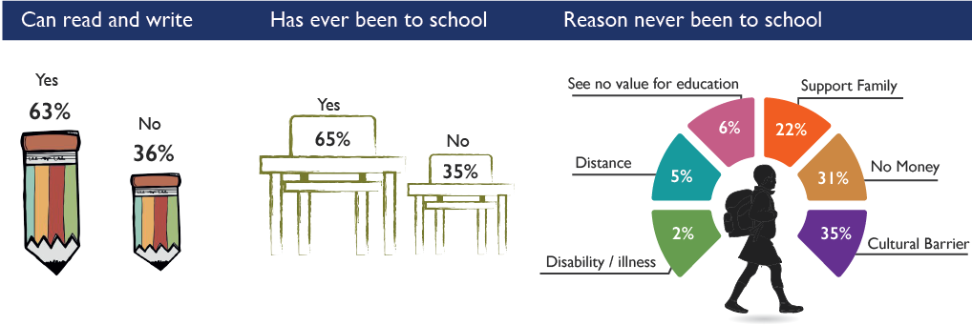

A significant number of primary school and secondary school children live beyond 5 kms from school and the lack of adequate transport infrastructure make it difficult to access educational institutions. Many girls suffer due to this distance, given the fact that they often collect water that is also located at a further distance.

Figure 15: Distance to School

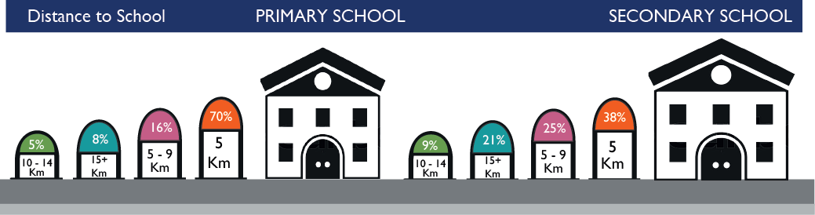

Overwhelmingly, the school systems in Yambio are owned and managed by the local government and the private sector. In certain situations, young females have taken incredible initiative to pay for school, and many work to save up before courses begin.

*“If you know that your mother is not able to get money to pay your school fees, then you have to know how to make business in order to pay your school fees.”*

When parents can pay school costs, qualitative data indicated that mothers’ incomes cover school fees. Safety, cultural barriers and young motherhood further inhibit girls’ access to education. Most young mothers postponed studies due to child-rearing, though many expressed desires to return. The level of capacities in the absence of resources to pay teachers, and the reliance on volunteer work, is notable and can be built upon.

Figure 16: Ownership of the Schools

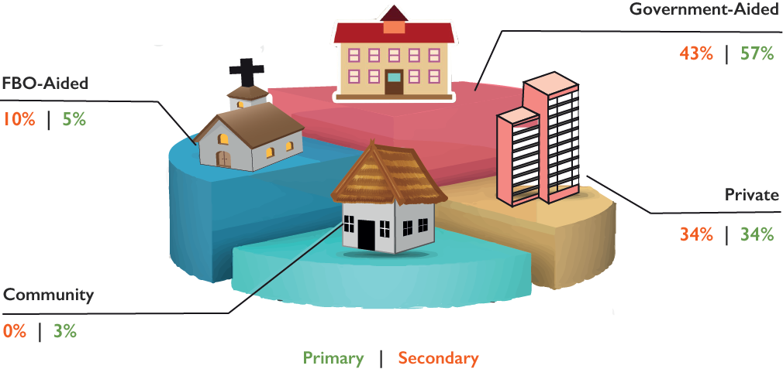

Several respondents indicated the significance of language in education, and the need for Arabic or English language skills have shifted over time. Now, many are attuned to the value of learning English due to NGO employment opportunities, and requested that language courses are taught earlier in school. FBOs and peace committees requested that schools to teach more vocational skills to help sustain students’ livelihoods following graduation. Comments indicated the commonality of children migrating to Kenya and Uganda for education, but for some this was wrought with tension, since sending children away for education is often exclusively possible for wealthy households.

Responses from focus group participants (i.e. youth, females, local leaders, FBOs, CBOs, peace committees, teachers etc.), revealed a growing need for education. Nonetheless, safety barriers and the lack of will and resources to put teachers on the ground persist. Cultural, social and economic hindrances continue, including limited education facilities and teachers. Youth, especially female youth, look to education for opportunities and meaning. Community leaders and organizations note that schools provide leadership and direction for youth—potentially keeping them out of conflict. Due to financial barriers to education, organizations could consider facilitating non-cash-based options to pay for school fees in situations where exchange of goods or trade services may be appropriate.

Figure 17: Education Excerpts



Relative to other CPAs, Yambio households have experienced “average” health care services. Roughly half of households indicated that healthcare services were not timely nor were families provided sufficient information. Focus group discussions highlighted general discouragement with health services, noting the following challenges: long distances to hospitals; absence of drugs in pharmacies; and limited amount of doctors due to low pay or no facilities. In addition to formal services, respondents cited less community investment in caring for the sick and disabled as a challenge. They also reported that NGO assistance is regularly requested, and called for support on trauma awareness and reconciliation.

While multiple water sources may be available in each community, most households depend on one or two primary sources. Hand pumps, boreholes and dug wells provide the predominant water sources in Yambio, and open running water serves roughly 12% of households. Most households travel less than one hour to the available water sources.

Figure 18: Water Sources

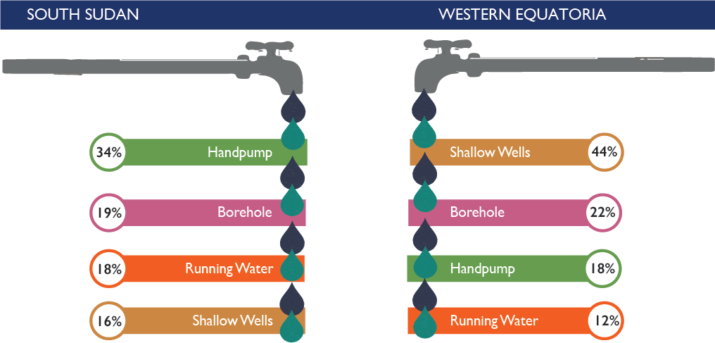

Many respondents cited concern for community management to protect separate boreholes for humans and livestock, and called for NGO and government support to bring boreholes to rural communities. Yambio community members complained of “getting diseases” from water, and mentioned using chlorine to treat water.

The seven CPAs generally have a poor view of government services, and Yambio is no exception. Respondents complained about poor job creation, corruption, infrastructure and price regulation.

During focus group discussions on government services, respondents complained of lack of trust and accountability, oil and resource conflicts, unqualified appointed administrators, and unequitable distribution of basic services. One Yambio peace committee believes that timely government pay would reduce night crime. This is because civil servants who are forced to go without pay often “use their guns to get food and money for school.” Many participants cited inflation and price volatility, the need to reach distant rural communities with services, and the paucity of schools, hospitals, and law and order as challenges. These responses also reflect a general decline in infrastructure, including road and market access.

Figure 19: Perception about Public Services

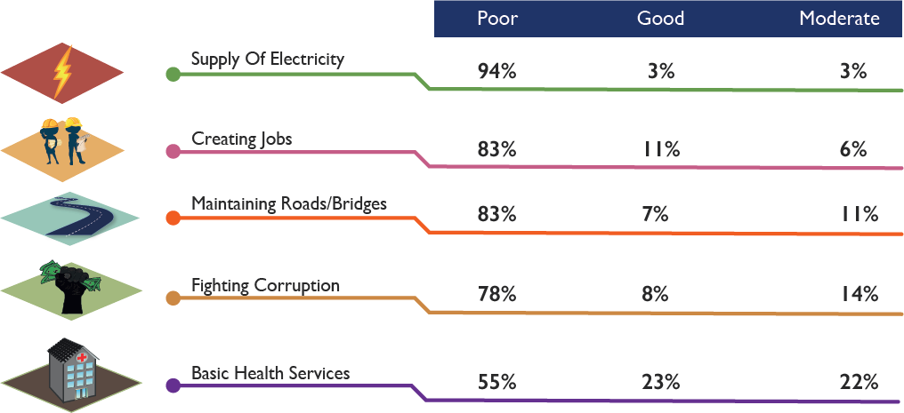

Conflict has serious implications on education. Due to conflict, schools and roads are closed or become too dangerous. Focus groups discussions indicate that dropout rates soar as school fees increase. A teacher in Yambio said “During times of peace, about 600 to 700 pupils were in school, but now only 200 pupils are here and the girls are very few… parents are unable to pay fees to sustain them in the school.”

Respondents stated that private schools are too expensive, yet within government schools, resources and teacher shortages affect educational quality. In addition, school resources and textbooks are often stolen. “You can go to school in the morning and spend the whole day there and no teacher, unless you go to private schools,” said one girl. Teacher salaries are low, and teachers often go unpaid for months or flee due to conflict. Comments were particularly sympathetic toward female teachers, who suffer disproportionately.

### Logical Framework

Table 5: Logical Framework for Pillar Two

|  | **KEY RESULTS** | **Baseline levels %** | **% increase targeted** | **Indicators** |
| --- | --- | --- | --- | --- |
| Intermediate Result 2.1 | 25% of the population in the 7 geographical areas, per year, have access to sustainable, quality, equitable and comprehensive health services. | TBD | 25% | * Number of blood bank established; 80% of immunization coverage for children and adults against Hepatitis B/C and Yellow Fever; * Reduction of maternal and infant mortality rate by 25%; * Community based surveillance system established and operational in 20 bomas; * Reduction of EPI drop out rates from 25% to 5% * Number of emergency operational centers for outbreak management established; * Number of health workers trained and certified; * Number of health facilities constructed |
| Intermediate Result 2.2 | 20% increase in the number of school going children (boys & girls), per year, have access to quality, basic, and inclusive education in the 7 GAs (payams) | TBD | 70% | * Seven complete primary schools constructed in the geographical areas by 2019; * Learning and teaching school materials supplied to all primary schools in Gbudue State; * 500 primary school teachers and 18 education managers are trained on pedagogical skills, supervision and inspection by 2019; * 30 primary school teachers and 6 inspectors trained on special needs education; |
| Intermediate Result 2.3 | 700 out of school youth, school drop-outs, per year, have access to quality and inclusive vocational skills and ALPs, in the 7 GAs (payams) | TBD | 2000 pers | * Construction of permanent full primary schools’ (up to primary 8) learning spaces in seven geographical areas; * Provision of learning and teaching materials in schools in the 7 geographical areas; * Training of teachers and education managers in the 7 geographical areas; * Training of teachers for inclusive education in the 7 geographical areas. Transport means for supervision and inspection. * Provision of Hygiene kits to matured girls in primary schools; * Raising awareness on the importance of girls’ education; * Provision of adult education, so as to encourage parents to send all children to school, including girls. * Establishment of WASH facilities in schools, so as to provide safe learning spaces to girls; * Constructing Community Girls’ Schools closer to communities, so as to reduce distance to schools for young girls. * Employ qualified teachers in primary schools in the 7 geographical areas; * Improve teachers’ salaries or give incentives to teachers of primary schools in the 7 geographical areas. |
| Intermediate Result 2.4 | 100% of children associated with armed groups are demobilized, capacitated and integrated in the community by 2020 | TBD | 100% | * % of children associated with armed group who are demobilized, capacitated and integrated into the community |
| Intermediate Result 2.5 | Increased access to basic safe drinking water by 30%, sanitation by 20% and improved hygiene and sanitation behavior change by 25%, in the GAs by 2020. (pending baseline....) | TBD | 30% | * 90,000 people (46,000 male; 44,000 female) have access to safe, sustainable drinking water in selected geographical areas (Ref. NBS population projection 2019) * 60,000 (31,000 male; 29 female) have access to basic sanitation in selected geographical areas. * 75,000 individuals (39,000 male; 36,000 female) practice the appropriate behavior in the 3 critical hygiene behaviors (hand washing after visiting latrine, before eating food, after cleaning baby’s bottom, before breastfeeding, and before preparing food) |
|  |  | TBD | 20% | % of households that have access to safe sanitation by 2020 |
|  |  | TBD | 25% | % of households that demonstrate improved hygiene and sanitation behavior change |
| Intermediate Result 2.6 | 50% of returnees (IDPs and refugees) have access to food and non-food packages to ensure sustainable integration by 2020 | TBD | 145,278 | * Number of people assisted  Quantity of food items and NFIs distributed * Number of people trained and able to apply skills acquired |
| Intermediate Result 2.7 | 200 women groups (30 per group) in 7 geographical areas have access to established and functional "women empowerment" centers established by 2020 | TBD | 200 groups | * Number of SGBV survivors access psychosocial and critical health services through women empowerment centers, SPU, and CMSGBV * Number of radio talk shows conducted on prevention of SGBV, community protection mechanism and economic recovery initiatives. * Functional SGBV referral pathways in place * Number of awareness materials produced (posters, t-shirts) * Number of boys and men mobilized and sensitized on SGBV prevention * Tracking and monitoring system established for SGBV cases |

### Institutional Architecture

The key institutions most relevant to the results for Pillar 2 are outlined below.

Table 6: Pillar Two Institutions

|  |
| --- |
| **Pillar Two Institutions** |
| Community development committees |
| Cooperative societies (YAFA etc….) |
| UN agencies (FAO, WFP, UNDP and UNOPS and UN women) |
| CBOs, NNGOs & INGOs (CSD, STO, WVI, AGRA) |
| MAFF, MCRD, & CADs, MoF&EP, MoPI |
| Private sector (Agro dealers, financial institutions) |
| Research and academic Institutions (ATTC, Mikesse University) |

Members of Pillar two whose objective is to re-establish access to basic services gave the following responses in regards to the administration of the IA4R tool in the table below. There was no institutional aspect that does not require attention.

Table 7: Institutional Perspectives for Pillar Two

|  |  |  |  |
| --- | --- | --- | --- |
|  |  | Score (%) | |
| **Absorptive Capacity** | **Red** | **Yellow** | **Green** |
| Institutions are present | 4.5 | 59.1 | 36.4 |
| Institution’s services meet minimum standards | 22.7 | 63.6 | 13.6 |
| Institutions have Human resources | 31.8 | 45.5 | 22.7 |
| Institutions services are accessible to households during shocks/stresses | 72.7 | 22.7 | 4.5 |
| **Adaptive Capacity** |  |  |  |
| Institutions are shock aware | 13.6 | 63.6 | 22.7 |
| Institutions know early signs and stages of shocks | 31.8 | 45.5 | 22.7 |
| Institutions have emergency response plans | 13.6 | 72.7 | 13.6 |
| Institutions have access to resources for emergency plans | 22.7 | 63.6 | 13.6 |
| Institutions have resourced human resources |  |  |  |
| **Transformative Capacity** |  |  |  |
| Institutions’ stakeholders participate in preparedness and response planning | 27.3 | 52.4 | 19 |
| Institutions employ Evidence-based approaches | 19.0 | 57.1 | 23.8 |
| Institutions are action ready | 14.3 | 57.1 | 28.6 |
| Institutions have and use resilience feedback loops | 47.6 | 38.1 | 14.3 |
| Institutions are inclusive | 23.8 | 57.1 | 19.0 |
| Institutions have social bonding capital | - | - | - |

A key institutional aspect under this Pillar that elicited responses for urgent attention is the inaccessibility of services to households during shocks and stresses. This may imply that institutions provide limited services during shocks and stresses, and that households have over-strained savings, assets or social capital to access basic services. It may also imply the absence of adequate social safety nets to endure shocks and stresses.

## Pillar Three: Restoring Productive Capacities

### Resilience Profiles

Focus group discussions highlighted the agricultural sector’s role in food security, as well as in cultural identity, peace and dignity. Many comments across demographics looked to farming for food security at the community and household level, yet others expressed a sense of vulnerability in agricultural survival and the need for training on extension services.

In general, food insecurity is a serious challenge in South Sudan, as the country is entangled in warfare, conflict and climate change threats. Most households in the seven CPAs experienced lack of food over a 12-month period. Comparatively, Yambio’s food insecurity rate of 55% is less severe than most CPAs. Civil war and conflict are the main drivers of food insecurity in Yambio. Other causes include the prevalence of insects and pests.

Most households responded to food insecurity by purchasing food with their own resources or relying on relatives. Gathering wild plants and animals also play a notable role in curtailing food shortages in Yambio. Given Yambio’s dependency on foraging and hunting during food shortages, protection from regional violence and community access to local natural resources became critical.

Figure 20: Food Security

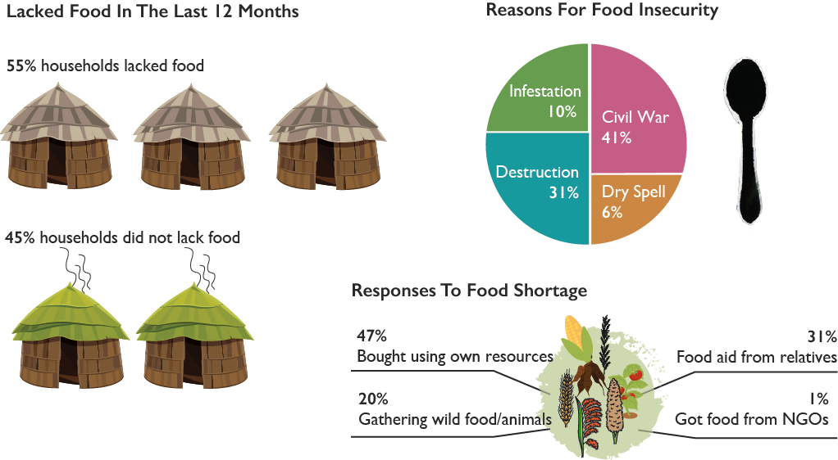

In addition to social and environmental factors that inhibit food security (Figure 20), human activities can threaten soil as well as threaten human health and livelihoods due to pollutants and destruction of natural resources. Bush burning is prevalent in all seven counties, but highest in Yambio. Bush burning threatens agricultural resilience by deteriorating soil structure, decreasing agricultural productivity and biodiversity, and exacerbating erosion and runoff pollutants (Ozaslan et al., 2015; Vagen et al., 2005). Prevalent charcoal burning further threatens air quality and respiratory health. Timber lumbering also threatens land and biodiversity resilience. Mining, toxic dumping and fishing chemicals also impact resilience.

Figure 21: Status of Social Capital and Assets / Environmental Problems

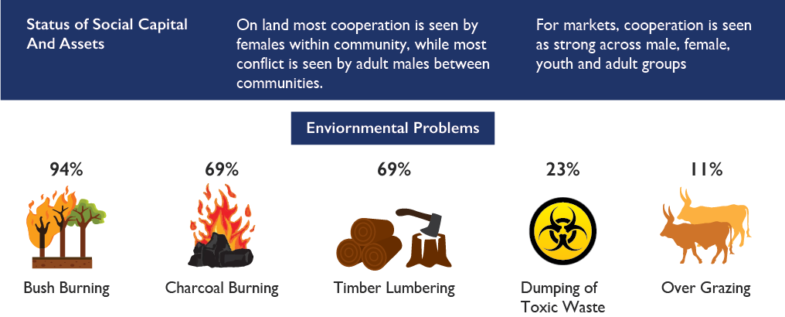

With respect to farming, the most important crops in all counties are carbohydrate-dense grains. Yambio similarly prioritizes maize and groundnuts. Agricultural diversification can reduce household and regional vulnerability to climate and market shocks (Brenda, 2011), as well as benefit health, provided households diversify with nutrient-rich crops and animal-sourced foods (Kennedy et al., 2010; Hoddinott et al., 2002). Many households cultivate multiple crops. Figure 21 presents the most common crops in Yambio. Carbohydrate-dense grains and groundnuts still dominate, with low representation from fruits and vegetables.

Respondents identified several threats to agricultural productivity, including lack of tools and skills, crop pests and security. Respondents’ comments called for assistance in pest management and to bring garden tools and insecticides. Some believed that, skilled and equipped with modern tools to grow a variety of crops, “production would be enough.” Security remains a constant threat to production, foraging and fishing.

Figure 22: Main Livelihood Challenges / Markets: Access & Coverage

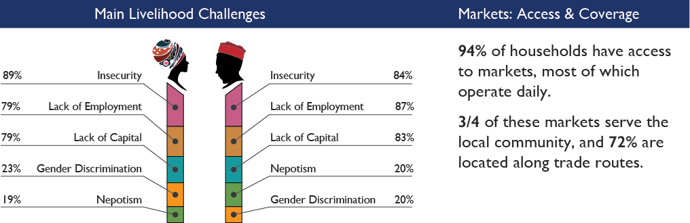

Most of Yambio’s working population is engaged in crop production. Women and young females are more likely to work in catering and baking, while males dominate construction, mechanical work and carpentry industries. Market livelihood activities varied less by gender. Alcohol brewing remains the dominant market livelihood activity. Yambio has strong access to broader markets compared to the other CPAs, which increases the attractiveness of this activity. Unfortunately, it is also more likely to contribute to the high prevalence of alcohol abuse, domestic violence and child abuse, which are more prevalent in Yambio than most other CPA communities.

Firewood collection and charcoal burning are also predominant market livelihood activities that unsustainably extract or exploit non-renewable resources. Yambio surveys indicated the environmental destruction from bush burning, charcoal burning and lumbering. To achieve more resilient futures and reduce conflict, sustainable livelihood practices should be adopted.

Figure 23: Top 4 Livelihood Trends by Community Groups

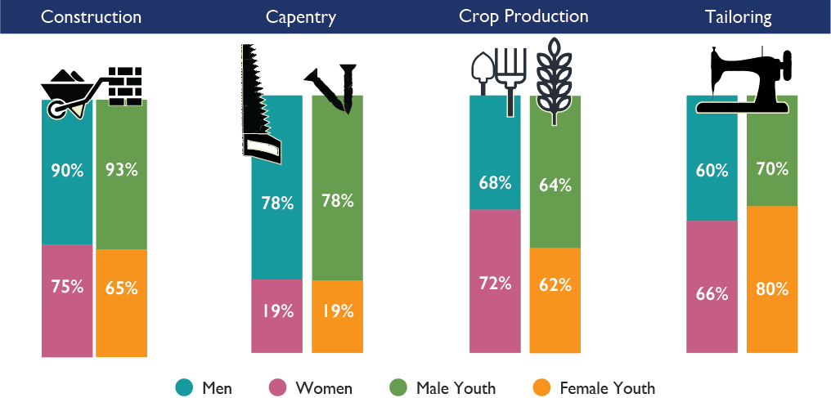

Males and females of all ages in Yambio generally agreed on the obstacles to livelihood activities, with the exception that females encountered far more gender discrimination. Youth predominantly complained of lacking employment opportunities, and adults complained more of age discrimination. The latter may suggest that youth can work for lower wages, distorting the labor market for adults. All participants cited insecurity, lack of employment opportunities, and lack of capital as the primary livelihood obstacles.

Similarly to the quantitative survey data, qualitative data revealed a lack of capital. FBOs articulated the need for “micro-finance, small-income generation and education” to help build financial and human capital, and meet strong demand for small-businesses. They also called for the development of vocational skills in construction, more factories that provide jobs, and the increase of agricultural export within the region. There were complaints over the high cost of materials, and the need for simple infrastructure to protect their investments and labor. Women’s tailoring collectives called for investment support, and additional machines and equipment. Farmers repeated the call for tools, with one participant stating, “If you don’t have money and the tools to clear your garden, then how can you move ahead farming?”

Again, cooperatives emerged as an important institution for financial and community support—especially for women’s and youth businesses. They also play a role in evolving gender relations. Respondents indicated that government and NGOs have pushed for cooperatives, which make it easier to distribute support. Young women, in particular, indicated the importance of collective economic and social support. Collectives also present positive opportunities to build gender relations in co-ed cooperatives; as a male farmer in Yambio stated “We saw that gender has to balance. In our cooperative, the treasurer, vice secretary and information secretary are all women. It is really very important.”

Comments from women’s focus groups indicate vibrant participation in local businesses, driven by the need for income. Women stated they were good at generating money and business, and “stay long in the markets” to secure income. They claimed that supporting women with livestock is especially helpful because women are “good at livestock,” though they also expressed the risk of theft of their resources—particularly of cattle

Both quantitative and qualitative data revealed the importance of alcohol brewing for income generation. Many girls indicated learning the trade from their mothers in order to pay their school fees. Interestingly, no comments articulated the connection between the livelihood activity and local conflict, even though surveys revealed a strong correlation with alcohol abuse, child abuse and domestic violence.

Livestock play a particularly contentious role in communities due to the powerful income-generation and nutritional benefits they offer. However, the threat of theft, violence and resource conflicts is also associated with livestock generation. Furthermore, livestock plays a complicated socio-cultural role; many comments connected cattle raiding to marriage, “because without livestock there is no marriage.”

Over 90% of Yambio’s households have regular access to a common open market, though only 60% of households have daily access. However, compared with other CPAs, Yambio has the highest general market access including both local and broader regional access.

Qualitative data highlighted the ramifications of limited market access for many farmers; “Without feeder roads our crops rot.” This data indicated a decline in road and market access in recent years. However, most qualitative data addressed poorly-functioning markets, rather than limited *physical* market access. Producers and consumers cited price uncertainty, limited or dishonest buyers, and in some cases low demand or supply of agricultural products as challenges.

Many consumers stated that “commodities in the market are still very expensive.” Both consumers and producers expressed anxiety over price uncertainty tied to the dollar. A woman in Yambio complained of limited supply and high cost: “Hen’s eggs are one of the most expensive things here, 150 SSP per a single egg and it is not there at all sometimes.” On the other hand, some producers have “given up due to low payment,” complaining that their “farm products are bought so cheaply” and that going to market is not worth the cost of production. Maize producers complained that “some buyers take the maize and delay payment,” or that they are “forced to sell maize in large bulk instead of smaller quantities.” Other producers have faced weak demand for the quantity of their production, stating that “If you have too much food and they don’t buy it, it will not help. NGOs also do not come and buy.” Some well-intentioned NGOs have supplied seeds that may not have been suited for market demand.

Yambio is highly dependent on agriculture for food and economic security yet faces severe agronomic, capital, environmental and market constraints. In addition to climate and market uncertainties, the internal and external conflicts that communities face requires special attention to the social, educational and gender components of any agriculturally-based intervention. In this regard, a diversity of agricultural development methods should be considered since some regions—particularly remote communities—may not be suited to conventional agricultural development practices.

In the absence of markets with access to agricultural inputs and consumer demand, farmer adoption of typical production-enhancing technologies could weaken resilience over the long-term if the entire socio-ecological system is not accounted for. Research has demonstrated that some agroecological systems simultaneously enable communities to improve nutrition outcomes and recuperate the inherent productivity of degraded soils such that it reduces dependency on external markets, and enhances climate resiliency in all regions (Tittonell et al., 2011; Boyd et al., 2013). In some areas, stronger gender and community relationships and farmer-to-farmer education may lead to improved livelihoods and sustainable management of natural resources. Biodiversity can offer protective measures for nutrition and food security, pest management, and sustainable livelihoods from ecosystem services—ranging from culinary livelihoods and food processing (Kerr et al., 2013; Gubbels, 2011).

Many respondents expressed a sense of collective strength in agriculture for information-sharing, coordination with external support, and collective-cultivation coordinated by cooperatives, CBOs or congregations. They highlighted the role of food security for strengthening re-integration in host communities. Some respondents addressed the risks of agronomic knowledge being lost, speaking of more diverse cultivation by previous generations, and the need to maintain agronomic education.

Qualitative data demonstrates strong resolve among producers. Within a young female focus group in Yambio, a participant stated: “We should be self-reliant. We should be able to do little business to pay school fees and to care for our young brothers and sisters.” While an array of data called on government or NGOs to subsidize capital investments and loans, build infrastructure and solve market failures, many commenters highlighted the desire for community-based resilience and self-sufficiency. Finally, focus groups discussions reveal how intimately vocation is intertwined with mental health resilience. As a women’s group member communicated, “We need activities that will make us busy. The only thing to make us free from this trauma is to bring things that will make us busy and we shall be self-reliant.”

### Logical Framework

The results from Pillar Three members whose objective is to strengthen productive capacities are outlined in the table below.

Table 8: Logical Framework for Pillar 3

|  |  |  |  |  |  |
| --- | --- | --- | --- | --- | --- |
|  | **KEY RESULTS** | **Baseline levels %** | **% increase targeted** | **Deadline** | **Indicators** |
| **Pillar 3:** | **Strengthening Productive Capacity** | | | | |
| **Intermediate Result 3.1** | Increased production and productivity by 50% by 2021 | TBD | 15% | 2020 | Gross agriculture yield per household measured in tons per year |
| **Intermediate Result 3.2** | At least 75% of surplus producing farmers have access to market and market information by 2020 | TBD | 75% | 2020 | % of respondents who claim their household accessed markets in 2020 |
| **Intermediate Result 3.3** | Increased and strengthened Private Sector Engagement, Financial services and entrepreneurship | TBD | TBD | TBD |  |
| **Intermediate Result 3.4** | Increased employment by xxx% by 2021 | TBD | 15% | 2020 | % of respondents who claim to be unemployed (by gender and age) |
| **Intermediate Result 3.5** | Sustainable use and management of natural resources adopted in 5 bomas by 2020 | TBD | TBD | 2020 | Number of bomas where sustainable use and management of natural resources is practices by at least 5 % of households |

### Institutional Architecture

In general, all institutional aspects in this Pillar require attention, with the exception of shock awareness. It is apparent that institutions have the capacity to identify the primary shocks and stresses that impact the local community, and can easily name them and describe their impact. A prominent institutional aspect that requires urgent attention is the inaccessibility of services to households during shocks and stresses.

Table 9: Pillar Three Institutions

|  |
| --- |
| **Pillar Three Institutions** |
| Community development committees. |
| Cooperative societies (YAFA etc….) |
| UN agencies (FAO, WFP, UNDP and UNOPS and UN women etc…. ) |
| CBOs, NNGOs & INGOs (CSD, STO, WVI, AGRA etc….) |
| MAFF, MCRD, & CADs, MoF&EP, MoPI |
| Private sector (Agro dealers, financial institutions) |
| Research and academic Institutions (ATTC, Mikesse University) |

Table 10: Institutional Perspectives for Pillar Three

|  |  |  |  |
| --- | --- | --- | --- |
|  | **Score (%)** | | |
| **Absorptive Capacity** | **Red** | **Yellow** | **Green** |
| Institutions are present | 18.2 | 77.3 | 4.5 |
| Institutional services meet minimum standards | 13.6 | 77.3 | 9.1 |
| Institutions have Human resources | 13.6 | 68.2 | 18.2 |
| Institutions services are accessible to households during shocks /stresses | 45.5 | 54.5 | 0 |
| **Adaptive Capacity** |  |  |  |
| Institutions are shock aware | 9.1 | 40.9 | 50 |
| Institutional know early warning signs and stages of shocks | 36.4 | 45.5 | 18.2 |
| Institutions have emergency response plans | 31.8 | 40.9 | 27.3 |
| Institutions can access resources for emergency plans | 22.7 | 63.6 | 13.6 |
| **Transformative Capacity** |  |  |  |
| Institutions’ stakeholders participate in preparedness and response planning | 13.6 | 50 | 36.4 |
| Institutions employ evidence-based approaches | 18.2 | 59.1 | 22.7 |
| Institutions are action ready | 22.7 | 59.1 | 18.2 |
| Institutions have and use resilience feedback loops | 28.6 | 61.9 | 9.5 |
| Institutions inclusive | 22.7 | 50 | 27.3 |

## Pillar Four: Nurturing Partnership

The Yambio JWP is introducing a new business model based on cooperation in the region. This requires implementing coordination structures from the bottom-up. It will build the capacity of the community’s institutions to set priorities and contribute towards results.

The Cooperation Framework builds upon stakeholder commitments to establish a vertically integrated colocation, coordination, and collaboration platform in Yambio from the Boma-level upwards. This will enhance the convergence of people, ideas, resources and efforts around priorities for resilience. Partners commit to putting the community first as they: collocate in geographic areas that are mutually determined on the basis of geographic selection criteria; coordinate through joint work planning and monitoring and evaluation; collaborate by performing complimentary tasks to achieve common outputs within the work plan; and converge people, ideas, resources and efforts around obstacles and opportunities to produce results that are aligned with the Joint Work Plan.

The partnership brings together development partners, civil society, private sector and traditional leaders, with the local government playing a supportive role in ensuring a conducive enabling environment. A range of other local and international players organize through hybrid institutions.

For the purpose of colocation, the following serve as geographic selection criteria:

1. Peace and accessibility (6-12 months of stability)
2. Business hub (presence of markets, potential traders and small enterprises)
3. Agricultural-productive areas
4. Diverse populated areas (over 6000 inhabitants)
5. Linked to major road network
6. High return areas (IDPs & Refugees)
7. Community buy-in PFRR
8. Presence of local and international partners

Application of these criteria led to identification of the following target areas for joint programming: 1) Yambio Payam; 2) Nzara Payam; 3) Ringasi Payam, 3) Bangasu Payam; 4) Basukangbi Payam; 5) Sakure Payam; 6) Nadiangere Payam; 7) Ri-Rangu Payam; 8) Gangura Payam; 9) Bazungua Payam; 10) Saangua Payam; 11) Ri-menze Payam; 12) Namaiku Payam; 13) James Diko Payam; and 14) Birisi Payam.

The ability of participants to achieve geographic selection criteria for sub-state targets was a function of: 1) appointing a task force; 2) assigning members to that task force from across the pillars; 3) providing time for the task force leads to adequately prepare; 4) quickly integrating reactions from the plenary after a presentation on the task force’s work; and 5) coming to an understanding with local leadership beforehand around core elements of the criteria.

### Structures of Cooperation

1. **Community Development Committees (CDCs):** sustain dialogue with community through relevant community-based institutions, and identify obstacles and opportunities for convergence, ensure local ownership of work plans, and optimize community participation.
2. **Resilience Platform:** supports the Pillar to monitor the work plan, revise targets as needed, and ensure optimal convergence.
3. **CPA-level Technical Committee:** serve as the forum where stakeholders from across government, community, and the international agencies monitor the joint work plan, execute programmatic decisions, co-create learning products, and flag policy-related issues to the Steering Committee.
4. **CPA-level Steering Committee:** serves as the policy-making body to direct and guide the CPA-level Partnership.
5. **Cluster Groups:** connect the PFRR to the humanitarian coordination.

### Processes of Cooperation

1. **Mutual Accountability:** partnership infrastructure shall be utilized to track contextual and program-specific information for continual improvement in program delivery. This process includes the following critical activities.
   * Tighten indicators – within the JWP and align with the PFRR M&E framework.
   * Joint Monitoring – collect and analyze relevant data, including conducting surveys (Resilience Profiling and Institutional Architecture Assessments)
   * Joint Evaluation - carry out evaluation after first year.
2. **Two-way information flow:** information shall flow from the field upward through the coordination structures, and also back downward from the center to the field. This process includes the following critical activities:
   * Pillar report writing – quarterly reports to the Technical Committee detailing progress in implementing the JWP.
   * Document dissemination – socialization of relevant documents from the Partnership, including reports from other geographic areas.
   * “Under the Tree” Town Halls – keep the community engaged in the Partnership by continually providing opportunities for feedback.
3. **Cross-agency resource deployment:** within the parameters of accountability and compliance, direct resources from multiple agencies to support the realization of results prioritized at the community level. This process includes the following critical activities:
   * Priority setting
   * Identify convergence points
   * Resource-tracking (in near real time)
4. **Idea generation:** to enrich prioritization by encouraging community members and partners to generate ideas for program improvement, evolve them through dialogue and implement them jointly as a basis for innovation. This process includes the following critical activities:

* Idea co-creation
* Defining learning questions
* Telling the story

### Activity Calendar for Cooperation

The following calendar is to be filled by the Pillar leads in consultation with the Pillar members.

Table 11: Activity Calendar for Cooperation

| Activity |  |  |  |  |  |  |  |  |  |  |  |  |
| --- | --- | --- | --- | --- | --- | --- | --- | --- | --- | --- | --- | --- |
|  | Jan | Feb | Mar | Apr | May | Jun | Jul | Aug | Sep | Oct | Nov | Dec |
| Joint M&E |  |  |  |  |  |  |  |  |  |  |  |  |
| **Tighten indicators** |  |  |  |  |  |  |  |  |  |  |  |  |
| **Conduct surveys** |  |  |  |  |  |  |  |  |  |  |  |  |
| **Joint evaluation** |  |  |  |  |  |  |  |  |  |  |  |  |
| Two-way information flow |  |  |  |  |  |  |  |  |  |  |  |  |
| **Pillar report writing** |  |  |  |  |  |  |  |  |  |  |  |  |
| **Disseminate Documents** |  |  |  |  |  |  |  |  |  |  |  |  |
| **Under the Tree Town Hall** |  |  |  |  |  |  |  |  |  |  |  |  |
| Cross-agency resource deployment |  |  |  |  |  |  |  |  |  |  |  |  |
| **Priority setting** |  |  |  |  |  |  |  |  |  |  |  |  |
| **Identify convergence points** |  |  |  |  |  |  |  |  |  |  |  |  |
| **Resource Tracking** |  |  |  |  |  |  |  |  |  |  |  |  |
| Innovation and Learning |  |  |  |  |  |  |  |  |  |  |  |  |
| **Idea Co-creation** |  |  |  |  |  |  |  |  |  |  |  |  |
| **Defining learning questions** |  |  |  |  |  |  |  |  |  |  |  |  |
| **Telling the story** |  |  |  |  |  |  |  |  |  |  |  |  |

### Institutional Architecture of Partnership

IA4R Pillar four component was the only one completed by all of the participants irrespective of Pillar membership. The responses are in the table below.

Table 12: Institutional Perspectives for Pillar Four

|  |  |  |  |
| --- | --- | --- | --- |
|  | Score (%) | | |
| **Absorptive Capacity** | **Red** | **Yellow** | **Green** |
| Information is available to identify new Partners | 18.2 | 54.5 | 27.3 |
| Institutions have the capacity to partner | 15.2 | 57.6 | 27.3 |
| Development Partners are present for humanitarian assistance | 3.0 | 39.4 | 57.6 |
| Private sector exists, but is largely subsistence | 18.2 | 48.5 | 33.3 |
| **Adaptive Capacity** |  |  |  |
| Institutions have partnership strategies | 27.3 | 51.5 | 21.2 |
| Development Partners are present for Humanitarian and Development assistance | 9.1 | 45.5 | 45.5 |
| Institutions have structured Partnerships | 12.2 | 57.6 | 30.3 |
| Diversity and inclusion in institutional partnerships | 31.3 | 43.3 | 25.0 |
| **Transformative Capacity** |  |  |  |
| Institutions’ stakeholders participate in regular Coordination meetings | - | 37.5 | 67.5 |
| Institutional Coordinating Bodies employ evidence-based approaches | 6.3 | 65.6 | 62.5 |
| Institutional Coordinating Bodies provide joint accountability to Constituents | 34.4 | 46.9 | 28.1 |
| Coordinating Bodies are Action-Ready | 28.1 | 34.4 | 37.5 |
| Coordinating Bodies have and use Resilience Feedback Loops | 12.5 | 71.9 | 15.6 |
| Coordinating Bodies are inclusive | 28.1 | 46.9 | 25.0 |

Pillar four results for Yambio affirm the presence of development partners for humanitarian and development assistance. This confirms that several capable organizations implementing donor-funded programs are operating in the area. However, key partnership and coordination aspects still require significant attention, including identification of new partners, capacity to partner, structuring partnerships, diversity, and the use of evidence and resilience feedback loops.

# Operationalizing the Work Plan

## Community-based Service Delivery Operational Model

From a community perspective, the six classes of assets include– natural (land, water, forests and animals); physical (roads, schools, hospitals, boreholes, ICT); financial (micro-credit and markets); political (courts, legal clinics, and prisons); social (ceremonies, sports and celebration); and human (curriculum, human resources). These constitute the community’s critical infrastructure. Community institutions emerge to help households leverage value from these infrastructures.

Figure 24: Institutions and Household and Communal Assets

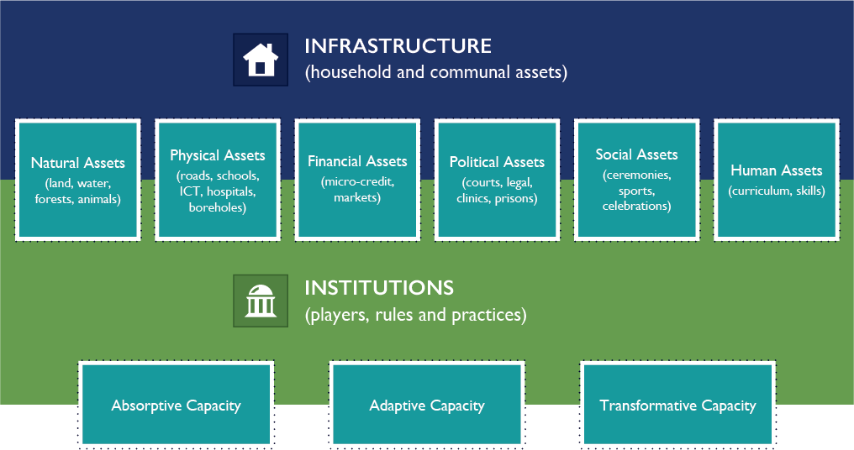

The JWP grounds resilience in community by considering the delivery mechanisms from the perspective of how households:

1. Access the assets made available through the Partnership, starting with those most essential to cope with shocks (absorptive capacity)[3];
2. Acquire the skills to influence how they are used for the purpose of adapting to shocks (adaptive capacity)[4]; and
3. Cooperate to ensure that higher levels of collective action result in sustainable and scalable solutions (transformative capacity)[5].

As a result of these coping capacities, a cycle of vulnerability caused by stressors can be disrupted, and the negative effects of shocks can be avoided. Each of these capacities is not mutually exclusive.

To make the IA4R tool (Annex I) tractable, the three coping capacities of recovery and resilience were used as the basis for developing the proposed indicators of institutional capacities for recovery and resilience within the four Pillars of PFRR.

## Activating the Convergence Points

Figure 25: Community-based Service Delivery Indicators

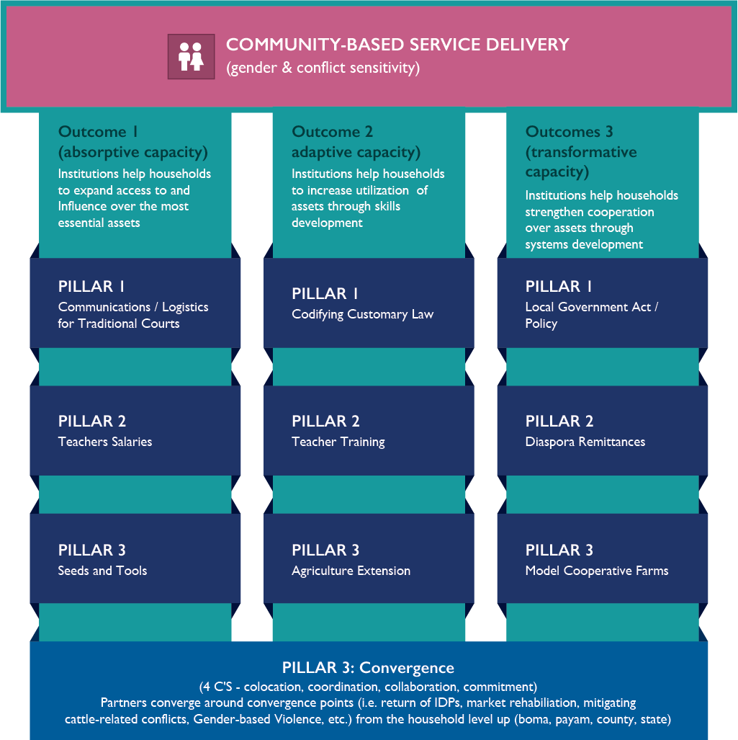

The community-based service delivery component of the framework presents an integral 3-pronged mechanism for building absorptive capacity (access to essential assets to cope with shocks), adaptive capacity (influence over and utilization of those assets for more sustainable coping capacity), and transformative capacity (higher levels of organization and cooperation around those assets for fuller sustainability).

Figure 26: Convergence Tool

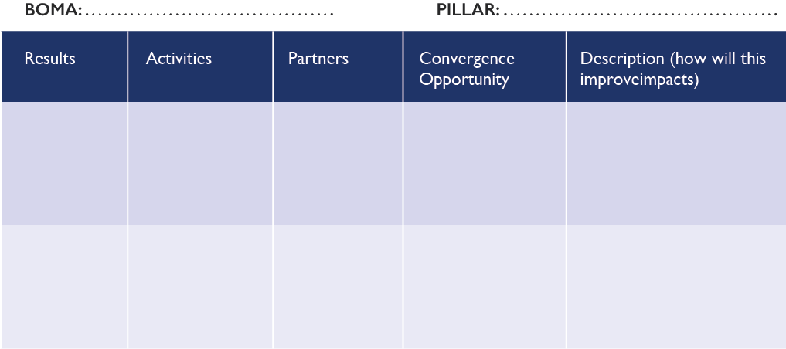

## The Monitoring & Evaluation Framework

The RIMA Plus serves as the tool for measuring resilience within the Partnership areas, while the IPC will continue to be used to assess vulnerability. Through econometric modeling, the Partnership is also simulating what variables are likely to have the biggest impact on resilience.

**Integrated Phased Classification (IPC):** The IPC is the common measure used to assess the status of food insecurity. In the Partnership, it is used for determining levels of vulnerability.

**Resilience Index Measurement and Analysis (RIMA):** RIMA is a measurement developed by the Food and Agricultural Organization (FAO) for assessing the status of food security. It consists of four pillars and related variables.

**RIMA Plus**: RIMA Plus is an adaptation of the RIMA that includes social cohesion, governance and conflicts. This is because respondents’ cited conflict rooted in governance issues as a major source of vulnerability, and also cited food insecurity at the household-level as challenge.

# Conclusion

## Lessons Learned

**Towards a shared understanding: do partners have a shared understanding of the basic concepts framing the Partnership?**

Partners were noted to not have a shared understanding, but were eager to work towards one. Using the first session to clarify concepts was an effective way to start the JWP.

Recommendation: Include other key terms and provide more feedback on refining terms. In addition, develop an updated glossary of terms.

**Towards greater impact: What are the results that would produce the greatest impact in reducing vulnerability and building resilience in Yambio?**

In future work planning, the appropriate level to focus on is IR level outcomes and high-level outputs. Too much granularity beyond this produces diminishing returns, consumes valuable time, and risks having no bearing on the realities to be faced on the grounds. Activity level discussion should only illustrate what convergence might look like in practice.

Recommendation: A system for harvesting ideas and monitoring incidents from the ground should be integrated in the JWP. Responding to these should be a core business process.

**Taking an inventory of Partners’ activities: Do we know what partners are currently doing in Yambio, where their activities are located, how long they will be active and what assets they have available?**

Partners generally do not know what others are doing on the ground. Rather than achieve this in the working sessions, the decision was made to introduce a database tool that Pillar leads will use to capture GPS-based coordinates of partner activities, and reflect these results on a GIS platform. FAO accepted responsibility to lead this process. Similar leadership will be required in each CPA for this tool to work.

Recommendation: The database and map should be made available as part of the central repository of the Partnership and form a part of the online learning platform.

Recommendation: Physical mapping on the wall should be attempted at the JWP to illustrate convergence, but enough time will have to be allotted.

**Making convergence work in practice – Can we layer, sequence and cluster our activities in Yambio for greater impact through strategic integration?**

The initial session indicated that there is no uniform understanding of these concepts. It would be beneficial to adopt a standard definition for participants. However, keeping convergence as the umbrella concept for the working sessions was effective. Participants may be burdened with nuanced technical distinctions regarding the various modes of convergence.

Convergence flows naturally from some of the risks, assumptions, mitigation measures and gaps that are captured using the log frame approach. Once again, activities are more valuable in providing concrete building blocks to illustrate convergence than they are valuable in controlling processes mechanistically through the logical framework as a management tool. Activities are the objects of adaptive management and should not be cast in stone. In practice, convergence must be responsive to issues, incidents, opportunities and obstacles faced on the ground.

One of the most effective inputs in making convergence understandable was the case study of the failed opportunity for convergence in response to the return of IDPs. In particular, providing the pictures humanized the issue and made it practical. This facilitation approach represents the “whole person” concept, where activating physical, intellectual, emotional and spiritual bodies are all required for an integral experience that produces optimal workshop outcomes.

Recommendation: An inter-operable task management, incident response and idea system would supplement the logical framework if it could be maintained in real time to focus on the sub-county Partnership areas.

Recommendation: Consideration of more case studies should be worked into the JWP.

Recommendation: Using convergence points as a starting point for this session is an effective approach that can be further developed, including by providing more time.

**Co-locating operations – Can we identify sub-county level geographic targets on which to converge our efforts for greater impact?**

The issue of non-recognition of the current administrative units in Yambio is a point of confusion, as it was nationally. This issue requires more consideration, as it may produce conflict or misunderstanding when operations in the Partnership areas commence.

Recommendation: Use Yambio sub-county geographic selection criteria as an input/example for JWP in future CPAs.

**Developing an activities calendar – Can we prioritize the most critical activities needed to stand up the Partnership in Yambio, commit to firm dates, and allocate core responsibilities and resources?**

With more time, the next step would have been to create a calendar. Instead, the plenary discussed coordination mechanisms. The power point presentation regarding coordination in activating the JWP as a living instrument of convergence was effective in eliciting ideas about the structure and processes that should support coordination.

Recommendation: Evolve the presentation on coordination, create cooperation plan for Yambio, and ensure enough time is structured into future JWP to create cooperation plans during the course of the workshop.

Recommendation: Utilize the activity plan contained in this JWP to activate coordination structures.

**Building consensus– What should the Partnership do in order to ensure that there is solid agreement and consensus on the Consolidated Workplan and the Partnership layering strategy for Yambio?**

This question was not addressed due to time constraints, but may fit into the remit of the C4C. However, while this refers to the promotion of the JWP after the workshop produces the logical framework, consensus building is also embedded within a much larger buy-in of the overall PfRR. In a CPA, the preparatory work should begin at least 2-3 weeks ahead so the Pillar leads have the required time to do their work. This also means they should be properly oriented. Stronger engagement with the field teams and more lead-time will allow for internalizing the process and providing inputs.

In this process, the sensitization of the Chief Executive in the Partnership area is a key success factor. If the Gbudwe state Governor was not fully onboard and understood the political context of the Partnership, the entire process would not have gone as smoothly. This process of trust building should be based in mutual accountability. Crafting a correct understanding of the government role in the Partnership is necessary in the short term.

Recommendation: Move from the concept of a work plan as a static document to joint work planning, and ensure continued dialogue within a strategic framework that is adaptive.

Recommendation: Carry out a Training of Pillar Leads (ToPLs) across all CPAs to take place in Juba, and equip them with all of the JWP tools, documents and guidance.

**Promoting adaptive management – Can we suggest to our donors any financing and/or compliance adjustments to make strategic integration and high impact programming more viable in Yambio?**

This question was not addressed due to time constraints, but may form a technical question that the facilitators and other researchers should continue to monitor and advise on.

Recommendation: Ensure that tools and modalities for more adaptive management form part of the learning agenda across CPAs by allotting time for this discussion at the JWP.

**Socialization of key documents and tools – Are we familiar with the key documents and tools that relate to the Partnership?**

Documents that were socialized include: 11 Point Agenda; UN Joint Program for Yambio; Resilience Profiles; and the IA4R. While all of these were important, the Resilience Profiles served the vital function of helping the participants to ground the priorities and indicators in the logical framework. The Resilience Profile prepared by IFPRI and presented by FAO did not capture Pillar 1 and did not clearly frame the significance of the evidence to Pillar 2 or Pillar 3.

Recommendation: The next presentation of the RP should: 1) provide a holistic view; 2) include clear analysis in layman’s terms along with description of data; and 3) be the subject of working groups so that it ties in directly with result setting. This session should be moved forward and given an entire day.

## Next Steps

1. Engage CDCs at boma level to ensure clear understanding of the Partnership and the JWP.
2. Work through the CDCs to secure the statistics of targeted Bomas to refine baselines and indicators.
3. Begin working towards establishment of a data center that can continue surveys.
4. Further prioritize key results and convergence points in targeted Bomas for collaboration.
5. Use Food for Work / Assets for Work as the model for how assets can be converted into community labor within a convergence framework, thereby linking humanitarian inputs to other activities, particularly.
6. Map partners’ activities against the selected bomas and payams.
7. Train and accompany CDCs and Champions to uphold and implement the JWP, including facilitation of the convergence process.
8. Formalize rules and procedures governing structures and processes laid out in this JWP.
9. Align JWP M&E system and Partnership M&E system, including harmonizing the learning agenda.
10. Formulate a strategic communications plan that will document the learning in Yambio.

## Summative Recommendation

The JWP is only as good as its practical application. If the JWP can serve as a living document, the convergence of people, ideas, resources and efforts around agreed upon priorities will be more likely. That is why in addition to the results, a mechanism is proposed for more adaptive management. An inter-operable task management, incident response and idea system operating at the ground level that is maintained in real time can help to maintain a focus on convergence in the sub-county Partnership areas, as partners co-operate on the ground, meeting challenges, and jointly allocating tasks to whoever can best deliver the required resources. Without such a mechanism, the Partnership still has the last mile to bridge in building resilience. With it, the Partnership will have established the community-first principle in practice.

# Annex 1: Background to the PfRR

### The Vision

The vision of the Partnership is to reduce the vulnerability[6] and to build the resilience[7] of citizens, communities, and institutions so that more households reach their resilience thresholds, graduate into recovery, and thereby reduce their reliance on humanitarian assistance.

### The Mission

The mission of the Partnership is to increase the scale, effectiveness, and efficiency of partner efforts to reduce vulnerability and increase the resiliency of households and communities in Yambio. Its success in the near term will be measured by its ability to increase the scale, effectiveness, and efficiency of Partnership efforts in selected Partnership Areas across Yambio.[8]

### The Four Pillars

Figure 27: The Four Pillars



### The Theory of Change

Figure 28: Theory of Change

**And,** the foundations for accountability are established that enable the transparent tracking of performance and progress;

**If** partnerships are established that reduce transaction costs for delivery of services, increases the scale and impact of efforts by working together, and improves effective use of funds by increasing alignment between priorities and resource use;

**And,** efforts are scaled up and aligned with priorities for recovery and resilience in selected geographic areas committed to creating the conditions and reforms to build or rebuild the communities’ coping capacity, and do this in ways that build trust in people and institutions, restore access to essential social services, rebuild and expand productive capacities and livelihoods;

**And,** a learning process and platform to support joint evidence-based decision making that enables all parties to effectively articulate the value of the partnership and its investments;

**Then,** we will jointly, through the Partnership, be able to increase the ability of households and communities to absorb context-specific shocks and stresses; enable households and communities to create new opportunities to adapt, and increase social cohesion within communities that can contribute to increased stability, prosperity and healthy lives.

## 

### The 6 Commitments

In March 2018, a meeting with more than 30 Heads of Cooperation, Heads of UN agencies, and Heads of NGOs resulted in a communique articulating six shared commitments. The joint commitments include:

Figure 30: The Six Commitments



Improve coordination, collaboration and strategic integration

Advance comprehensive frameworks and partnerships in selected geographic areas



Stop the trend of   
increasing vulnerability

Scale up delivery of integrated efforts in Yambio and other geographic areas



Work together across humanitarian and development efforts to meet basic needs and protect coping capacities

Enhanced mutual accountability and learning

# Annex 2: Existing Interventions, Proposed Activities and Gaps

## Pillar 1: Trust in People and Institutions

**IR 1.1: People’s confidence and trust in local and traditional governance institutions that sustain peaceful social co-existence in Gbudue state increase by 10% by 2019**

Areas of Intervention/Activities (Proposed and Current)

* Establishment of Justice Confidence Centers to support legal assistance for women, youth, refugees, and returnees
* Provide mobile legal clinics
* Capacity building and networking of CSOs
* Support judiciary through mobile and county courts
* Supporting community policing through the establishment of PCRC.
* Community security safety assessments (Hot spot mapping)- early warning
* Case management training to support prosecutorial services for case management
* Capacity building of legal aid service providers
* Training of community leaders in Child protection and advocacy for child act bill
* Public finance training management (accountability to end corruption)
* Training of traditional leaders on leadership, human rights (women and child rights) traditional justice jurisdiction, and peace and conflict management.
* Link the traditional leadership and institutions to peace committees.
* Construction of court infrastructures

**IR 1.2 RESULT 2: Maintain the effectiveness of peace and conflict resolution mechanisms for peace and social cohesion.**

Areas of Intervention/Activities (Proposed and Current)

* Setting up of referral pathways for access to justice mechanisms
* Formation of Peace working groups
* Round table discussions on peace and return and reintegration of ex-combatants.
* Provision of sport and other recreational material (Sport for Peace)
* Return and reintegration support for ex combatants
* Training of community Psychosocial Counsellors
* Peace education
* Provision of sport and other recreational material (Sport for Peace)
* Return and reintegration support for ex combatants
* Training of community Psychosocial Counsellors
* Peace education

**IR 1.3: RESULT 3: Increased intra- inter and state society cooperation on peace by 5% by 2019**

Areas of Intervention/Activities (Proposed and Current)

* Inter- intra community dialogues and debates
* Peace awareness campaigns
* Training on peace building and community SGBV/ GBV
* Resilience training and community engagement of formal and informal service providers
* VSLA for GBV survivors

**IR 1.4 RESULT 4: Increased participation of women in community decision making by 25% by 2019.**

Areas of Intervention/Activities (Proposed and Current)

* Formation of women peace networks
* Conduct community awareness on the Revitalized Peace Agreement
* Training of women on leadership, lobbying and advocacy skills
* GBV community awareness campaigns
* Awareness campaigns on women and child rights, HIV
* Conduct gender sensitivity training
* Organisation and training of youth on leadership governance peacebuilding and entrepreneurship
* Provision of youth friendly space for girls to discuss key issues
* Training in trauma healing
* Cultural diversity and tolerance campaigns
* Training of SGBV peer educators
* Setting up of referral pathways for GBV survivors

## Pillar 2 Re-establish access to basic services

The following are being pursued by Pillar 2.

1. Deliver Life Saving Humanitarian Assistance
2. Restore Access to Education, Health & WASH Services
3. Strengthen State Government, Traditional Authorities, Civil Society Capacities to Deliver Services

The following strategies are being pursued by Pillar 2:

* Prioritize hard to reach areas/communities, reduce delays, address high maternal mortality and neonatal rates, address outbreaks such as Ebola
* To create access to more children in school to reduce vulnerability,
* High number of out of school & school drop outs (13%), will lead to reduction of crime in communities
* Reduce crime, children are protected from further harm, rehabilitated and integrated. Over 1,ooo already supported and reintegrated.
* Water is critical and cuts cross. Will reduce morbidity and mortality
* Displaced due to conflict, need to be reintegrated to resume their livelihoods. A total of 145,278 returnees and IDPs registered by IOM.

**IR 2.1 – health 25 % of the population (baseline … ?) in the 7 geographical areas, per year, have access to sustainable, quality, equitable, and comprehensive health services.**

Areas of Intervention/Activities (Proposed)

* Implementation of Comprehensive emergency maternal Obstetric and Neonatal care;
* Basic emergencies maternal Obstetric and Neonatal care;
* Nutritional services include stabilization, OTIP, TSFP & BSFP
* Expansion program on immunization (EPI, emphasis on Yellow Fever and Hepatitis B/C);
* Integrated disease surveillances and response (EVD Preparedness and Readiness Plan);
* Neglected tropical deceases and non – communicable deceases;
* Training of health workers against the thematic areas;
* Clinical management of Gender based violence (GBV)
* TB, HIV/AIDS and malaria support services
* Limited ENT and dental services
* Lack mental health services
* Inadequate imaging/Radiology services
* Inadequate referral systems (Ambulance services)
* Inadequate Health Tutors
* Lack of medical drug stores in Health Facilities
* Limited human resource for health
* Lack of blood bank services
* Inadequate laboratory services
* Low salary scale
* Inadequate drugs supply (Push system – not on need base)
* Lack of support to the medical and surgical department
* Lack of support for the Health Science institute in Yambio

Areas of Intervention/Activities (Current)

* Implementing of Comprehensive emergency maternal Obstetric and Neonatal care.
* Basic emergencies on maternal Obstetric and Neonatal care.
* Nutritional services
* Expansion program on immunization (EPI)
* Integrated decease surveillances and response
* Neglected tropical deceases and non – communicable deceases
* Training of health workers
* Clinical management of Gender base violence (GBV)
* TB and HIV/AIDS services

**Result 2.2 Education: 20% increase in the number of school going children (boys & girls), per year, have access to quality, basic, & inclusive education in the 7 GAs (payams).**

Areas of Intervention/Activities (Proposed and Current)

* Construction of permanent full primary schools’ (upto primary 8) learning spaces in seven geographical areas;
* Provision of learning and teaching materials in schools in the 7 geographical areas;
* Training of teachers and education managers in the 7 geographical areas;
* Training of teachers for inclusive education in the 7 geographical areas.
* Transport means for supervision and inspection.
* Provision of Hygiene kits to matured girls in primary schools;
* Raising awareness on the importance of girls’ education;
* Provision of adult education, so as to encourage parents to send all children to school, including girls.
* Establishment of WASH facilities in schools, so as to provide safe learning spaces to girls;
* Constructing Community Girls’ Schools closer to communities, so as to reduce distance to schools for young girls.
* Employ qualified teachers in primary schools in the 7 geographical areas;
* Improve teachers’ salaries or give incentives to teachers of primary schools in the 7 geographical areas.

Gaps

* Construction of full primary schools (up to primary 8) permanent learning spaces in the 7 geographical areas;
* Inadequate learning and teaching materials in schools in the 7 geographical areas;
* Inadequate trained teachers and education managers in the 7 geographical areas;
* Lack of trained teachers for inclusive education in the 7 geographical areas.
* Transport means
* Lack of full primary schools (up to primary 8) permanent learning spaces in the 7 geographical areas;
* Inadequate learning and teaching materials in schools in the 7 geographical areas;
* Inadequate trained teachers and education managers in the 7 geographical areas;
* Lack of trained teachers for inclusive education in the 7 geographical areas;
* Transport means for supervision and inspection;
* Inadequate hygiene kits for matured girls in primary schools;
* Insufficient number of teachers in primary schools in the 7 geographical areas
* Establishment of more WASH facilities in primary schools in the 7 geographical areas;

Areas of Intervention/Activities (Proposed and Current)

* Construction of some Temporary learning spaces and one permanent one in some schools with support from UNICEF and JRS through partners;
* Training of primary school teachers only in selected schools, by Windle Trust International, ADRA, WVSS, and INTERSOS;
* Supply of reference textbooks and teaching and learning materials by UNICEF and JRS, through partners;
* Grant of few Scholarships to 43 student teachers in Diploma and Degree: 22 for Diploma and 21 for Degree by JRS;
* Provision of menstrual Hygiene kits for girls in some secondary and primary schools by JRS, UNICEF and partners;
* Establishment of WASH facilities in selected schools with support from UNICEF and partners.
* Payment of low salaries to teachers in primary schools in the 7 geographical areas by the government;
* Payment of incentives to few primary school teachers by European Union in the ratio of 50:1+1;
* Supply of few teachers to primary schools in the 7 geographical areas.
* Psychosocial support to GBV survivals in primary and secondary schools, by JRS and WVSS.

**IR2.3 a 100% of children associated with armed groups are demobilized, capacitated and integrated in the community by 2020**

**IR2.3 b 700 Out of school youth, school drop-outs, per year, have access to quality and inclusive vocational skills and ALPs, in the 7 GAs (payams)**

No activities listed.

**I.R. 2.4: WASH Increased access to basic safe drinking water by 30%; sanitation by 20%; and improved hygiene and sanitation behavior change by 25%, in the 7 GAs by 2020. (pending baseline …)**

Areas of Intervention/Activities (Proposed and Current)

* Construction of new water points (handpumps, water yards, small water distribution systems)
* Repair/rehabilitate nonfunctional waterpoints
* Support for the YUWASCO
* Installation of rainwater harvest systems
* Formation and training of the WMC
* Carry out regular water quality analysis/tests
* Protect hand dug wells and springs (construction of slabs, rims, etc)
* Train boreholes mechanics
* Construction of institutional latrines
* Sanitation Promotion (CLTS, subsidized latrine construction,)
* Medical Waste management
* Installation of handwashing stations in schools, and health facilities
* Conduct hygiene promotion in communities, schools, and public places.
* Conduct distribution of hygiene kits (water containers, soap, dignity kits, water purifiers, etc)
* Form and train CHAST, and PHAST clubs in schools, and communities respectively
* Rehabilitation and repair of non-functional boreholes (Yambio and Nzara)
* Drilling of boreholes (in Yambio & James Diko)
* Water quality analysis, and chlorination (Yambio and Nzara)
* Construction of VIP latrine in institutions (Yambio & Nzara)
* Conducting CLTS in Yambio and Nzara
* Hygiene promotion campaigns (Yambio & Nzara)
* Distribution of hygiene kits (dignity kits, water containers, purifiers)
* Installation of rain water harvesting system and handwashing facilities
* Training of water management committees, pump technicians, CHAST, and PHAST

Areas of Intervention/Activities (Proposed and Current)

* Repair of boreholes (30 by CMMB; 50 by WVI)
* Drilling of boreholes 2 WVI
* Water quality testing (70 by WVI)
* Construction of VIP latrines in schools, and in health facilities
* Conducting of CLTS in villages
* Distribution of NFIs (soap, jerry cans etc)
* Installation of rain water harvest systems

**IR 2.5 FSL: 50% of returnees, (IDPs, and refugees) have access to food, and non-food packages to ensure sustainable integration by 2020.**

Areas of Intervention/Activities (Proposed and Current)

* Coordination, assessment of needs, verification and registration
* Distribution pf food and non-food items as identified.
* Training of stakeholders tailor-made thematic areas
* Post-distribution monitoring

**IR 2.6.: (Gender) 200 women groups (30 per group) in 7 geographical areas have access to established and functional “women empowerment” centers by 2020**

Areas of Intervention/Activities (Proposed and Current)

* Provide First aid trauma healing and basic counselling services to SGBV survivors accessing women empowerment center, including establishing Information Management System for cases (Prodoc 2.1.2)
* Conduct radio talk shows, awareness rising and leading mass campaigns to sensitize communities about behavioral change related to gender based violence, and promote community protection mechanisms, indulging provide updated information on the access to economic recovery, sexual and reproductive health rights and SGBV services (Prodoc 2.2.4
* Train community activists in community outreach and referral skills to sensitize, advocate and promote protection mechanism to assist survivors to access critical response services (Prodoc 2.1.3)
* Develop information, education and communication (IEC) materials for community members to use during outreach for the community-based sensitization, advocacy and promotion of protection mechanism to assist survivors to access critical response services (Prodoc 2.2.3)
* Enhance the GBV reporting system by ensuring that targeted communities adopt the GBV Referral Pathway (Prodoc 2.1.5)
* Develop modalities for the recruitment and training of male champions on ending SGBV.
* Train 200 community, religious and political male leaders on ending SGBV (100 in Yambio and 100 in Bentiu).
* Identify and provide additional skills training, including on gender norms, SGBV for interested male champions with agreed plan of action (50 in Yambio and 50 in Bentiu).
* Provide technical and financial support to security sector and counties to establish simple systems of tracking, monitoring and responding to SGBV cases in Yambio and Bentiu.
* Train 30 women leaders to provide initial first response, trauma counselling and referral services in Yambio and Bentiu (10 in Yambio) and (20 in Bentiu).
* Support psycho-social support and referral services to survivors through Women Empowerment Center in Yambio and through women peace groups in Bentiu.
* Low reporting of SGBV cases
* Stigmatization of SGBV survivors and victims (rape cases, defilement of women and girls)
* Absence of mechanism to end impunity for perpetrators
* High number of settling out-of court (compensation vs prosecution – affects trust in the system)
* Bribery - paying of the right authority to dismiss the case

## Pillar 3: Productive Capacities

From 11-Point Agenda

**Agenda 7:** Increase production and value of key agricultural commodities

**Agenda 8:** Close skills and capacity gaps of vulnerable women and youths

**Agenda 9:** Rehabilitate access to critical farm land and market access infrastructure

**I.R. 3.1: Increased production and productivity by 15% by 2019**

Reason: The state can only produce xxxx% if what they consume, bulk of it is imported.

Areas of Intervention/Activities (Proposed and Current)

* Crop Production
* Develop investment plan and invest in 5 food value chains.
* Increase production and access to high quality improved Seeds and other inputs
* Advocate for access to land
* support productive, community assets creation for food production in 3,000 households
* Create a robust community based extension system
* Strengthen farmer capacity to adopt and practice good agronomic practices
* Livestock, fisheries and apiculture

**Result 3.2: Improved Marketing and market access**

Reason: Almost xxx% of the food consumed is accessed through markets. Regional markets continue to be important source of critical farm inputs as well as food commodities in the state. Building own markets can create jobs, income, employment and markets for local produce.

Areas of Intervention/Activities (Proposed and Current)

* Map current market infrastructure
* rehabilitate 10 market centers
* rehabilitate 50km feeder and trunk roads
* expand P4P volumes
* Access to regional markets
* Storage and aggregation

**Result 3.3: Increased and strengthened Private Sector Engagement, Financial services and entrepreneurship**

Reason: Private sector play a critical role in not only enhancing production and productivity, but also in provision off farm income generating activities. E.g. access to agriculture finance, access to financing SMEs and access to appropriate technologies can be provided for by or through the private sector.

Areas of Intervention/Activities (Proposed and Current) Microfinance

* Banks
* VSLA
* SACCOs
* Other investors in the sector

**Result 3.4: Increased Employment by xxx% by 2021**

Areas of Intervention/Activities (Proposed and Current)

* Value addition (food processing)
* Skills development (vocational skills)
* Diversify employment options

**Result 3.5: Sustainable use and management of natural resources adopted**

Reason: Sustained production and productivity is dependent on responsible use of natural resource on which it is carried out, land water sources forestry cover etc

Reason: 70% of our youths are not employed. Not all of them are willing to engage in agriculture, alternative employment opportunities are therefore necessary

Areas of Intervention/Activities (Proposed and Current) Agroforestry

* Water resource management
* Natural resource management committees
* Soil management

Convergence Points

* Cluster systems (WASH, Health, Education, Protection, and FSL)
* School Feeding Programme
* Support for CAAFAG reintegration programme
* Returnees reintegration programme
* **SGBV (referral systems); eg: PSS – Police – Counselling – treatment; WaSH programming, Education Programming, and**

# Annex 3: Glossary of Partnership Terms (as defined by the Yambio JWP)

**Under the theme, *Towards a Shared Understanding*, the session sought to determine the following:** do partners have a shared understanding of the basic concepts framing the Partnership?

The following concepts were written on pieces of paper: congruence (1), layering (2), sequencing (3), clustering (4), resilience (5), absorptive capacity (6), adaptive capacity (7), transformative capacity (8), commitment (9), collaboration (10), coordination (11), colocation (12), partnership (13), institution (14), community (15). The group of 90+ participants broke into 15 working groups with each being assigned a concept. The 15 concepts were further clustered under the four umbrella concepts: congruence (group A), resilience (group B), commitment (group C), and partnership (Group D). The following are the definitions and discussions as per output of the working groups. The red writing was added based on discussion. These definitions are not authoritative, but do indicate where the understanding of partner in Yambio is on key terms. **In order to combat the “babel effect”, where each partner is speaking a different technical language, the partnership should progressively work towards adoption of a common language.**

Group A: Congruence Definitions

* **Congruence** is the coming together of different entities in the context of partnership to bring together ideas, skills, knowledge and capacities to address a common problem.
* **Sequencing** series of events, actions or activities intentionally or purposively following each other leading to a particular result. It is an act of prioritizing.
* **Clustering** is putting together components based on same activities or characteristic. What is the cause? The purpose of clustering goes beyond similar activities but based on complementarity.
* **Layering** is putting or arranging activities according to priorities and levels.

Discussion

* Partners cluster in monthly coordination meetings.
* But clusters meetings are just to present what you have done; we have not seen clusters planning together – need for *joint planning*.
* This approach to cluster meetings can avoid duplication.
* When members get together, they are able to hold other members accountable to common standards and procedures – for example “do no harm”.
* Cluster meetings helps partners to offer better service delivery – i.e. in GBV cluster one partner may do psycho-social while others offer complementary activities within the same thematic area.

Group B: Definitions of Resilience

* **Resilience** ability of individual, household or community to receiver from shock or a stress. Shocks illness, disaster, displacement, economic crisis, and drought. Stress is economic crisis, rise of prices in the market.
* **Transformative capacity** is the ability to effect positive change in appearances, attitudes, values and perceptions from one state to another. That ability comes in technical expertise, resource availability, networking, being influential, mobilization of skills, and necessary structures for community to absorb and put in place the changes.
* **Adaptive capacity** is the ability of an individual, household, community or a system to cope up with the changing environment or situation, i.e. new technology (how do you cope up), and/or climate change.
* **Absorptive capacity** is the ability to contain or mitigate impact of vulnerability.

Discussion

* The word recover could be replaced by cope, because recover implies a breakdown which is not necessarily the case.
* Recover means restoring what had gone bad.
* Another word that can be used in withstand, so that despite the shock you can endure.
* Capacity to manage the challenge that you faced – cope does not give the longevity (manage forever)
* How do we as partners treat the community? If we do a training on that aspect, how is our language? How do we move with the community to understand the concept. Do we create the environment for them to absorb the knowledge? How do we engage the community we have?
* Let us define resilience in local Azande language.

Group C: Commitment

* **Commitment** is willingness and determination to work hard to achieve a specific goal.
* **Colocation** is a process by which resources are consolidated with mutual understanding on a targeted location to maximize wellbeing outcome of community, i.e. FAO helps farmers within Yambio town to increase production; WFP provides market to farmers; WFP and UNOPs support access to market – complementary activities. Expanding the program from one center to the grassroots.
* **Collaboration** is a mechanism (a way) of working together, sharing information, resources, and increasing strength for a common purpose, i.e. coming together collaboratively to develop a common work plan.
* **Coordination** is the act of sharing information and resources to work together for a common purpose or goal, example is Yambio resilience program.

Discussion

* What is the difference between coordination and collaboration?

Group D: Partnership

* **Community** is an organized group of people living together in a given environment sharing goals, having a leader, and some of the same characteristics (want to live in peace). People who can be affected by the same event, i.e. conflict. There may be differential access to resources.
* **Institutions** organized and recognized entities with bylaws, policies, resources and people working together to achieve purpose – government, kingdom, churches, “merry-go-rounds” (rotational savings and loan groups), colleges. Institutions should have physical locations with structures designed for accountability purposes (as opposed to briefcase organizations). Difference between institution and organization. Institutions include the rules and procedures of how the organization are run.
* **Partnership** refers to different entities complimenting each other to achieve a common goal. These entities are called partners. Important that the partnership should have some binding (legal) terms of reference such that it is sustanaible.

Discussion

* Let’s internalize these concepts and think how we define them.

# Annex 4: Proposed Agenda for Future Work Planning

### Facilitation

The Joint Work Planning approach combines elements of:

* **Open Space** (by framing a question and allowing the participants in small discussion units to brainstorm and self-structure their presentations, it maximizes participation and allows participants to think out of the box)
* **Whole Person** (to sustain engagements and unlock creativity a mix of physical movement, creative exercises, active listening, and other activities purposefully engage with the intellectual, physical, emotional and spiritual bodies)
* **Future Search** (to arrive at agreements, a logical process and negotiations are used).

**3 facilitators** with strong extension support at the Co-Lead and Pillar levels.

### Structure

The structure of the sessions follows a **Logical Framework** approach where results are refined in an iterative fashion as participants spiral back on previous session work to refine work products and apply learning. The relevant columns include: Result (Goal, Pillar, Outcome, Outputs), Indicators, Benchmarks, Responsibility, Relevant Institution, Assumptions/Risks/Mitigation, Gaps, Convergence Points.

### Products

* **Institutional architecture assessment** will include current institutional capacities against a desired state. Capacity building plans can be developed on this basis.
* **Cooperation plan** will interconnect processes and structures to stand up the Partnership – to Co-operate we must Co-locate, Co-ordinate, and Collaborate.
* **Strategic communication plan** will center on the needs for a Champions for Change component.

### DAY 1:

Towards a shared understanding: do partners have a shared understanding of the basic concepts framing the Partnership? (Eg. Partnership, Community First, Colocation, Coordination, Collaboration, Commitment, etc.)

| TIME | TOPIC | DESCRIPTION | RESOURCESS |
| --- | --- | --- | --- |
| 8:00am – 8:30am | Participants arrive. Tea is served. | | |
| 8:30am – 8:45am | Welcome & Introductions  Plenary | Any Protocol should be addressed here. Protocol should produce not a time delay. | Advance sensitization with local authorities. |
| 9:00am – 9:05am | Word of prayer  Plenary | To set a conducive atmosphere. | Someone to lead the prayer. |
| 9:05am – 9:20am | Clarifying the Agenda  Plenary | Simple read for basic understanding of workshop structure. | Power point projector.  Bulk Pack (include Chpt 1: Agenda) |
| 9:20am – 9:40am | Expectations  Plenary | Listed expectation on the wall for reference throughout the workshop. Ranking exercise. | Poster paper, tape and markers. |
| 9:40am – 10:00am | Background  Plenary | History, roots and evolution of the Partnership for Recovery and Resilience. | Power point projector.  Bulk Pack (Chpt 2: Background and FAQs): |
| **10:00am – 10:15am** | **HEALTH BREAK** | | |
| 10:15am – 10:30am | Clarifying Key Concepts Explanation of the exercise  Plenary | Key point – concepts form a language which allows for communication – basis of 4 Cs | Written instructions  Bulk Pack (Chpt 3: Key Concepts): |
| 10:30am – 10:45am | Assignment of concepts and group work  Plenary | The concepts will be distributed. | Each concept printed on one page with lines on the back for definitions. This makes output easy to capture and record. Bulk Pack (Concepts template) |
| 10:45am – 11:15am | Groupwork 1  Small discussion group. | Define each concept individually | Appointment of chair, rapporteur and presenter in each group. |
| 11:15am – 11:45am | Groupwork 2  Larger discussion group | Discuss the umbrella concepts into which individual concepts are rolled up. | Appointment of chair, rapporteur and presenter. |
| 11:45am – 12:00pm | Presentations  Plenary |  | Power point presenter and computer. Definitions entered into computer in real time. |
| 12:00pm – 12:15pm | Refining of terms  Plenary |  | Adjustments done in real time. |
| 12:15pm – 12:30pm | Campaign preparation  Working Groups (at level of roll up) | In order to deepen the working knowledge of these concepts. Groups will choose a party name, slogan, and create a 2 min stump speech while their concept is #1 | Poster paper for each group.  Banner paper to write slogan on. |
| 12:30pm – 12:50pm | Campaign speech | Plenary | Voting will be done for the best concept (the one most essential to the PfRR). |
| 12:50pm – 1:00pm | Resilience in Local Language  Plenary. | Other examples of South Sudan language definitions of resilience. They will have to propose definitions throughout. | South Sudan language definitions placed on the wall. |
| **1:00pm – 2:00pm** | **LUNCH** | | |
| 2:00pm – 2:15pm | 6 Commitments, 4 Pillars, and FAQ’s  Plenary Presentation | Socializing key documents | Advance print out  Bulk Pack (Chpt 4: 6 Commitments, 4 Pillars & FAQs) |
| 2:15pm – 2:45pm | 6 Commitments, 4 Pillars, and FAQ’s  Group Work | Socializing key document | Advance print out  Bulk Pack (Chpt 4: 6 Commitments, 4 Pillars & FAQs) |
| 2:45pm – 3:15pm | Presentation of Resilience Profiles  Plenary | Socializing key document. This includes providing background and methodology discussion. | Advance print out  Bulk Pack (Chpt 5: Resilience Profiles)  Power point presentation (Resilience Profiles) |
| 3:15pm – 4:15pm | Identifying gaps and framing issues.  Group Work | The group prepares to assign and infuse evidence. | Poster Board |
| 4:15pm – 5:00pm | Validation  Plenary |  | Computer. Recording real time inputs. |
| **5:00pm – 5:30pm** | **HEALTH BREAK** | | |

### DAY 2:

Towards greater impact: What are the results that would produce the greatest impact in reducing vulnerability and building resilience in Yambio?

| TIME | TOPIC | DESCRIPTION | RESOURCESS |
| --- | --- | --- | --- |
| 8:00am – 8:30am | Participants arrive. Tea is served. | | |
| 8:30am – 9:30am | What is Convergence?  Plenary. | Participants will give examples after hearing a presentation. | Power point presenter.  Technical presentation on convergence.  Bulk Pack **(Chpt 6:** Convergence Case Study) |
| 9:30am – 9:45am | Convergence Case Study  Small Working Group | Continued | Poster paper |
| 9:45am – 10:45am | Discussion of Convergence Larger Working Group | What were convergence points? What were the missed opportunities? What was done correctly? What was not? | Poster Paper  Bulk pack (Convergence Template) |
| 10:45am – 11:00am | Group Work  Plenary Discussion | Presented | Capture convergence points and put them on the walls (printer/computer) |
| **11:00am – 11:15am** | **HEALTH BREAK** | | |
| 11:15am – 11:45am | Defining SMART Results  Plenary | Participants review essentials of result-setting. | Bulk Pack (Chpt 7 SMART Results) |
| 11:45am – 12:15am | Understanding the Logical Framework  Plenary | Participants will discuss each column of the logical framework, why it is important and how it will guide planning. | Bulk Pack (logframe template) |
| 12:15am – 1:00pm | Other important frameworks  Plenary | Sustainable homestead/sustainable village/sustainable Boma look like? | Bulk Pack (Chpt 8: Planning Instruments)  (Institutional Architecture, Assets (IHD), social capital, and conflict. |
| **1:00pm – 2:00pm** | **LUNCH** | | |
| 2:00pm – 2:15pm | Activity mapping  Plenary presentation. | Clarify what is an “activity” and why it should be mapped. | Large map of the CPA with bomas indicated. Colored stick up. Sticky tape. |
| 2:15pm – 2:45pm | Mapping activities by pillars | Collaborative mapping of activities on wall by agencies. | Room should be big enough to allow for this movement. |
| 2:45pm – 3:15pm | Most important results  Small discussion groups. | Describing importance of results in terms of the evidence. | Break out rooms. Writing materials. |
| 3:15pm – 4:30pm | Most important results  Larger pillar groups. | Presentation prepared. | Breakout rooms. Computers for group work. |
| 4:30pm – 5:00pm | Presenting key results  Plenary | The focus is on outcomes, Intermediate results and high level outputs. | Power point |

### DAY 3:

Co-locating operations – Can we identify sub-county (payam and/or boma) level geographic targets on which to converge our efforts for greater impact?

| TIME | TOPIC | DESCRIPTION | RESOURCESS |
| --- | --- | --- | --- |
| 8:00am – 8:30am | Participants arrive. Tea is served. | | |
| 8:30am – 9:00am | The Yambio Sub-CPA Geographic Selection Criteria  Plenary. | Participants will give examples after hearing a presentation. | Bulk Pack: Chpt 8: Colocation (CPA Geographic Selection Criteria and Process Yambio Selection Criteria) |
| 9:00am – 10:00am | Geographic Selection Criteria Validation  Group work | Laying the ground for an endorsement of the Framework | Template – endorsement form (allows each participant to make observations and endorse as an input to the Task Team) |
| 10:00am – 10:30am | Adjustments  Plenary | Opportunity for adjustments. Nomination of a task team to apply the criteria for Boma selection. | Bulk Pack: Terms of Reference for Task Team |
| 10:30am – 11:00am | E-team Case Study  Plenary Discussion | Digging deeper into convergence points in action through case study | Chpt 8: E-team case study (the 9-11 Response) |
| **11:00am – 11:15am** | **HEALTH BREAK** | | |
| 11:15am – 11:30am | Institutional Architecture  Plenary | Community-based service delivery and the “Journey to Self-Reliance”. What sustainability means in the PfRR. |  |
| 11:30am – 12:00am | Institutional Architecture | Small discussion groups: what are the most important institutions to your result? | Written definitions of Institution  Bulk pack: IAA Template |
| 12:15am – 1:00pm | Risks, assumptions, mitigation and gaps  Pillar discussions | Refining the log frame. This process is leading towards convergence points. | Bulk Pack: Template on risks, assumptions, measures and gaps. |
| **1:00pm – 2:00pm** | **LUNCH** | | |
| 2:00pm – 2:30pm | Presentation of Log Frames  Plenary presentation. | Opportunity for refinement and elaboration. | Power point.  Computer. |
| 2:15pm – 3:15pm | Institutional Architecture Assessment  Plenary | Per each institution, complete the assessment. Individual exercise. | Bulk Pack: IAA Assessment forms |
| 3:15pm – 4:00pm | Capacity building  Working groups | Brainstorm on capacity building options | Posters. |
| 4:00pm – 4:15pm | CommonTrust Case Study  Working Groups | Which of the four pillars is most important. Opportunity to discuss cross-pillar thinking. | Bulk Pack (Chpt 9: CommonTrust Case Study) |
| 4:15pm – 4:45pm | CommonTrust Case Study  Working Groups | Examples of Trust building in action. | Bulk Pack: Template (CT observations form) |
| 4:30pm – 5:00pm | Co-location  Plenary presentation | Geographic targets | Power point presentation |
| **5:00pm – 5:30pm** | **HEALTH BREAK** | | |

### DAY 4:

Making convergence work in practice – Can we layer, sequence and cluster our activities in Yambio better for greater impact through strategic integration?

| TIME | TOPIC | DESCRIPTION | RESOURCES |
| --- | --- | --- | --- |
| 8:00am – 8:30am | Participants arrive. Tea is served. | | |
| 8:30ma – 9:00am | The Convergence Points  Plenary | Pillars present their convergence points and group brainstorms on what it means for the 4 C’s. | Poster paper |
| 9:00am – 10:00am | Layering, sequencing and clustering around the map  Group work | Different activities and organizations shall reconfigure their activities into convergence groups. | Different colored strings to indicate layering, clustering and sequencing |
| 10:00am – 10:30am | Lessons learned  Group work | What did your experience teach you that you can illustrate for us as a lesson | Power point |
| 10:30am – 11:00am | Presenting the lessons learned  Plenary |  |  |
| **11:00am – 11:15am** | **HEALTH BREAK** | | |
| 11:15am – 11:30am | Indicators & Benchmarks | Explain the exercise. | Bulk Pack (Instructions) |
| 11:30am – 12:00pm | Indicators & Benchmarks | Choose indicators based on existing evidence Set benchmarks from the existing evidence |  |
| 12:15pm – 12:45pm | Presentations and wrap up  Plenary | Take ideas for refining indicators, benchmarks and tools | Bulk Pack – the FSNMS, CHRS and RIMA explanations |
| 12:45pm – 1:00pm | The qualitative database  Plenary | Real time presentation of qualitative database and group discussion about how to use it. | Power point.  Internet |
| **1:00pm – 2:00pm** | **LUNCH** | | |
| 2:00pm – 2:30pm | Coordination Presentation  Plenary presentation – a | Activating the institutional architecture for Partnership through horizontal, vertical and diagonal integration. | Bulk pack – the Integration Model  Power Point |
| 2:15pm – 3:15pm | Identifying the Building Blocks by pillar  Group work | Structures, rules, policies, actions for technical engagement | Bulk Pack: TOR for the exercise |
| 3:15pm – 4:00pm | Identifying the Building Blocks  Group work | Structures, rules, policies, actions for Grassroots engagement | Poster board |
| 4:00pm – 4:30pm | Identifying the Building Blocks – for Government interface/engagement | Structures, rules, policies, actions for Grassroots engagement | Poster board |
| 4:30pm – 5:00pm | Integrating the structures  Plenary presentation | Presentations |  |

### DAY 5:

Building consensus around the way forward for the collective impact model of partnership

| TIME | TOPIC | DESCRIPTION | RESOURCESS |
| --- | --- | --- | --- |
| 8:00am – 8:30am | Participants arrive. Tea is served. | | |
| 8:30am – 9:00am | Revisiting the case studies – Abyei Return, 9-11 Response and CommonTrust  Plenary | This session will serve to get participants thinking in terms of “Business Models”. Questions will interrogate different aspects of business modeling. | Bulk Pack: case studies  Guiding questions |
| 9:00am – 10:00am | Assessment of the current business model  Working Group | This will establish the baseline with regards to the Business Model. | Bulk Pack: Chpt 10: Business Models  Template: Guiding Questions  Poster paper |
| 10:00am – 10:30am | Visualization of the desired business model | This creates a creative tension requiring participants to figure out how to move from the current state to a desired state. | Template: Guiding Questions  Poster paper |
| 10:30am – 11:00am | Suggestions for adaptive management | These are the practical examples. | Template: Guiding questions  Poster paper |
| **11:00am – 11:15am** | **HEALTH BREAK** | | |
| 11:15am – 11:30am | The strategic role of Dialogue in Partnership  Plenary | Presentation of a model for sustained dialogue as the heart of Partnership Pillar 4 | Bulk Pack: Chapter 10: Collective Impacts  The Dialogue framework |
| 11:30am – 12:00pm | Champions for Change  Plenary | Presentation of the C4C Program | Written definitions of Institution |
| 12:15pm – 1:00pm | Strategic Communications  Working Groups | Pillar discussions: what are the core messages, audiences, messengers, media and outcomes? | Template: Strat Comms |
| **1:00pm – 2:00pm** | **LUNCH** | | |
| 2:00pm – 2:30pm | Strategic Communications  Working Groups | Presentations. | Power point |
| 2:15pm – 3:00pm | Activity Calendar  Plenary | Capturing commitments moving forward. | Power point |
| 3:15pm – 4:00pm | Consolidation of the Work Plan  Plenary | Presentation | Power point |
| 4:00pm – 5:00pm | Closing remarks | Final words from various partners. Prayer. |  |

# Annex 5 Institutional Capacity for Resilience Assessment Framework (IA4R) Tool

Key:

Red: Institutions require significant attention to ensure the Pillar Objective is achieved.

Yellow: Progress is mixed. The conditions required to achieve Pillar Objective are partially achieved, but additional attention is required.

Green: The Pillar objective, from an institutional perspective, is realized to a sufficient degree, and additional attention to this area is not required now.

**Institutional Capacity for Resilience Assessment Framework**

|  |  |  |  |
| --- | --- | --- | --- |
| **Institutional Capacity for Resilience Indicators** | **Status** | | |
|  | ⃝ | ⃝ |
| **Pillar 1: Trust in People and Institutions**  Relevant institutions: (select those that apply to the community being assessed)  Local government  State Ministry of Local Government  County Department of Local Government  State and County Legislative Councils  Police/Army/Judiciary  Church  Peace committees  Traditional leaders  NGO, CBO, FBOs addressing security, peace building, reconciliation, social cohesion, conflict resolution and rule of law  Civil society | | | |
| **Institutions Exist and have Absorptive Capacities** | | | |
| **Institutions are Present:**  With the assessed community, institutions and/or their representatives exist and provide **security, peace building, reconciliation, social cohesion, conflict resolution and rule of law** on a regular basis. |  | | |
| **Institutional Roles are Clearly Defined:** Institutions have defined roles that are known within the community and respected by other institutions and people, regardless of how they are carried out. |  | | |
| **Institutions are Predictable:** Institutions consistently follow formal or informal processes (*i.e.* *play by the rules*). |  | | |
| **Institutions have Human Resources:** Institutions have capable staff and/or volunteers with assigned responsibility to respond to shocks/stresses in the community, and they have know how to carry out their role. |  | | |
| **Institutions have Access to Resources:** Institutions have the capacity and/or relationships to access basic resources in response to shocks and stresses from relevant sources (government, donors, private sector, community members). |  | | |
| **Institutions have Social Bonding Capital:** Families and localized community groups cooperate internally with each other to provide safety nets for those in need and organize collective action (ex: community gardens, donations for needy families, etc.) when needed. |  | | |
| **Institutions have Adaptive Capacities** | | | |
| **Institutions are Shock-Aware:** Institutions have identified the primary shocks and stresses that impact the local community, and can easily name them and describe their impact. |  | | |
| **Institutions know Early Warning Signs and Stages of Shocks:** Institutions have clear criteria to detect early warning signs of shock and identify the stages of shocks (warning, eminent, early, full, recovery) including knowing whose role it is to apply the criteria and who to report the assessment to. |  | | |
| **Institutions have Emergency Response Plans:** Institutions have, or participate in, emergency response plans for all identified primary shocks and stresses. They can describe their response plans in sufficient detail or provide response plan documents. |  | | |
| **Institutions can Access Resources to carry out Emergency Plans:** Institutions have identified resources to implement emergency response plans and have relationships and regular communication with these sources. |  | | |
| **Institutions have Social Bonding and Linking Capital:** Families and localized groups cooperate internally with each other, and with their Local Government and Humanitarian/Development Partners to provide social safety nets and organize collective actions. |  | | |
| **Institutions have Transformational Capacities** | | | |
| **Institutions’ Stakeholders participate in Preparedness and Response Planning:** Institutions have built consensus around solutions to overcoming shocks and stresses with stakeholder buy-in, and conduct periodic updates. |  | | |
| **Institutions employ Evidence-Based Approaches:** Institutions use evidence to evaluate and improve their services. They can easily identify a recent improvement they made and the evidence that led to the decision. |  | | |
| **Institutions are Action-Ready:** Institutions proactively seek resources to implement preparedness and response solutions. A green rating is justified if an institution currently has two or more identified sources covering their key shocks. |  | | |
| **Institutions employ a Cooperative Approach**: Institutions in the community work cooperatively to undertake collective actions and produce development coalitions. |  | | |
| **Institutions have and use Resilience feedback loops:** Institutions have and regularly use methods to measure community satisfaction on their performance. |  | | |
| **Institutions are Inclusive:** Institutions are inclusive of vulnerable groups (women, widows, orphans, youth, religious/ethnic minorities, etc.) as demonstrated by their service records and/or feedback from vulnerable groups. |  | | |
| **Institutions have Social Bonding, Bridging and Linking Capital**: Families and other localized groups cooperate internally, with each other, with other communities, Local Government and Development Partners in creating institutional arrangements to mitigate against future shocks. |  | | |
| **Pillar 2: Restoring Basic Services**  Relevant institutions: (select those that apply to the community being assessed)  State Ministry of Social Services  County Department of Social Services  Schools  Health facilities  Water committees  NGO/CBOs/FBOs providing education, health services, WASH, and basic infrastructure  Local government | | | |
| **Institutions Exist and have Absorptive Capacities** | | | |
| **Institutions are Present:**  Within the assessed community, institutions and/or their representatives exist and provide **education, health services, WASH, and basic infrastructure** (roads, etc.) services on a regular basis. |  | | |
| **Institution’s Services meet Minimum Standards:** Institution’s services meet the most basic quality and reliability standards during non-shock periods. |  | | |
| **Institutions have Human Resources:** Institutions have capable staff and/or volunteers with assigned responsibility to respond to shocks/stresses in the community, and they have know how to carry out their role. |  | | |
| **Institution Services are Accessible to Households During Shocks/Stresses:** Not only do institutions provide services during shocks/stresses, but their clients/households have savings, assets or social capital to access basic services and social safety nets to survive/endure shocks and stresses. |  | | |
| **Institutions have Adaptive Capacities** | | | |
| **Institutions are Shock-Aware:** Institutions have identified the primary shocks and stresses that impact the local community, and can easily name them and describe their impact. |  | | |
| **Institutions know Early Warning Signs and Stages of Shocks:** Institutions have clear criteria to detect early warning signs of shock and identify the stages of shocks (warning, eminent, early, full, recovery) including knowing whose role it is to apply the criteria and who to report the assessment to. |  | | |
| **Institutions have Emergency Response Plans:** Institutions have, or participate in, emergency response plans for all identified primary shocks and stresses. They can describe their response plans in sufficient detail or provide response plan documents. |  | | |
| **Institutions can Access Resources to carry out Emergency Plans:** Institutions have identified resources to implement emergency response plans and have relationships and regular communication with these sources. |  | | |
| **Institutions have Resourced Human Resources:** Institutions have capable staff or volunteers with assigned responsibility to respond to shocks/stresses in the community and the ability to pay them competitive wages or retain them with other incentives. |  | | |
| **Institutions have Transformative Capacities** | | | |
| **Institutions’ Stakeholders participate in Preparedness and Response Planning:** Institutions have built consensus around solutions to overcoming shocks and stresses with stakeholder buy-in, and conduct periodic updates. |  | | |
| **Institutions employ Evidence-Based Approaches:** Institutions use evidence to evaluate and improve their services. They can easily identify a recent improvement they made and the evidence that led to the decision. |  | | |
| **Institutions are Action-Ready:** Institutions proactively seek resources to implement preparedness and response solutions. A green rating is justified if an institution currently has two or more identified sources covering their key shocks. |  | | |
| **Institutions have and use Resilience feedback loops:** Institutions have and regularly use methods to measure community satisfaction on their performance. |  | | |
| **Institutions are Inclusive:** Institutions are inclusive of vulnerable groups (women, widows, orphans, youth, religious/ethnic minorities, etc.) as demonstrated by their service records and/or feedback from vulnerable groups. |  | | |
| **Pillar 3: Strengthening productive capacities**  Relevant institutions: (select those that apply to the community being assessed)  Extension Service  Private sector input suppliers, off-takers, and supporting businesses  Markets actors  Financial Services  Government – relevant regulatory, production and commerce departments  NGOs, CBOs, FBOs providing productive inputs, market access, extension services, financial services and business support  Production Cooperatives  Land Commissions  State and County Ministries/Departments of Agriculture  State and County Ministries/Departments of Infrastructure | | | |
| **Institutions Exist and have Absorptive Capacities** | | | |
| **Institutions are Present:**  Within the assessed community, institutions and/or their representatives exist and provide **productive inputs, market access, extension services, financial services and business support** services on a regular basis. |  | | |
| **Institution’s Services meet Minimum Standards:** Institution’s services meet the most basic quality and reliability standards during non-shock periods. |  | | |
| **Institutions have Human Resources:** Institutions have capable staff and/or volunteers with assigned responsibility to respond to shocks/stresses in the community, and they have know how to carry out their role. |  | | |
| **Institution Services are Accessible to Households During Shocks/Stresses:** Not only do institutions provide services during shocks/stresses, but their clients/households have savings, assets or social capital to access basic services and social safety nets to survive/endure shocks and stresses. |  | | |
| **Institutions have Adaptive Capacities** | | | |
| **Institutions are Shock-Aware:** Institutions have identified the primary shocks and stresses that impact the local community, and can easily name them and describe their impact. |  | | |
| **Institutions know Early Warning Signs and Stages of Shocks:** Institutions have clear criteria to detect early warning signs of shock and identify the stages of shocks (warning, eminent, early, full, recovery) including knowing whose role it is to apply the criteria and who to report the assessment to. |  | | |
| **Institutions have Emergency Response Plans:** Institutions have, or participate in, emergency response plans for all identified primary shocks and stresses. They can describe their response plans in sufficient detail or provide response plan documents. |  | | |
| **Institutions can Access Resources to carry out Emergency Plans:** Institutions have identified resources to implement emergency response plans and have relationships and regular communication with these sources. |  | | |
| **Institutions have Transformative Capacities** |  | | |
| **Institutions’ Stakeholders participate in Preparedness and Response Planning:** Institutions have built consensus around solutions to overcoming shocks and stresses with stakeholder buy-in, and conduct periodic updates. |  | | |
| **Institutions employ Evidence-Based Approaches:** Institutions use evidence to evaluate and improve their services. They can easily identify a recent improvement they made and the evidence that led to the decision. |  | | |
| **Institutions are Action-Ready:** Institutions proactively seek resources to implement preparedness and response solutions. A green rating is justified if an institution currently has two or more identified sources covering their key shocks. |  | | |
| **Institutions have and use Resilience feedback loops:** Institutions have and regularly use methods to measure community satisfaction on their performance. |  | | |
| **Institutions are Inclusive:** Institutions are inclusive of vulnerable groups (women, widows, orphans, youth, religious/ethnic minorities, etc.) as demonstrated by their service records and/or feedback from vulnerable groups. |  | | |
| **Pillar 4: Nurturing partnerships**  Relevant institutions:  All listed in pillars 1 through 3 | | | |
| **Institutional Partnerships - Absorptive Capacities** | | | |
| **Information is Available to Identify New Partners:** Information on institutional activity/services exists and is generally available to institutions. |  | | |
| **Institutions have the Capacity to Partner:** Institutions know how to contact potential partners and have designated staff/volunteers to lead partnership activities. |  | | |
| **Development Partners are Present:** Several organizations implementing donor-funded programs and/or government-funded programs are operational in the area and capable of providing humanitarian assistance when needed. |  | | |
| **Private sector activity exists, but is largely subsistence:** Actors are mainly smallholder farmers with only minimal market orientation. Trade and service sector exists but is nascent. |  | | |
| **Institutional Partnerships have Adaptive Capacities** |  | | |
| **Institutions have Partnership Strategies:** Shock preparedness and response plans are analyzed to identify key partnership areas (ex. land tenure policy reform, etc.) and partnership strategies to address them. |  | | |
| **Development Partners are Present:** Several organizations implementing donor-funded programs and/or government-funded programs are operational in the area and capable of providing humanitarian ***and development*** assistance when needed. |  | | |
| **Institutions have Structured Partnerships**: Structures/Forums are operational for coordination based on geographic or sector criteria, and incorporate most the relevant stakeholders (traditional, formal, private, public, etc.). |  | | |
| **Diversity and inclusion in institutional partnerships:** Institutional partnerships span sectoral boundaries and include often neglected sectors such as local institutions, civil society, private sector and traditional administration. |  | | |
| **Institutions have Transformative Capacities** | | | |
| **Institutions’ Stakeholders participate in Regular Coordination Meetings:** Coordinating bodies/forums have active representation and participation from various sectors/geographies to build consensus around solutions to overcoming shocks and stresses. |  | | |
| **Institutional Coordinating Bodies employ Evidence-Based Approaches:** Coordinating bodies/forums use evidence to improve services and inform decisions. |  | | |
| **Institutional Coordinating Bodies provide Joint Accountability to Constiuents:** Partners/members provide constructive feedback to each other and are proactive against bad actors. |  | | |
| **Coordinating Bodies are Action-Ready:** Coordinating bodies/forums proactively seek resources and plan collective action to implement joint solutions. |  | | |
| **Coordinating bodies have and use Resilience Feedback Loops:** Coordinating bodies/forums have and regularly use methods to measure member and/or community satisfaction on their performance. |  | | |
| **Coordinating Bodies are Inclusive:** Coordinating bodies/forums are inclusive of vulnerable groups (women, widows, orphans, youth, religious/ethnic minorities, etc.) as demonstrated by their service records and/or feedback from vulnerable groups. |  | | |

# Annex 6: List of Participants

| Name | Gender | Sector | Organization | Contact | Email |
| --- | --- | --- | --- | --- | --- |
| Akuru Richard | Male | DONOR | USAID | 0912164773 | [arichard@usaid.gov](mailto:arichard@usaid.gov) |
| Alex Kondo Sizo | Male | NGO | YWCA | 0916619175 | [alexkondo75@gmai.com](mailto:alexkondo75@gmai.com) |
| Alex Kubako Ibiko | Male | NGO | RDAA | 0916164993 | [ibikoalex@gmail.com](mailto:ibikoalex@gmail.com) |
| Aloro Babanju Sila | Male | NGO | Cordaid | 0912709706 | [Aloro.sila@cordaid.org](mailto:Aloro.sila@cordaid.org) |
| Amuda Joseph | Male | DONOR | USAID | 0912117823 | [jamuda@usaid.org](mailto:jamuda@usaid.org) |
| Anne Mbaabu | Female | NGO | AGRA | 254733122306 | [ambaabu@agra.org](mailto:ambaabu@agra.org) |
| Annet Giryang | Female | DONOR | USAID | 0912117891 | [agiryang@usaid.gov](mailto:agiryang@usaid.gov) |
| Anthony Somongare | Male | PfRR | Yambio Technical committee | 0914980786 | [somongore1@gmail.com](mailto:somongore1@gmail.com) |
| Beeyo Simon | Male | NGO | World Vision International | 0916628932 | [simonberee@wvi.org](mailto:simonberee@wvi.org) |
| Benjamin Matundo | Male | NGO | JRS (Jesuit Refugee Service) | 0916623438 | [benjamin.matundo@jrs.net](mailto:benjamin.matundo@jrs.net) |
| Binza Joel | Male | NSA/CSO | Star Trust Organization (STO) | 0917108246 | [jbinza@sto-ss.org](mailto:jbinza@sto-ss.org) |
| Charles Elison | Male | Government | South Sudan Police Service |  |  |
| Clement Mbiko | Male | UN | UNICEF | 0925461083 | [cmbiko@unicef.org](mailto:cmbiko@unicef.org) |
| Daniel A. Dagbayo | Male | Government | SMPI-WASH | 0914897862 | [dagbayodo@gmail.com](mailto:dagbayodo@gmail.com) |
| Daniel Deng | Male | DONOR | DAI/AFRICA LEAD |  | [Daniel_Deng@dai.com](mailto:Daniel_Deng@dai.com) |
| Data Fred | Male | NGO | World Vision International | 0916626636 | [data.fredfield@wvi.org](mailto:data.fredfield@wvi.org) |
| Deng Acol | Male | Government | SPLA |  |  |
| Dennis Bambura | Male | Government | CAO | 0916628422 | [dbambura@gmail.com](mailto:dbambura@gmail.com) |
| Diagbia Roda Moses | Male | NSA/CSO | CODEP/CDTY | 0914980769 | [diagbiaroda66@gmail.com](mailto:diagbiaroda66@gmail.com) |
| Dr Weki Wayo Joseph | Male | Government | SMOTH/DG | 0916619234 | [weki58@yahoo.com](mailto:weki58@yahoo.com) |
| Edward Ali Minio | Male | Traditional Authority | Traditional Authority - CHIEF | 0916092917 |  |
| Elinana Joshua | Male | Government | DG. Local Government | 09915333137 |  |
| Emannuel Apollo | Male | Government | SMOH.M/COO | 0916621600 | [emanuel.health@gmail.com](mailto:emanuel.health@gmail.com) |
| Emannuel Ziwe | Male | NGO | World Vision International | 0920429005 | [emmanuel.ziwe@wvi.org](mailto:emmanuel.ziwe@wvi.org) |
| Emmanuel Django | Male | DONOR | USAID | 0912118112 | [edjango@usaid.gov](mailto:edjango@usaid.gov) |
| Faraji Nyamasano | Female | NGO | Non Violence Peace Force | 0926091878 | [nfarayi@nonviolent.org](mailto:nfarayi@nonviolent.org) |
| Felix Philip Danabumtiyo | Male | CBO | Community Organization peer education (COPE) | 0914978124 | [felixrokoyo@yahoo.com](mailto:felixrokoyo@yahoo.com) |
| Franco Cube Kalisto | Male | NSA/CSO | CMMB | 0919705706 | [fkalisto@cmbb.org](mailto:fkalisto@cmbb.org) |
| Gabriel Yonya | Male | Government | South Sudan Police Service |  |  |
| Galdino Sakondo | Male | NGO | SAFERWORLD | 0927879898 | [gsakondo@safeworld.org.uk](mailto:gsakondo@safeworld.org.uk) |
| George Ngoha | Male | DONOR | DAI/AFRICA LEAD | 0917168012 | [George-Ngoha@dai.com](mailto:George-Ngoha@dai.com) |
| Gibson Doro | Male | Government | ML/LE | 0920505033 |  |
| Gibson Francis | Male | Government | SMOE | 0915057153 | [gwazu8@yahoo.com](mailto:gwazu8@yahoo.com) |
| Godwill Bullen Nathan | Male | Government | DG.SIMOPI&PA | 0916620526 | [gbiandie@yahoo.com](mailto:gbiandie@yahoo.com) |
| Grace Ezekiel | Female | Government | CAO | 0916036493 |  |
| Gregory Omachi | Male | NSA/CSO | RDAA | 09162688441 | [gregoryomachi@gmail.com](mailto:gregoryomachi@gmail.com) |
| Haile Gimari | Male | Government | IGAD - CTSAMVM | 09258558930 | [hailezernib@gmail.com](mailto:hailezernib@gmail.com) |
| Henry Kumbo | Male | UN | UNDP | 0915109045 | [henry.kumbo@yahoo.com](mailto:henry.kumbo@yahoo.com) |
| Hon Moses Samson | Male | Government | Local Government | 0915030015 |  |
| Hon Paul Tambua | Male | Govt | State Ministry of Agric | 0916619178 |  |
| Hon Peter Benjamin B | Male | Government | COMMISSION | 0916625685 |  |
| Hon. Anthony Samongore | Male | Government | COMMISSIONER | 0914980786 | [samongore1@gmail.com](mailto:samongore1@gmail.com) |
| Hon. Gibson Wande | Male | Government | SMAFF | 0915766043 | [gatokura7@gmail.com](mailto:gatokura7@gmail.com) |
| Hon. Grace Datiro | Female | Government | Deputy State Governor | 0916685144 | [gracedatiro@gmail.com](mailto:gracedatiro@gmail.com) |
| Hon. Moses Samson | Male | Government | Local Government | 0915030015 | [moseskpoti87@gmail.com](mailto:moseskpoti87@gmail.com) |
| Hrh. Wilson Peni | Male | Local Authority | Traditional Authority Leader - (Paramount Chief) | 0916669655 | [wilsonpeni@yahoo.com](mailto:wilsonpeni@yahoo.com) |
| Ignatius Mborihenga | Male | Traditional Authority | CSD | 0917142521 | [ignatiouszasi@gmail.com](mailto:ignatiouszasi@gmail.com) |
| Isaac Zumgua | Male | Government | SMOEG/WS | 0916619719 |  |
| Jackson Moses | Male | LNGO | Passion for the Needy | 0915355777 |  |
| James Jaabu | Male | Govt | Nzara Payam Commission | 0915542811 | [mabujames@gmail.com](mailto:mabujames@gmail.com) |
| James Richard Ramoda | Male | Government | FINANCE REVENUE | 0914098744 |  |
| James Zuido | Male | Government | State Revenue Authority | 0914932668 | [jdzindo2000@gmail.com](mailto:jdzindo2000@gmail.com) |
| Jane Ininda | Female | NGO | AGRA | 25473469999 | [jininda@agra.org](mailto:jininda@agra.org) |
| John Gasi | Male | Government | State Ministry of Education | 0916626119 | [gasijohn@yahoo.com](mailto:gasijohn@yahoo.com) |
| John Zebuna | Male | Government | SMOEG/WS | 0916626119 | [gasijohn@yahoo.com](mailto:gasijohn@yahoo.com) |
| Joice Anibie | Female | Government | Women Commission | 0915109091 |  |
| Jose Manzano | Male | UN | UNDP |  | [jose.manzano@undp.org](mailto:jose.manzano@undp.org) |
| Josephate Levi | Male | NGO | Passion for the Needy | 0925572020 | [josephatelevi@gmail.com](mailto:josephatelevi@gmail.com) |
| Justin Baito | Male | Government | South Sudan Police Service | 0916979698 |  |
| Justin David Baki | Male | Government | SM/COOPS | 0916621913 |  |
| Justin Embere | Male | NGO | Passion for the Needy | 0928887017 | [jginana3@gmail.com](mailto:jginana3@gmail.com) |
| Justin Miteng | Male | NGO | AGRA | 0927765272 | [JMITENG@AGRA.ORG](mailto:JMITENG@AGRA.ORG) |
| Kenyi Noel | Male | UN | UNOPS | 0916276464 | [kenyid@unops.org](mailto:kenyid@unops.org) |
| Kumbo Martin | Male | Government | Local Government |  |  |
| Lako James Kenyi | Male | NGO | JRS (Jesuit Refugee Service) | 0915111365 | [jamessokiko@jrs.net](mailto:jamessokiko@jrs.net) |
| Louis Bagare | Male | UN | FAO | 0922001650 | [louise.bagare@fao.org](mailto:louise.bagare@fao.org) |
| Mariano E. Mangu | Female | Government | SMAFF | 0916927010 | [bakindo17@gmail.com](mailto:bakindo17@gmail.com) |
| Maritina John | Female | NSA/CSO | RDAA | 0916628196 | [martina20@yahoo.com](mailto:martina20@yahoo.com) |
| Martina Kani | Female | NGO | SAFERWORLD | 0922500735 | [mnakani@safeworld.org.uk](mailto:mnakani@safeworld.org.uk) |
| Mary Constatino | Female | NGO | YWCA | 0924738075 | [marybii90@yahoo.com](mailto:marybii90@yahoo.com) |
| Monalisa Zatjirua | Female | UN | UN -WOMEN | 0917126517 | [monalisa.zatjirua@unwomen.org.](mailto:monalisa.zatjirua@unwomen.org.) |
| Ndikiri Benjamin | Male | NGO | SPARK | 0917115696 | [b.ndikiri@spark-online.org](mailto:b.ndikiri@spark-online.org) |
| Nelson Rakish | Male | Government | SMOEG/WS | 0915287326 |  |
| Nhamo Ndebele | Male | NGO | World Vision International | 0928059364 | [nhamondebele@wvi.org](mailto:nhamondebele@wvi.org) |
| Noel Wani | Male | DONOR | USAID | 0912151397 | [nwani@usaid.gov](mailto:nwani@usaid.gov) |
| Norah Zangabego | Female | CSO/NSA | State Women Leader | 0927765636 | [Norahedward@yahoo.com](mailto:Norahedward@yahoo.com) |
| Owen Calvert | Male | UN | FAO |  | [owen.calvert@fao.org](mailto:owen.calvert@fao.org) |
| Paul Gamba | Male | DONOR | DAI/AFRICA LEAD |  | [pgamba2002@gtmail.com](mailto:pgamba2002@gtmail.com) |
| Paul Wambua | Male | Government | IGAD - CTSAMVM | 0916760349 |  |
| Pauline Carreon Murum | Female | UN | UNDP | 0927684056 | [ma-pauline.carreon-murum@undp.org](mailto:ma-pauline.carreon-murum@undp.org) |
| Peter Elia | Male | Government | South Sudan Police Service | 09116977492 |  |
| Peter Sadiq | Male | Government | Min. of Environment & Wildlife | 0917175382 |  |
| Peter Salah R. | Male | Government | South Sudan Police Service | 0916629117 |  |
| Philip Crispus Giazi | Male | Government | Directorate of Public service | 0912032242 |  |
| Pia Philip | Male | Government | Minister of Education | 0918928899 |  |
| Rev. Tito Taban Ringara | Male | NSA/CSO | ECSS & WELP | 0911062863 | [mazegutito@gmail.com](mailto:mazegutito@gmail.com) |
| Richard Aludra | Male | DONOR | Netherlands Embassy | 0924005566 | [richardaludra@nimbuza.nl](mailto:richardaludra@nimbuza.nl) |
| Richard Issa Mizan | Male | Government | SMPI&P.N | 0915388877 |  |
| Russon Hubtegabriel | Male | UN | World Food Programme | 0922556584 | [russon.habtegrabriel@wfp.org](mailto:russon.habtegrabriel@wfp.org) |
| Sallah Lexson | Female | UN | UNFPA | 0920717246 | [lexson@unfpa.org](mailto:lexson@unfpa.org) |
| Sallah Samuel | Male | Government | South Sudan Police Service | 0915610701 |  |
| Samuel Basiame | Male | Government | LOCAL GOVERNMENT/P.A AFFAIRS | 0916094190 | [basiamesamuel@gmail.com](mailto:basiamesamuel@gmail.com) |
| Samuel Zigizo | Male | Government | SMAFF/DG | 0915009588 | [samzingizo@gmail.com](mailto:samzingizo@gmail.com) |
| Santere Jede | Male | Government | South Sudan Police Service |  |  |
| Silvas John Sebit | Male | UN | UNFPA | 0923162000 | [sabito@unfpa.org](mailto:sabito@unfpa.org) |
| Simon Mbata | Male | Other | GAIS | 09915339990 | [s.mbatia@gaisinder.com](mailto:s.mbatia@gaisinder.com) |
| Susan K. George | Female | DONOR | USAID | 0912117893 |  |
| Tako James Kenyi | Male | NGO | JRS (Jesuit Refugee Service) | 0915111365 | [james.tako@jrs.net](mailto:james.tako@jrs.net) |
| Tangun Stephen | Male | NSA/CSO | Star Trust Organization (STO) | 071710746 | [stangun@sto-ss.org](mailto:stangun@sto-ss.org) |
| Twanda Napwanya | Female | UN | UNDP | 0924683840 | [twanda.napwanya@undp.org](mailto:twanda.napwanya@undp.org) |
| Udie Daniel | Male | NGO | ASF | 0923158380 | [udiedaniel@gmail.com](mailto:udiedaniel@gmail.com) |
| Victor Lako | Male | DONOR | USAID | 0912164863 | [vlako@usaid.go](mailto:vlako@usaid.go) |
| Victoria Yotoma Jacob | Female | NGO | NSDI/WEC | 0916078693 | [vickyotoma@gmail.com](mailto:vickyotoma@gmail.com) |
| Wilfred Lokuju | Male | UN | UNOPS | 0917777124 | [wilfredl@unops.org](mailto:wilfredl@unops.org) |
| Yabang Emelia Moses | Male | NSA/CSO | Arika Womens ASS | 0921611597 | [emeliayuby@gmail.com](mailto:emeliayuby@gmail.com) |

1. This history was thoroughly narrated by the Bishop of Yambio at the PfRR Learning and Accountability Event in Juba.
2. The Institutional Architecture Assessment (IAA) was designed to examine the capacities fundamental to policy development and implementation and to align with the commitments and principles of the African Union’s Comprehensive Africa Agriculture Development Programme (CAADP). Since 2013, the USAID Bureau of Food Security, USAID Missions, local policymakers and other key stakeholders have carried out in-depth IAAs in countries such as Ethiopia, Tanzania, Malawi, Ghana, Senegal, Kenya and regionally for the East African Community (EAC). IAAs are now a core component of the approach to agricultural transformation in these countries as they bring together national policy makers, key stakeholders, and development partners to collectively analyze a country’s institutional capacity to undertake agriculture and food security policy and to create action plans for change.
3. Absorptive capacities reflect the ability to cope, typically over the short term, with a shock and its effects.
4. Adaptive capacities support a household or community to not only withstand shocks but to positively adapt in the face of social, economic and environmental change. They tend to be more pre-emptive than absorptive capacities and operate on a longer time scale.
5. Transformative capacities tend to be part of longer-term responses that fundamentally address vulnerabilities at community, environment or systems level.
6. Reduction in vulnerability will be measured through the Integrated Phased Classification (IPC)
7. Increases in resilience will be measured through the Resilience Index Measurement and Analysis (RIMA) Plus.
8. The Partnership Areas within Yambio are: 1) Yambio Payam; 2) Nzara Payam; 3) Ringasi Payam, 3) Bangasu Payam; 4) Basukangbi Payam; 5) Sakure Payam; 6) Nadiangere Payam; 7) Ri-Rangu Payam; 8) Gangura Payam; 9) Bazungua Payam; 10) Saangua Payam; 11) Ri-menze Payam; 12) Namaiku Payam; 13) James Diko Payam; 14) Birisi Payam (subject to amendment).