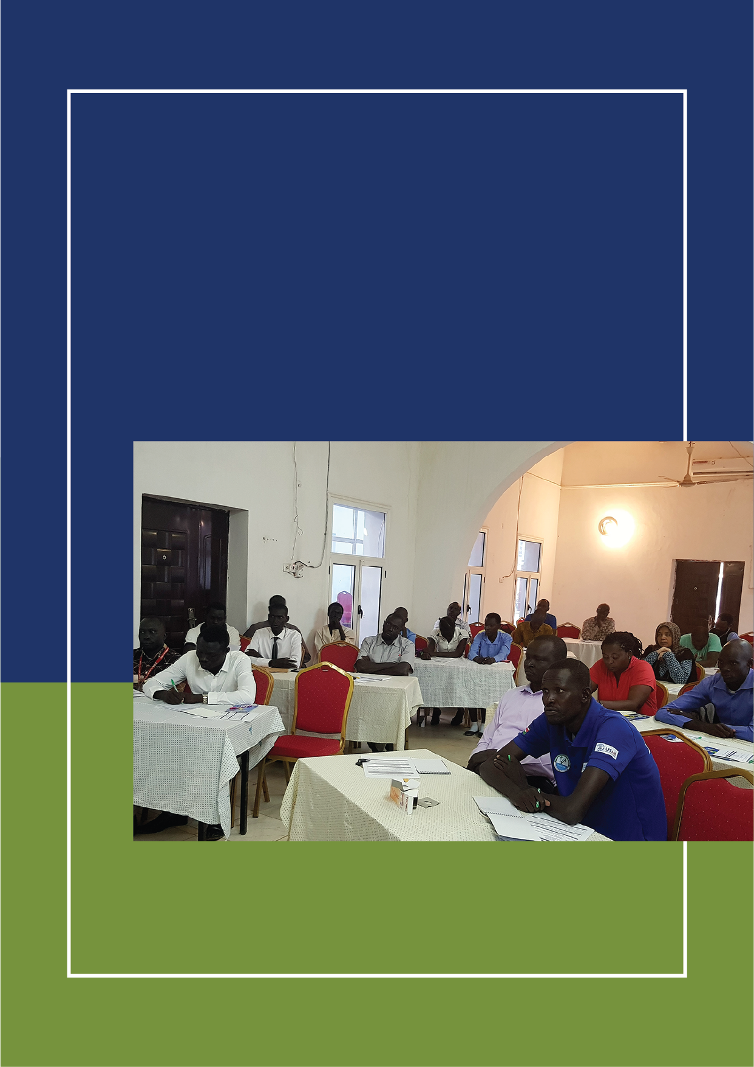

JULY 10th, 2019

**DRAFT REPORT OF VALIDATION OF RESLIENCE PROFILES STUDY FINDINGS WORKSHOP IN AWEIL, SOUTH SUDAN**

Partnership for Recovery and Resilience (PfRR)

# CONTENTS

CONTENTS 2

List of Figures 3

List of Tables 3

Acronyms 4

Executive Summary 5

Background 7

The Partnership for Resilience and Recovery (PfRR) 7

About the Resilience Profiles Study 8

Welcome Session 8

Official Opening Remarks 8

Methodology 9

Validation of Resilience Profiles Study Findings 9

Validation of Resilience Profiles Findings on Trust in People and Institutions 9

Validation of Resilience Profiles Findings on Access to Basic Services (Pillar two) 11

Productive services 14

Nurturing Partnerships 16

Measuring Resilience 16

Critical Institutions per PfRR Pillar 17

Conclusion 18

Annex I: Program for Aweil Resilience Profiles Study Validation 19

Tentative Programme for Validation of Resilience Profiles 19

Annex II: Aweil IA4R Workshop Participants List 20

Recovery and Resilience Profiles Validation Workshop 20

Annex III: Aweil IA4R Participants by Gender 22

# List of Figures

Figure 1: Major institutions affecting households 9

Figure 2: Predominant Social risks in Aweil 10

Figure 3: Adult household members that can read and write 11

Figure 4: Distance to Primary school 11

Figure 5: Reason for not attending school 12

Figure 6: quality of health care services 12

Figure 7: Main water sources 13

Figure 8: Rating of government services in Aweil 13

Figure 9: Causes of lack of food in Aweil 14

Figure 10: Market livelihood activities by gender 15

Figure 11: Geographic market coverage 15

Figure 12: Average resilience capacity index in Aweil 16

# List of Tables

Table 1: Institutions identified by Participants as critical Per Pillar 17

# Acronyms

|  |  |
| --- | --- |
| ABS | Absorptive capacity |
| AC | Adaptive Capacity |
| AST | Assets |
| CBO | Community based Organizations |
| CSO | Civil Society Organizations |
| FGD | Focus Group Discussion |
| FSNMS | Food Security and Nutrition Measurement Surveys |
| HoFO | Head of Field Office |
| INGOs | International Non-Governmental Organizations |
| KII | Key Informant Interview |
| MAARF | Ministry of Agriculture, Animal Resources and Fisheries |
| MESP | Monitoring and Evaluation Support Project |
| MSI | Management Systems International |
| PAs | Partnership Areas |
| PfRR | Partnership for recovery and Resilience |
| RIMA | Resilience Measurement Index Analysis |
| SSN | Social Safety Nets |
| UN FAO | United Nations Food and Agriculture Organization |
| UNDP | United Nations Development Programme |
| UNICEF | United Nations Children’s Fund |
| UNMISS | United Nations Mission in South Sudan |
| WFP | World Food Programme |
| WVI | World Vision International |

# Executive Summary

On June 18th 2019, Africa Lead facilitated Resilience Profiles Study Findings Validation Workshop in Aweil, South Sudan for the Partnership for Resilience and Recovery (PfRR). A total of 37 people attended the two day event that was preceded by a Resilience Profiles Study validation. The participants included members from local NGOs, private sector, civil society, community based organizations, international NGOs, UN Agencies, and traditional and local authorities (See Annex V).

Results from the 2018 South Sudan Community Resilience Household Perception Survey conducted by the USAID-funded Monitoring and Evaluation Support Project (MESP) were used to provide a basis for discussion of Aweil Resilience Profiles. Data and information that had been collected from the field were presented and validated, thereby enabling participants to better understand the resilience capacities in Aweil. The four Pillars of the Partnership for Recovery and Resilience (Pillar one- Rebuilding Trust in people and institutions, Pillar two – Access to Basic services, Pillar three – Restoring Productive capacities and Pillar four – Nurturing Partnerships) were used to explain and validate the findings.

For Pillar one, rebuilding trust in institutions, it’s true that mothers are more present in the household than the fathers. Traditional Authorities are more influential and have a key role in settling disputes and in Peace Committees. They are also the main government representatives on the grounds and do everything raising questions as to their skills set that may require capacity development in certain respects. The capacity development mainly relates to the role of traditional authorities in traditional courts. In recent times there has been an inordinate increase in the number of appointed vis-a-vis hereditary traditional authorities. Dialogue is the most utilized means of conflict resolution.

For Pillar Two, access to basic services, it is true that Education Status is Low to moderate compared to the other Candidate Partnership Areas an aspect that brings to question peace dividends. Cultural barriers is the most significant reason for low education status and is responsible for the very low enrollment rates and very high dropout rates especially amongst the girl child. Participants think people in Aweil don’t see the value of education and consequently, parents do not send their kids to school. Student participants blamed the parents and also the unavailability of quality education facilities in some areas. Access to health services is limited by the low presence of professional service providers. Aweil may appear to seem to have a better status in terms of access to water. However, accessible might not be an issue but rather availability. The hand pumps could be there but water might not be available in them.

For Pillar Three, Access to productive resources, only Aweil recorded that less that 25% of its population lacked food in the last 12 months among all the PAs. It was clarified further that conflict was not a major cause of food insecurity in Aweil however, Conflict in other areas could create food insecurity in Aweil. It was noted that long dry spell is different from long dry seasons. It is the long dry spells and floods that mainly contribute to food insecurity in Aweil. There is also only one planting season in Aweil and this may contribute to food insecurity.

The Aweil community mainly responded to food shortages by purchasing using own resources, obtaining supplies from relatives and food aid. The major crops grown included Sorghum, Okra, Ground Nuts, Maize, tomatoes, Watermelon and Rice. Sesame should be included since it’s grown even more than maize.

On Pillar 4, nurturing partnerships, it was observed that while external aid is important it needs to be supplemented by local resources. Humanitarian Footprints differs by Candidate Partnership Areas. The Partnership should be about putting the community first and ensuring that dialogue is a core response mechanism

On measuring resilience through RIMA, it was noted that RIMA is based on the FSNMS, is contextual and that a person may be resilient in one location but more vulnerable if moved to other locations and that Resilience is not driven by one factor only. It was true that Male headed households are more resilient than female headed households and assets and adaptive capacity are the key drivers of resilience in Aweil.

The Aweil resilience profiles validation exercise was designed to elicit the views of the community in respect to the concurrence of the findings of the study with the actual situation. The participants of the exercise concurred that the findings of the resilience profiles study on the whole represents and reflects the Aweil community with few exceptions. The findings should be used to inform the design of the various interventions and development initiatives through strong partnerships that will work toward reducing vulnerability and increasing resilience in Aweil that is at the core of the PfRR. The results are critical in institutional capacity development for improved governance, service delivery and increased economic productivity. The validation exercise of the resilience profiles study shows the critical role played by data and consequently evidence in informing development initiatives.

# Background

## The Partnership for Resilience and Recovery (PfRR)

In many parts of South Sudan, communities were calling for change, resisting conflict and focusing on recovery. To support this, a different partnership model was called for -- one which relies directly on communities and civil society to drive change in governance, health, education, food and nutrition security and economic well-being. This model calls for increased partnership and accountability between donors, UN agencies, and nongovernmental organizations at both national and local levels.

It is with this background that the Partnership for Recovery and Resilience (PfRR) in South Sudan was formed. The PfRR unites donors, UN agencies, and non-governmental organizations to ensure that support reaches the communities and households that require it. PfRR targets seven geographic areas within South Sudan, and builds on community-identified strengths and priorities, while tapping into the remarkable survival abilities of local populations.

The PfRR in South Sudan is committed to a “new way of working” that shifts the focus from “meeting needs” to “reducing needs, risks, and vulnerability”. The Partnership promotes a comprehensive approach that brings together collective efforts to address political solutions, peace building, development, humanitarian, security and environmental dimensions.

Consequently, the PfRR in South Sudan agreed to the following as the core Partnership commitments:

* Decrease vulnerability
* Work together across peace building and humanitarian development efforts to meet basic needs and protect coping capacities
* Improve coordination, collaboration and strategic integration
* Advance comprehensive frameworks and partnerships in selected geographic areas
* Scale up delivery of integrated efforts in selected geographic areas
* Enhance mutual accountability and learning.

To operationalize its functions, the PfRR developed a partnership common framework that guides communities in pursuing four pillar objectives that shape and facilitate alignment around a shared agenda: These four pillar objectives were defined as:

* Rebuild trust in people and institutions
* Re-establish access to basic services
* Restore and build productive capacities and economic opportunities
* Nurture effective partnerships

USAID supports the specialized units of the United Nations (UN) such as the United Nations Development Program (UNDP), whose core mandate in South Sudan is recovery and stabilization. The Partnership for Recovery and Resilience is focused on durable solutions and agenda-setting between the United Nations, donor partners, external agencies and state and local actors in various areas of South Sudan. This is a large and challenging partnership arrangement for development partners working within the resilience and recovery space in South Sudan. Significant and achievable opportunities exist to leverage these relationships, provide facilitative and collaborative support to the Partnership, bolster champions at the local level, and create a momentum toward stability and improved livelihoods.

## About the Resilience Profiles Study

To lay the foundation for the strategic support program envisaged under the PfRR, USAID through MSI-MESP Project conducted a Resilience Profiles study in 2018 in which data was collected from seven counties, known as Partnership Areas (PAs) in South Sudan: Yambio, Awiel West, Torit, Wau, Bor South, Yei and Rumbek East. The sampling frame was based on the 2008 Population and Housing Census with some updated information.

The Resilience Profiles Study used a quantitative (household survey) and qualitative (KIIs and FGDs) methods. In the process, between 400-800 households were surveyed in each of the 7 PAs using random selection of households.

The KIIs targeted key institutional actors while FGDs targeted Community Groups to supplement the household survey. The study presents snapshots from the survey data organized around the 4 Pillars of the Partnership Framework.

The Resilience Profiles study was intended to bring evidence together to serve as a common reference for baselining, benchmarking and discussing priorities across and within PAs.

The objective of the Resilience Profiles Study was therefore the profiling of community resilience as it relates to conflicts, livelihoods, poverty, shocks, markets, and their distinct impacts on men, women, children and elders to inform PfRR interventions. Aside from demographic information it conveys the perception of respondents around issues deemed important by the Partners.

# Welcome Session

On the 18th of June, USAID through Africa Lead organized and facilitated a session designed to validate the Resilience Profiles Study findings by the Aweil Community. The validation exercise was attended by participants from the PfRR (Annexe I).

## Official Opening Remarks

The validation exercise was opened by the State Minister for information, Culture, Youth and Sports and the Aweil UNDP Head of Field Services.

The State Minister’s key remark was that “Aweil people are peaceful not because of the various interventions but because peace is a culture of the Aweil people”. It was therefore critical that peace dividends accrue to the Aweil community.

The UNDP Head of Field services observed that the transition from war to peace requires a mindset change. It is necessary to reset our minds from crisis and conflict to a focus on development initiatives that empower communities to mobilize resources and share responsibilities and ultimately a shift from government to governance.

# Methodology

The main methodologies utilized during the validation included Presentations, Plenary discussions and Group work. These methodologies provided an opportunity for participants to understand the Resilience study processes, findings and implications.

# Validation of Resilience Profiles Study Findings

The validation of the Resilience Profiles Study findings were discussed according to the PfRR Pillars.

## Validation of Resilience Profiles Findings on Trust in People and Institutions

### The Family

The Family was treated as the first institution and it was noted that Mothers are more present in households than Fathers. The population age pyramid was such that there are more young people (the under 30s constitute more than 70%) than the elderly. From the discussions, it was observed that development interventions are more likely to have a greater impact on the Aweil society if they target women and Youth.

### Governance

From the figure below, traditional authorities as an institution, play a significant role in the lives of Aweil residents. The Paramount Chief and other traditional Chiefs constitute the major institutions affecting households in Aweil. By performing major tasks such as settling disputes especially land disputes, collecting taxes, keeping law and order, humanitarian coordination among others. The participants agreed that this revelation reflects Aweil as expressed by one of the elder participants who remarked that “Traditional authorities do everything, and actually without the chiefs there is no government in Aweil”. It was however noted that this raises fundamental issues with regard to the ability of the Traditional Authorities to handle such a wide range of matters competently and points at capacity gaps. It also points at coordination gaps with National Government and Local Authorities.

Figure : Major institutions affecting households

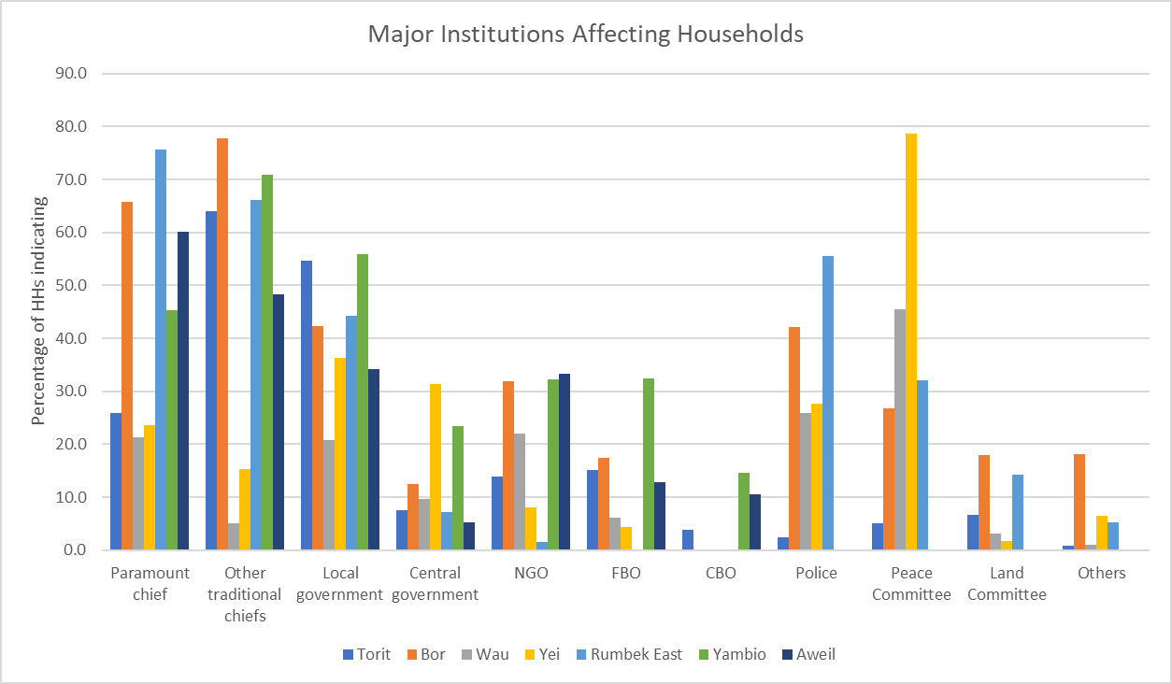

The participants explained that the traditional authorities that exert significant influence in Aweil are often hereditary with some appointed and very few elected. There was animated debate on the basis of traditional authorities shifting toward more appointees. This trend was claimed to be responsible for the declining influence of traditional authorities.

The critical role of traditional authorities in Aweil was amplified by the revelation from the study that the nature of social risks are derive from the break down in law and order. The major social risks in Aweil include alcohol abuse, burglaries, teen pregnancy, domestic violence and gang violence in respective order among others as shown in the figure below.

Figure : Predominant Social risks in Aweil

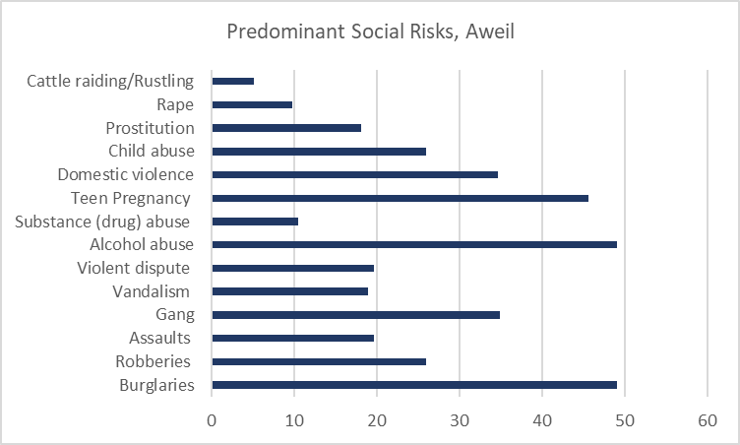

### Conflicts

The major sources of conflict were agreed to be lack of rule of law, corruption, unemployment and misunderstanding between National government and community. However, tribalism was not considered by the participants as a major source of conflict given that Aweil is fairly homogenous in ethnic terms and welcoming to non-indigenous populations. The youth were also found to be the most prone to conflicts.

The major resource based conflicts arose from oil, forestry, water and fisheries respectively. However, Aweil is distinct from the other PAs in that livestock did not constitute a major source of conflict.

The main conflict resolution method was through dialogue and the traditional authorities. The participants noted that even the traditional authorities use dialogue as a means of resolving conflicts.

The effects of conflicts on the Aweil community was not contested and was agreed to be mainly death, loss of household assets, displacement, civil war and loss of animals respectively while the main bottlenecks to conflict resolution were observed to be lack of trust, dishonesty between parties, greed by politicians and lack of seriousness.

## Validation of Resilience Profiles Findings on Access to Basic Services (Pillar two)

### Education

The education levels as measured by the ability to read and write among the Aweil population was well below some of the CPAs that share the same conditions. For instance, the peaceful CPAs such as Yambio have a much higher level of those who can read and write compared to Aweil.

Figure : Adult household members that can read and write

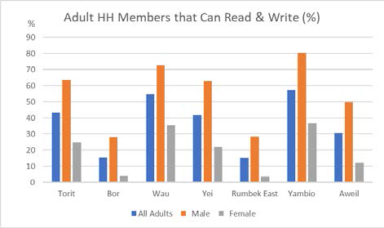

The puzzle to the participants was why Aweil lagged behind in education yet it has been peaceful and most of its primary schools were less than 5 kms away as shown below.

Figure : Distance to Primary school

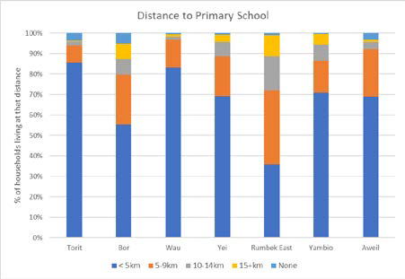

The discussion led to unraveling the reasons for not attending school. It was argued that the peace in Aweil has led to increased non-attendance of schools due to adherence to cultural values for females and the need to support family for males.

Figure : Reason for not attending school

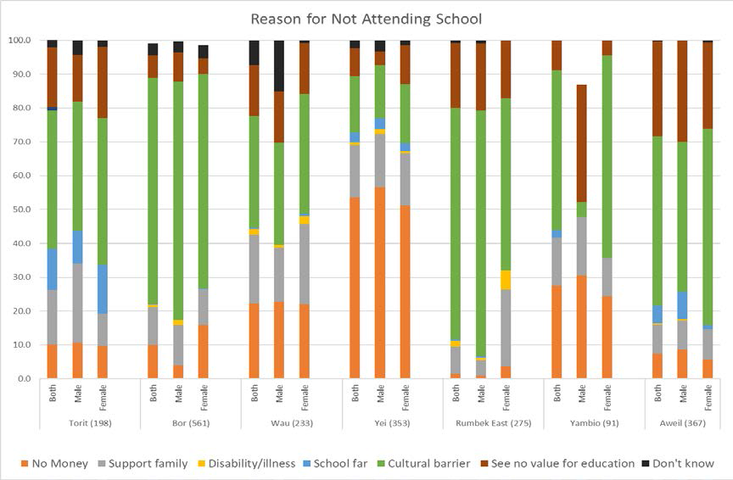

The tendency to drop out of school to support family was thought to be an indicator of the need for vocational skills that can assist pupils to earn a livelihood. Education interventions were also required to have a gender focus that would encourage increased female enrollment and completion rates.

### Health

The participants concurred with the study findings that Aweil appeared to have the poorest health services in all the CPAs under scrutiny as shown in the figure below.

Figure : quality of health care services

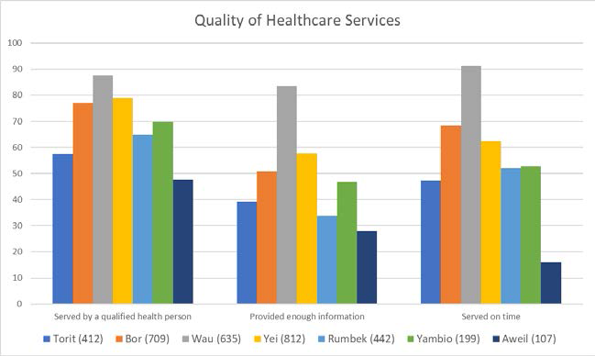

Some of the participants felt that conflict areas received more attention in terms of health services leaving doubts on the issue of peace dividends accruing to Aweil. The participant agreed with the FGDs that “highlighted the general discouragement with health services, noting the long distances to hospitals, absence of drugs in pharmacies, and that doctors have given up because of low pay or no facilities”. It was concluded that the health sector needed serious attention.

### Water

It was noted that Aweil has access to multiple water sources and fared much better than its contemporaries as per the figure below.

Figure : Main water sources

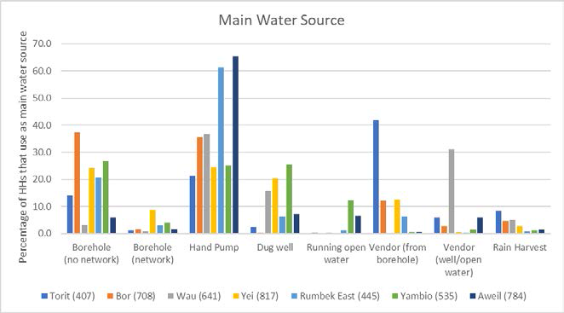

Most of Aweil community takes less than 15 minutes to access a water source. This is attributed to the many water hand pumps in Aweil. However, the classification of hand pumps as a water source elicited some debate. It was suggested that water pumps should really not be treated as a water source.

### Quality of Government services

The quality of most government services was agreed as poor except in resolving violence and national defense.

Figure : Rating of government services in Aweil

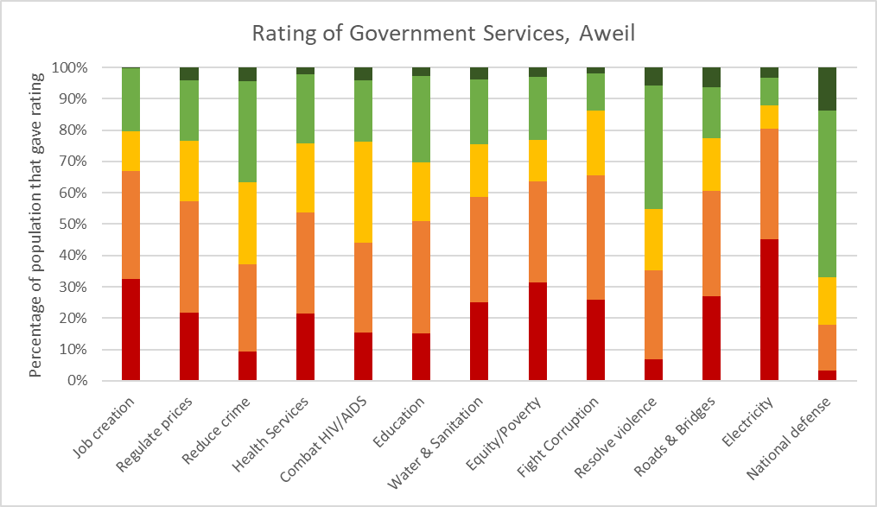

The rating of most government services as poor brought about serious discussion as to remedial actions. Many of the participants felt that the government staff required significant capacity building in their responsibilities as well as incentives in terms of remuneration.

## Productive services

### Food Security

It was noted that most households in Aweil often lack food in the course of the year. The cause of lack of food while mainly agreed to be climate and environmental related presented a kind of paradox. From the findings, as shown below, long dry spells and flooding were the major causes of lack of food. Participants pointed out that it important to distinguish long dry spells from long dry seasons.

Figure : Causes of lack of food in Aweil

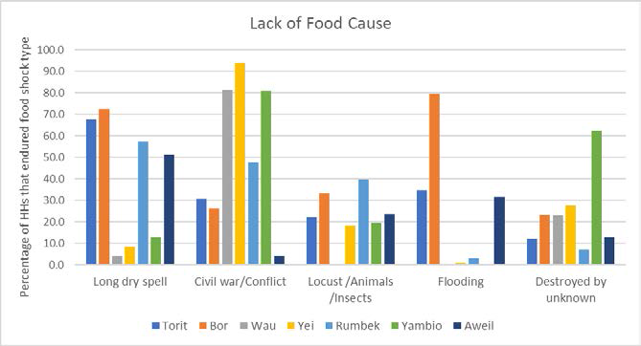

The major causes of lack of food in Aweil presented a challenge in view of the necessary interventions. The participants proposed water management as a key factor in tackling food insecurity.

Purchases from own resources, getting food from relatives and gathering of wild animals and plants were not contested as responses to food insecurity. What was in contention was the diminished role accorded to WFP and government food aid.

Sorghum was by far the most commonly grown food crop but it was felt that okra, maize, sesame and groundnuts are equally important. Sesame appeared to have been missed out among the most important crops grown in Aweil and should be included. Fruits and vegetables are hardly grown pointing to limited dietary diversity.

### Livelihoods

The major livelihood activities in Aweil were crop production, livestock production, construction, carpentry and retail respectively for all gender categories (female youth, male youth, women and men). These were not disputed.

There were disparities in the market livelihood activities by gender as shown in the figure below. While the major activities were petty trade, casual labour, firewood collection, hair dressing and brewing of alcohol the distribution by gender showed some unexpected results.

Figure : Market livelihood activities by gender

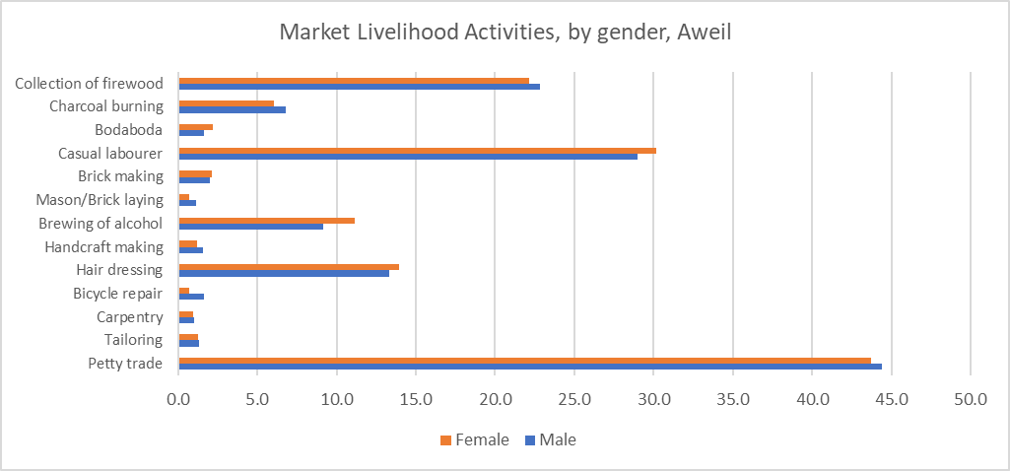

For instance, there were more men than women in petty trade and firewood collection and the reverse was the case under casual labour. The participants explained that this was contrary to expectations.

The participants agreed on the livelihood challenges as mainly emanating from lack of capital, lack of employment and nepotism. There were some livelihood challenges also attributed to insecurity, gender and age differences.

### Market Access

In Aweil, it was observed that a large proportion of the population source their food supplies from the market. While the markets are both local and regional, as shown below, the price of commodities are generally high thereby restricting access.

Figure : Geographic market coverage

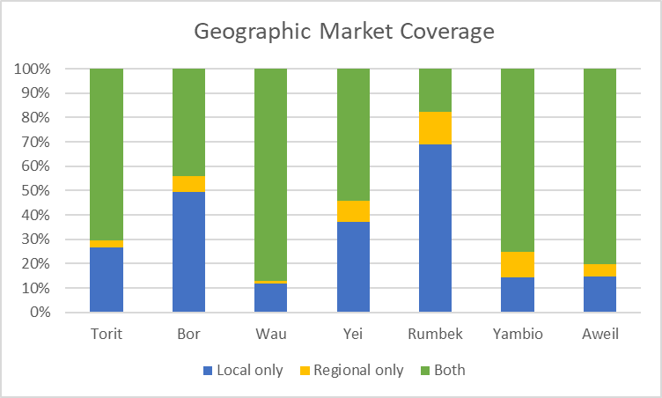

It is ironical that Aweil is a predominantly agricultural area yet the price of food commodities is often out of reach.

## Nurturing Partnerships

The partnership element was captured by considering responses to questions on awareness of agencies operating in the area. Aweil community was barely aware of agencies operating in the area. The participants intimated that this shows that humanitarian footprints differ by Partnership Areas. This was argued to be the case in that the community mostly depended on its own resources for food. It was noted that while external aid is important it needs to be supplemented by local resources. This implies that the Partnership has to be about putting the community first.

# Measuring Resilience

This session was meant to introduce and share the results of the Resilience Measurement Index (RIMA II) by UN FAO.

It was explained that for this session the RIMA II was based on the Food Security and nutrition Measurement Survey (FSNMS) round 2 data collected in July – August 2018 in which a total of 7263 households were surveyed, of which 544 households are in the Aweils. The Sample was drawn by NBS and the obtained data representative at County level. Each county had at least 108 households (9 clusters of 12 HHs each). For subsequent rounds, the FSNMS questionnaire has been modified to include more resilience measurement indicators.

**The RIMA II** is a quantitative approach that estimates resilience to food insecurity using **4 Pillars:** Access to basic Services (ABS), Assets (AST), Social Safety Nets (SSN) and Adaptive Capacity (AC).

The results indicated that Resilience differs by area and that Aweil North was the most resilient while Aweil South is the least resilient.

Figure : Average resilience capacity index in Aweil



It was found that male headed households were more resilient than female headed households. These results provoked a major debate as to the underlying causes. It was explained that resilience is not driven by one factor only and consequently investments in resilience capacity building should take into account the unique drivers in each county/state. Similarly, gender aspects are key in building resilience and designing new programmes. It was also observed that not all drivers have similar effects and that assets, and adaptive capacities are leading the way at this time.

# Critical Institutions per PfRR Pillar

As part of the Resilience Profiles and as a prelude to the IA4R session, the participants were asked to Identify and agree on the critical institutions for their Pillars. The perceived critical institutions in Aweil as identified by Pillars one, two and three members are shown in the table below. The institutions were however not ranked. These results are consistent with the PfRR Pillar tasks where Pillar one is composed of governance oriented institutions including traditional authorities, peace committees, county courts and law enforcement agencies. Pillar Two is on social service delivery and includes government line ministries concerned with education, health and social welfare. Pillar Three is on Productive service delivery covers government line ministries such as MAARF, water and Irrigation and research and training institutions. The Private sector is listed as critical in Pillars Two and Three but not Pillar one. UN agencies, International INGOs, NGOs, CBOs, and CSOs are found across all the Pillars indicating their significant roles in the Aweil community development efforts.

Table : Institutions identified by Participants as critical Per Pillar

| **Pillar One Institutions** | | **Pillar Two Institutions** | **Pillar Three Institutions** |
| --- | --- | --- | --- |
| **County Government** | Government line ministries [WASH, Education, Health, and Protection – Child social welfare] | | Government Ministries (MAARF, Water and Irrigation, Infrastructure) |
| **Office of the commissioner** | INGOs, UN Agencies | | Private sector (Financial institutions, Agro-input dealers, Extension services) |
| **Community development** | Traditional Authorities | | Research and training institutions (Universities and colleges, Research centers) |
| **County Court** | Women Groups | | Development Partners (UN Agencies, NGOs, CBOs, INGOs, CSOs, FBOs) |
| **County council, Land council** | Youth Groups | |  |
| **Department of co-operative** | Private sector | |  |
| **COTAL (Council of traditional authority and leaders)** | Community structures (Peace committee, Council of Chiefs and elders) | |  |
| **Rural water department (WASH)** | NNGOs, CBOs, FBOs | |  |
| **Department of education** |  | |  |
| **Department of health** |  | |  |
| **RRC (Peace committee)** |  | |  |
| **CBOs, FBOs, women, youth groups, trade unions** |  | |  |
| **UN agencies, INGOs** |  | |  |
| **Law enforcement agencies (Police and Judiciary)** |  | |  |

# Conclusion

The Aweil resilience profiles validation exercise was designed to elicit the views of the community in respect to the concurrence of the findings of the study with the actual situation. The participants of the exercise concurred that the findings of the resilience profiles study on the whole represents and reflects the Aweil community with few exceptions. The findings should be used to inform the design of the various interventions and development initiatives through strong partnerships that will work toward reducing vulnerability and increasing resilience in Aweil that is at the core of the PfRR. The results are critical in institutional capacity development for improved governance, service delivery and increased economic productivity. The validation exercise of the resilience profiles study shows the critical role played by data and consequently evidence in informing development initiatives.

# Annex I: Program for Aweil Resilience Profiles Study Validation

## Tentative Programme for Validation of Resilience Profiles

### 18th June, 2019 Aweil, South Sudan

|  |  |  |
| --- | --- | --- |
| **TIME** | **ACTIVITY** | **RESPONSIBLE** |
| **DAY I** | | |
| 8.00 – 8.30am | ARRIVAL AND REGISTRATION | ALL |
| 8.30 – 9.00am | WELCOME AND INTRODUCTION  OPENING REMARKS  HoFO | Africa Lead |
| 9.00 – 9.30am | Overview of PfRR | Juba TEG |
| 9.30 – 10.00am | Background and Overview of Resilience Profiles Study | Africa Lead |
| 10.00 – 10.30am | Aweil Resilience Profiles (Pillar 1: Trust in People and Institutions) | Africa Lead |
| 10.30 – 11.00am | Health Break |  |
| 11.00am – 12.30pm | Aweil Resilience Profiles (Pillars 2: Access to Basic Services, Pillar 3: Productive Capacities and Pillar 4: Nurturing Partnerships) | Africa Lead |
| 12.30 – 13.00pm | Plenary | ALL |
| 13.00 – 14.00pm | Lunch Break |  |
| 14.00 – 15.00pm | RIMA II | FAO- JUba |
| 15.00 – 15.30pm | Plenary | ALL |
| 15.30 – 16.30pm | Group Work (Identification of critical institutions for Resilience per Pillar) | ALL |
| 16.30 – 17.00pm | Tea Break |  |
| 17.00 – 18.00pm | Group Presentations | ALL |
| 18.00 – 18.30pm | Way Forward | ALL |

# Annex II: Aweil IA4R Workshop Participants List

## Recovery and Resilience Profiles Validation Workshop

### Participant Email Contact List

**Aweil – Grand Hotel**

| **Name of Participant** | **Gender** | **Email Address** |
| --- | --- | --- |
| 1. Benjamin Anyuon | M | [cawdcafrica@gmail.com](mailto:cawdcafrica@gmail.com) |
| 1. Francis Aakot | M | [francisakot@gmail.com](mailto:francisakot@gmail.com) |
| 1. Shahida Paul | F | [Shahida.Paul@fao.org](mailto:Shahida.Paul@fao.org) |
| 1. Mayuol Diing | M | [Mayuoldiing@gmail.com](mailto:Mayuoldiing@gmail.com) |
| 1. Tako Seme | M | [Seme.Tako@fao.org](mailto:Seme.Tako@fao.org) |
| 1. Wono Luke | M | [Wono.luke@usf-suisse.org](mailto:Wono.luke@usf-suisse.org) |
| 1. Joseph Lual Deng | M | [Joslual2015@gmail.com](mailto:Joslual2015@gmail.com) |
| 1. Frank Kessy | M | [fkessy@nonviolentpeaceforce.org](mailto:fkessy@nonviolentpeaceforce.org) |
| 1. Lita Jackson | M | [Jackson.Lita@fao.org](mailto:Jackson.Lita@fao.org) |
| 1. Emmanuel Ramba | M | [eramba@unicef.org](mailto:eramba@unicef.org) |
| 1. Elizabeth H | F | [nyanut.care46@gmail.com](mailto:nyanut.care46@gmail.com) |
| 1. Dominic Anyanga | M | [dominic.anyanga@undp.org](mailto:dominic.anyanga@undp.org) |
| 1. Ajang Santino | M | [ajongsantino631@gmail.com](mailto:ajongsantino631@gmail.com) |
| 1. Upieu Jongkor | M | [upieu1979@gmail.com](mailto:upieu1979@gmail.com) |
| 1. Philip Thon | M | [Philip.garagg@gmail.com](mailto:Philip.garagg@gmail.com) |
| 1. Santino Garang | M | [akotsantinoskot@gmail.com](mailto:akotsantinoskot@gmail.com)  [cipadsouthsudan@gmail.com](mailto:cipadsouthsudan@gmail.com) |
| 1. Aguak Kuach | F |  |
| 1. Akun Amet Amet | F |  |
| 1. Archangelo Diing | M | [diingarchangelo@gmail.com](mailto:diingarchangelo@gmail.com) |
| 1. Angelo Lual | M |  |
| 1. Efange Sophie | F | [effange@unfpa.org](mailto:effange@unfpa.org) |
| 1. Khalif Fareh | M | [Fareh2@un.org](mailto:Fareh2@un.org) |
| 1. Yusuf Mohammed | M | [mohammed89@un.org](mailto:mohammed89@un.org) |
| 1. Rogers Otuta | M | [rogers.otuta@concern.net](mailto:rogers.otuta@concern.net) |
| 1. Emmett Watson | M | [emmett.watson@undp.org](mailto:emmett.watson@undp.org) |
| 1. Sampson VK Dolo | M | [fieldco-nbeg@ssd-actionagainsthunger.org](mailto:fieldco-nbeg@ssd-actionagainsthunger.org) |
| 1. Solomon Telan | M | [Solomon.Tilahan@wfp.org](mailto:Solomon.Tilahan@wfp.org) |
| 1. James Amet | M | [jamesamet1983@gmail.com](mailto:jamesamet1983@gmail.com)  [James_Dhiau@wvi.org](mailto:James_Dhiau@wvi.org) |
| 1. Moses Jiel | M | [Jielmoses@gmail.com](mailto:Jielmoses@gmail.com) |
| 1. Aron Afuer | M | [arunjok@gmail.com](mailto:arunjok@gmail.com) |
| 1. Dee Santos | M | [deesantos10@gmail.com](mailto:deesantos10@gmail.com) |
| 1. Nicholas Kerandi | M | [NICHOLAS.KERANDI@FAO.ORG](mailto:NICHOLAS.KERANDI@FAO.ORG) |
| 1. Dan Dunlop | M | [Dunlop2@un.org](mailto:Dunlop2@un.org) |
| 1. Bona Yak | F |  |
| 1. Deborah Amor | F |  |
| 1. Wawien Ayom | M |  |
| 1. James Chol | M | [Choljames37@gmail.com](mailto:Choljames37@gmail.com) |

# 

# Annex III: Aweil IA4R Participants by Gender

**Aweil IA4R Participant Analysis by Gender**

|  |  |  |  |  |
| --- | --- | --- | --- | --- |
|  | **Frequency** | **Percent** | **Valid Percent** | **Cumulative Percent** |
| Male | 30 | 81.1 | 81.1 | 81.1 |
| Female | 7 | 18.9 | 18.9 | 100.0 |
| Total | 37 | 100.0 | 100.0 |  |

The table above represents the participants in the IA4R workshop in Aweil by gender. Eighty one (81) per cent of the participants were male representing different organizations in Aweil, government officials, NGOs, NNGOs, Cultural leader (s) and CBOs. One school was also represented. Only 19 per cent of the participants were female. As seen above males, were over represented in the workshop