Dimensions: 1 metre x 2 metres

Knowledge-Sharing
Engagement
Networking
Coordination

Collaboration
Representation
e-Platform

Learning
Advocacy

Resilience Exchange Network

Launch

27 March, 2018
Event sponsored by: 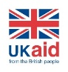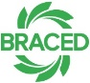

Colour for BRACED LOGO:
Red: 0
Green: 176
Blue: 80

